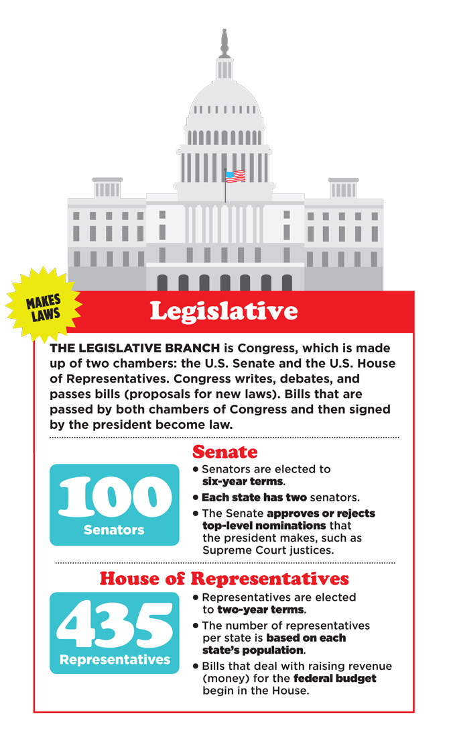**I. US INSTITUTIONS**

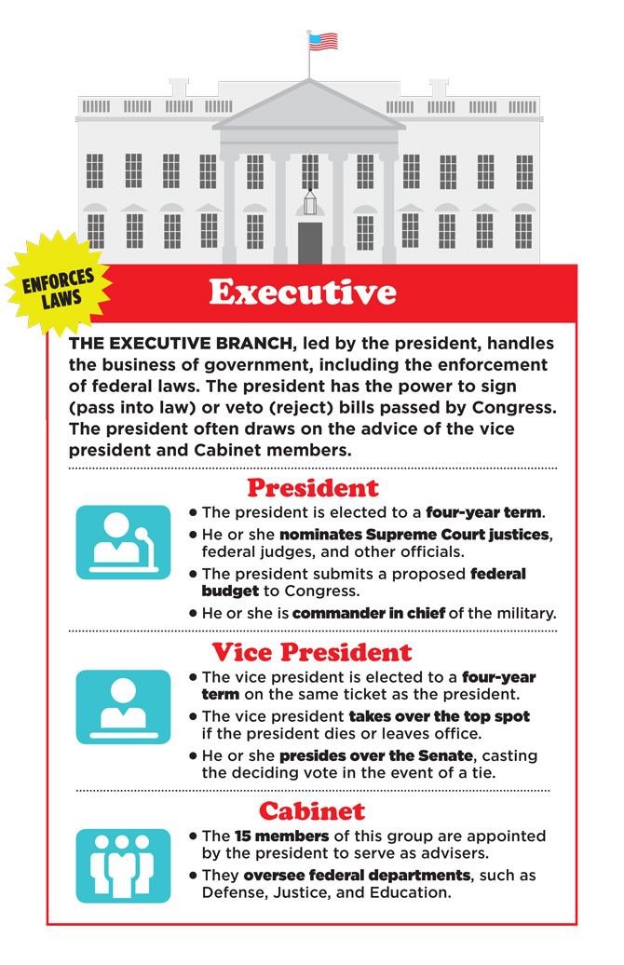

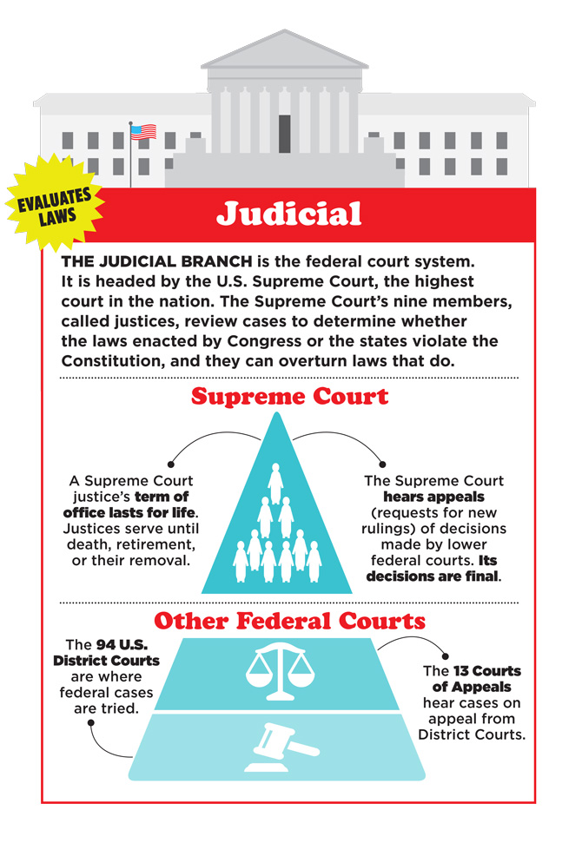

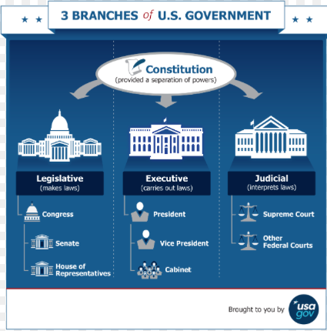

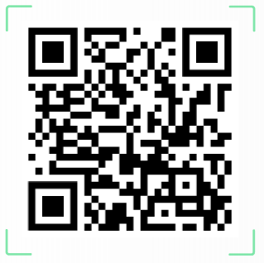**II. US PRESIDENTIAL ELECTIONS**

Watch this video from the BBC : <https://www.youtube.com/watch?v=LY8L6C7tsx8>

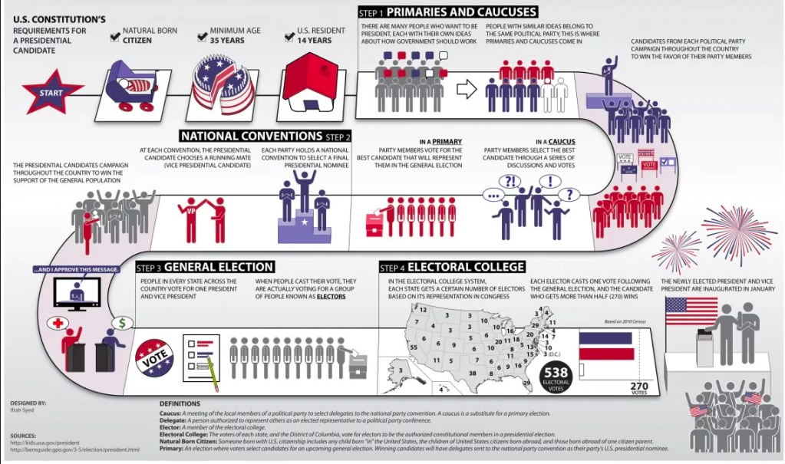

https://kz.usembassy.gov/summary-of-the-u-s-presidential-election-process/