1 – Introduce yourself

2- Describe and analyse the picture

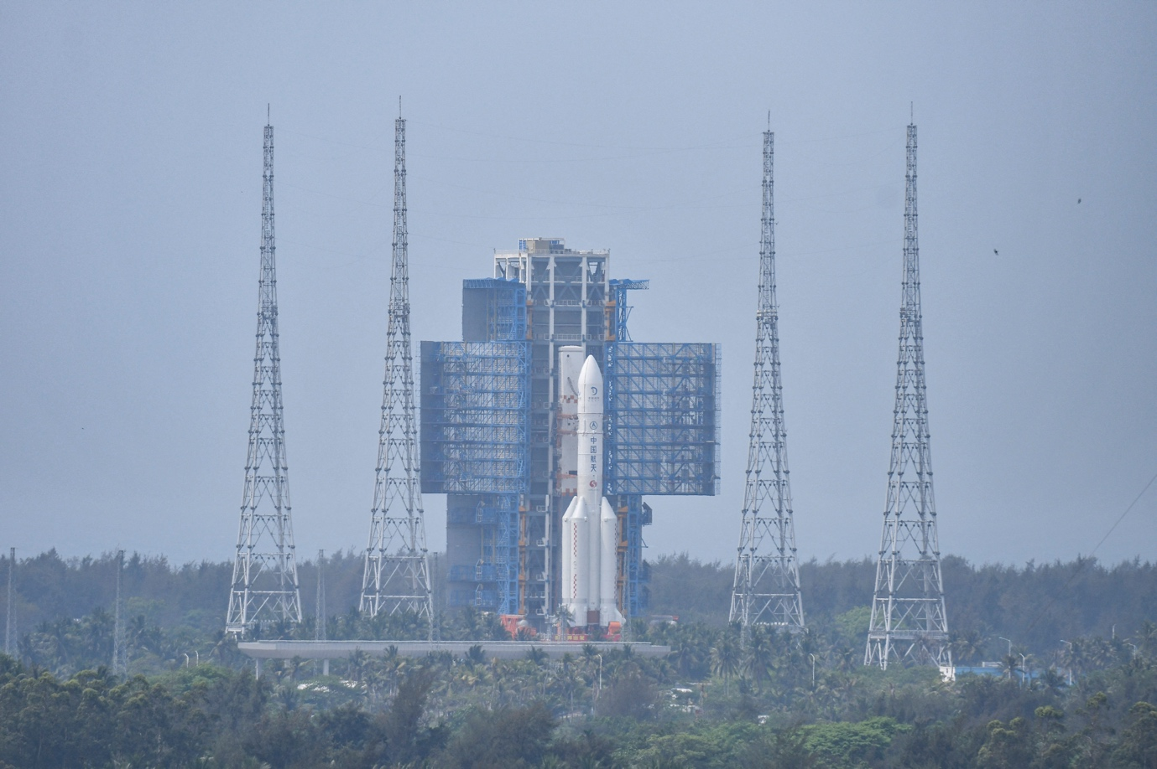

3 – Role play situation

You work for the European Space Agency. China’s unprecedented feat of landing an unmanned spacecraft on the far side of the moon is all any of the media can talk about.

What is your opinion of China’s entrance into the new “space race”? Is China outperforming the ESA and NASA? What about Elon Musk’s Space X and the other private space enterprises?

BEIJING, June 2, 2024 (Reuters) - China landed an uncrewed spacecraft on the far side of the moon on Sunday, overcoming a key hurdle in its landmark mission to retrieve the world's first rock and soil samples from the dark lunar hemisphere.
The landing elevates China's space power status in a global rush to the moon, where countries including the United States are hoping to exploit lunar minerals to sustain long-term astronaut missions and moon bases within the next decade.

