Mines Telecom
1. Personal presentation
2. Picture : description + analyse
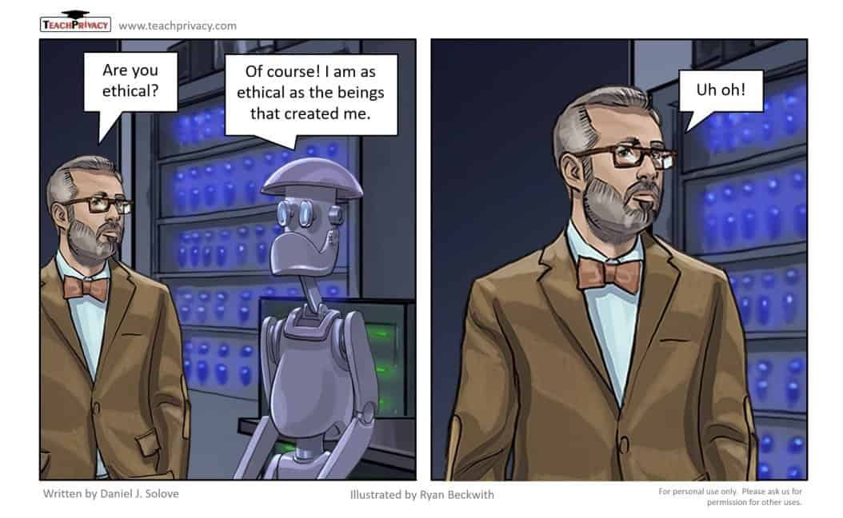

3. ROLE PLAY :
In April 2024, Michael Bommer, a 61-year-old German who was terminally ill with cancer, decided to preserve his personality into an interactive AI version of himself. Although he is now dead, his family is able to access his voice, thoughts and memories through an app created by the company Eternos Project.
The person in front of you is a representative from the firm. Ask more about what they do and discuss the implications about this new possibility.
----------------------------------------------
https://nypost.com/2024/05/14/lifestyle/i-have-weeks-left-to-live-thanks-to-ai-my-family-can-talk-to-me-forever/
Michael Bommer’s days are numbered but his presence will carry on — thanks to artificial intelligence.
Everything changed for Bommer, a 61-year-old software designer from Berlin, Germany, when he received a devastating colon cancer diagnosis two years ago. After many procedures and ups and downs, the married father of four has recently come to terms with these next few weeks likely being his last.But his family may never truly have to say goodbye: Bommer meticulously input his intimate recollections, speech patterns and overall knowledge into a first-of-its-kind, sophisticated AI program — one heavily expedited to be completed before he passes.
“It’s giving me the opportunity to leave my memories in the vault,” he told The Post.
Weeks of testing the novel AI has shown spot-on accuracy in how it can rationalize and speak as Bommer would.
It all began in March when Bommer posted an emotional note on social media, revealing that his time was running short. That note caught the attention of an old friend and colleague, Robert LoCascio, founder of the publicly traded AI service LivePerson. LoCascio — motivated by the loss of his own father — had spent a year developing Eternos.life, an AI program that allows people to interact with a digital replication of loved ones through their voice and words.
The user-friendly format is practically identical to writing prompts with ChatGPT, only the responses come in both text and speech, a groundbreaking concept he thought would help heal and comfort those grieving a lost loved one.
Hearing of Bommer’s unfortunate fate, LoCascio reached out to his longtime friend and asked a historic question: Would you want to be immortalized in AI? He said yes in a heartbeat.
“I’m not the memoir guy. I’m not the guy who writes a memoir,” he said. “I’m the technology guy, I love technology, I’ve seen what that technology can do in the past, and I’m totally delighted about this opportunity.”
Knowing he will be digitally enshrined, Bommer takes solace in the fact that Eternos.life is a secured program that only approved loved ones can access.
“We had to basically construct two things. One is, how do we capture everything from the person?” LoCascio told The Post, adding that his team “had to accelerate development” to finish while Bommer is still alive.
LoCascio explained that the AI works in three parts: talking about the life and times of Bommer, allowing his virtual self to advise those interacting and a third “imaginative” mode to tell bedtime stories or write things like a touching poem to his wife.
No one has participated in such a sophisticated program to the extent Bommer has, LoCascio said, and technology is moving quickly.
“Eventually, we’re going to move on to him as a video, like really as a person,” LoCascio added. “But for the high quality we want, we’re only at voice right now.”
There are other AI programs dedicated to memorializing humans forever, but Eternos.life said it will be the first to use machine learning to create reason like its user would.
The company also noted that the program has enough intuition to maintain the values the person abided by during their life, essentially allowing the person to live on in digital format.
The next phase for Bommer’s Eternos.life AI is that when it recalls stories of his life, pre-input photos and videos will accompany the text and voice to create an artificially intelligent neural network that embodies the subject.
LoCascio’s goal for when the product is fully launched is to have people input anecdotes throughout their lives like a diary as something they plan to leave behind.
But Bommer’s project isn’t just for family who are here and now. It is also designed for his grandchildren to get to know their grandpa, whenever they make it into the world someday.

