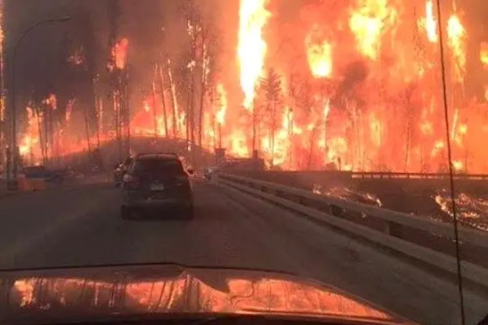

- After reporting on the evacuation of hundreds of residents in a small town in Alberta Canada in the midst of horrific wildfires, you now interview a climate expert on the role of climate change in the natural catastrophe raging.

