- I’ve been(present perfect) here for 10 min. for + durée
- She left ten min ago. (il y a 10 minutes = le temps/la durée)
- There was a post office in the village. (il y a = pour dire que quelque chose existe dans un lieu, une situation)
- There must be a problem.
- There must have been a pb.

- He listens to music when he goes to work.
- I can’t wait for you because I’m in a hurry.
- The wife was talking to her husband but he was not listening to her.
- I’m looking for my glasses. Where are they?
- We might go to the cinema but it depends on the weather.
- What are you looking at?
- She’s exhausted because she’s looking after / taking care of her mother who is ill.
- Look up this word in the dictionary.
- I don’t know how she could put up with him for so long! He’s so selfish!
- When does your plane take off? (horaires prévus = present simple pour renvoyer à l’avenir)

- How long have you known him?
- I’ve known him for 5 years.
- He’s gone out / he’s been going out with her since Christmas.
- You’re getting on my nerves. You’re annoying. You are always complaining.
- I’ve heard this song for the first time.
It’s the first time I’ve heard this song.
- He runs once a week.

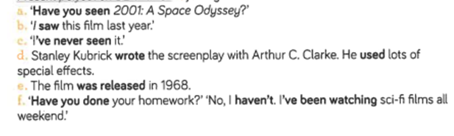
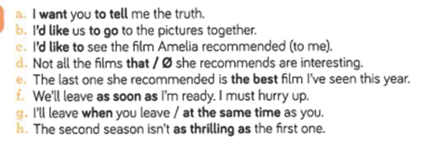

- What has happened to you? I fell in the stairs, and with a broken arm, I find it hard to dress.

- By telling the truth straight away/ right away, you might get away with it with only a fine/ you may be let off if with only a fine.

- I’ll have to stop at the chemist’s when I comehome tonight.

- In Great Britain, they / people drink tea, but in our country, we drink wine.

- At nights all cats are grey.

- In spite of all the efforts she was making, she was getting stiffer and stiffer. / Despite all her efforts, she was becoming stiffer and stiffer.

- Her husband was to join her for the end of the holidays but he has just phoned to tell that he would not be able to.

- His wife was a few years older than him/ than he was.

- I wish I had been able to phone them earlier.
- Expression du regret

- She spoke more as a member of the Conservative Party than as a former Prime Minister.

- This interesting map shows the former British colonies.
- Once upon a time = Il étaitunefois
Once, these territories belonged to the British Empire. It is not the case anymore.
These territories used to belong to the British Empire.
- This territory (sing)
- These territories (pluriel)
- It was nicknamed“the empire on which the sun never sets”.
- Since decolonisation in the middle of the 20th century, these countries have been independent.
- Even if the author does not praise/ does not champion the Empire, he shows/underlines the long-lasting legacy of this institution on the United Kingdom today.
Although that author….
I owe you an apology = je te dois des excuses

- Tu devrais arrêter de chanter. Ils veulent que tu arrêtes. (conseil).
You should stop singing. They want you to stop.
- Tu peux partir si tu veux arriver à l’heure. (permission)
You may go now if you want to arrive on time.
- Il doit être en train de travailler. (probabilité forte sur un événement présent)
He must be working.
- Il a peut-être volé cette voiture hier soir (probabilité faible sur un événement passé).
He might have stolen this car yesterday evening.
- S’il avait su que Sherlock Holmes était là, il se serait caché.
If he had known Sherlock Holmes was here, he would have hidden.

- So far, God has been good to let me /make me find what I was looking for. (to allow me to)
- Have you ever thought you were Christ?
- I have been working on this invention for a long time.
- Three hours ago, I told him “I want you to bring this to Dr. Mathews.”

- Peut-elle/Sait-elle parler allemand ? Combien de fois est-elle allée en Allemagne ?
Can she speak German? How many timesdid she go to Germany?
- Ira-t-il en Nouvelle-Zélande l’année prochaine ? Combien de temps dure le voyage ? (to last)
Will he go to New Zealand next year? How long does the trip last?
- Ont-ils une belle maison ? Quelle est la profondeur de leur piscine ?
Do they have a nice house? How deep is their swimming pool? Depth= (le nom) = la profondeur

- Ce magasin a été construit en 1899. Cependant, il a été détruit par un feu il y a 2 ans.
This shop was builtin 1899. However, it was destroyed by a fire 2 years ago. PRETERIT au passif
Auxiliaire “BE” au preterit + participe passé
PAST PERFECT –
This shop had been built.
It had been destroyed.

This shop has beenbuilt.
It has been destroyed.
- Depuis l’incendie, il a été reconstruit. Mais sa cave n’est pas utilisée (cellar).
Since the fire, it has been rebuilt. But its cellar is not used.
Its ≠ it is/it’s
Its population is very diverse. It is/it’s a multicultural nation.

