Politics
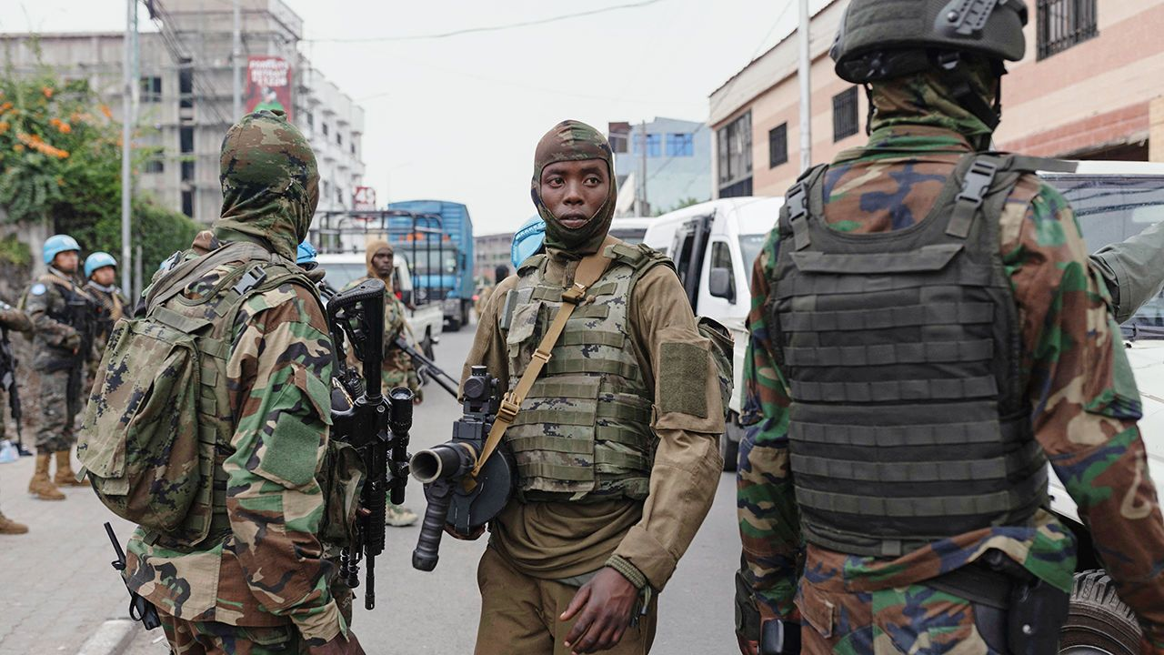Photograph: Reuters
Jan 30th 2025
1 Goma, the largest city in the east of the Democratic Republic of Congo, fell to M23, an armed group backed by Rwanda. The capture of Goma marks a stunning escalation of hostilities between Paul Kagame, Rwanda’s president, and his country’s much larger neighbour. African and Western diplomats have roundly condemned the attack but are unlikely to force Mr Kagame to reverse course. The incursion raises the risk of a wider conflict in the region, which suffered two devastating wars between 1996 and 2003. avec force
2 Burkina Faso, Mali and Niger left the Economic Community of West African States, Africa’s main regional bloc, and unveiled a common passport for their Alliance of Sahel States. The trio of military regimes claim they left ECOWAS because it failed to help them fight jihadists. But the more likely reason is their desire to escape pressure to hand power back to civilian governments.
3 Israel opened part of the Netzarim corridor into northern Gaza to allow displaced Palestinians to return to what remains of their homes. It opened the route 48 hours later than expected after disputes with Hamas over which hostages would be released as part of the ceasefire. More than 300,000 Palestinians returned to the area, which has been devastated in the war.
4 Donald Trump invited Binyamin Netanyahu to visit the White House. The Israeli prime minister is the first foreign leader to be invited during Mr Trump’s second term. Mr Trump also resumed shipments of 2,000lb (907kg) bunker-buster bombs to Israel. Deliveries were suspended under Joe Biden last year. Destructeur de bunker
5 A law banning activity by UNRWA, the UN’s agency for Palestinians, on Israeli soil came into effect. The Israeli government says UNRWA is complicit with Hamas and that some of its employees took part in the massacres of October 7th. It is unclear how the ban will affect UNRWA’s activities in Gaza or the West Bank. Complice de
6 Ahmed al-Sharaa, Syria’s de facto ruler since the ousting of Bashar al-Assad, declared himself the country’s interim president. He also announced the dissolution of Mr Assad’s Baath party and the formation of a legislative council to govern Syria until a new constitution can be agreed.
7 An American Airlines flight from Wichita carrying 64 people crashed into the Potomac river by Washington, DC. The plane collided with an army Black Hawk helicopter that had three people on board. Roger Marshall, a senator from Kansas, described the “unbearable sorrow” of many people dying. chagrin
8 Confusion reigned in Washington after the White House issued and then retracted a memorandum that aimed to freeze trillions of dollars in federal loans and grants. A judge had suspended the edict. Separately, most federal workers were given the option of resigning with eight months’ pay. The State Department, meanwhile, seemed to back away a little from an earlier announcement to pause nearly all foreign-aid spending.
9 The Senate held confirmation hearings for Robert F. Kennedy junior as Donald Trump’s health secretary. Earlier, Pete Hegseth was confirmed as secretary of defence. The Senate was split 50-50 on confirming him, forcing J.D. Vance, the vice-president, to cast his tie-breaking vote in favour of Mr Hegseth. It was only the second time ever that a tie-breaker has been needed for a cabinet appointment. décisif
10 The Justice Department fired a dozen lawyers who had worked on the two criminal investigations into Mr Trump during Joe Biden’s presidency. A spokesman said they could not be trusted to implement the new president’s agenda. The head of the department’s public-integrity section decided to step down.
11 Robert Menendez, a former Democratic senator from New Jersey, was sentenced to 11 years in prison for accepting bribes and acting as a foreign agent for Egypt. After the conviction was read out, Mr Menendez seemed to make an appeal to Mr Trump to pardon him, saying the president could restore “integrity” to the justice system. In 2017 Mr Menendez was tried for corruption in a separate case, but the jury couldn’t reach a verdict.

Hardball diplomacy
12 Mr Trump threatened to impose stiff tariffs on Colombia, after the country’s leftist president, Gustavo Petro, said he would not allow American military planes carrying Colombians deported from the United States to land. Mr Petro soon backed down and offered his presidential plane to transport the migrants. Mr Trump lifted the threat of tariffs and the first migrants arrived back in Bogotá, Colombia’s capital, on Colombian military aircraft. Droits de douane élevés
13 South Korea’s president, Yoon Suk Yeol, was officially charged with insurrection over his order in December that briefly imposed martial law. A former defence minister and several security chiefs have been similarly charged. Mr Yoon’s separate impeachment trial is being heard by the Constitutional Court.
14 Dozens of people were killed in a stampede at the Maha Kumbh Mela religious festival in northern India. Hundreds of millions of Hindus attend the six-week event attempting to take a ritual dip in waters that are considered sacred. Mouvement de foule plongeon
15 The German parliament passed non-binding measures to restrict migration, including the automatic refusal of entry to illegal migrants. The proposals were put forward by Friedrich Merz, the leader of the Christian Democratic Union parliamentary bloc, which is on track to win the forthcoming general election. Mr Merz sparked outrage by turning to the Alternative for Germany (AfD) to help pass his measures, breaking a long-standing convention of snubbing the hard right. Non-contraignant déclencher l’indignation
16 Estonia and Lithuania promised to increase their spending on defence to more than 5% of GDP, a level that Donald Trump has called on NATO countries to aim for. A NATO summit in June is likely to raise spending targets for its members above the current 2% of GDP.
17 Milos Vucevic resigned as prime minister of Serbia, following weeks of protests over the collapse of a railway-station roof in Novi Sad, the country’s second-biggest city, which killed 15 people. The roof collapsed after renovations that were carried out by a Chinese-led consortium. The fall of Mr Vucevic is a blow to Aleksandar Vucic, Serbia’s president.
18 Alexander Lukashenko doesn’t have to worry about democratic accountability. He was re-elected for a seventh term as president of Belarus with 87% of the vote in another sham election. The Kremlin congratulated Mr Lukashenko on his “solid victory”. Poland’s foreign minister mocked the result, and wondered if there would be room in prison for the 13% who voted for other candidates.

Never forget
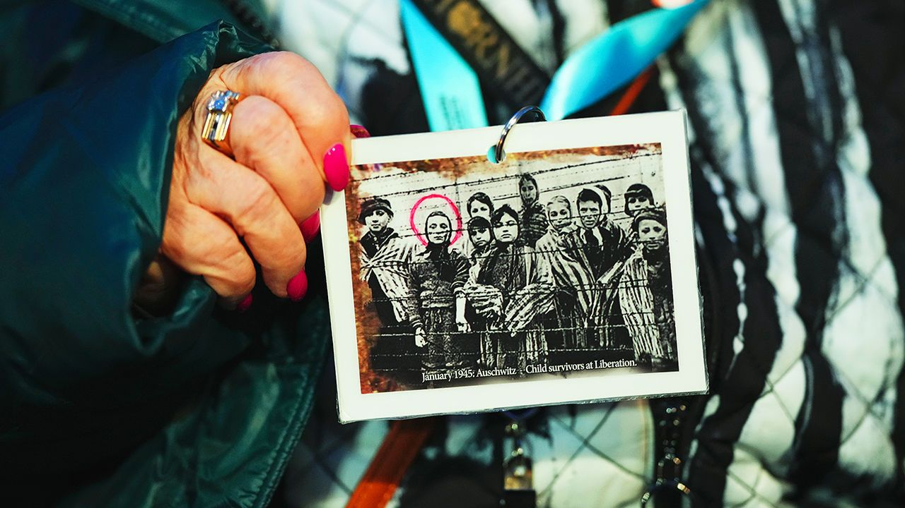Photograph: AP
19 The remaining survivors of the Auschwitz death camp commemorated the 80th anniversary of its liberation. The Nazis murdered 1.1m people at the camp, 1m of whom were Jewish; 6m Jews were killed in the Holocaust overall. Several world leaders attended the commemorative event, including Emmanuel Macron, Volodymyr Zelensky, Olaf Scholz and King Charles. None made a speech; that was left for the survivors to do. Surveys in various countries have revealed a lack of awareness about what happened during the Holocaust, especially among younger people.

KAL

