Politics
Photograph: dpa
Feb 27th 2025

1 The conservative Christian Democratic Union (CDU) and its sister party, the Christian Social Union in Bavaria, won Germany’s election with 29% of the vote. The hard-right Alternative for Germany (AfD) scored 21%, its best-ever result. The incumbent Social Democrats (SPD) took just 16% and the Greens 12%. Friedrich Merz, the probable next chancellor, has refused to work with the AfD so he will try to form a coalition with the SPD. After his victory Mr Merz said Europe could no longer rely on America for its defence and would have to take responsibility for its own security. He also ruled out a quick reform to Germany’s “debt brake”, which restricts government borrowing and spending, even on defence, saying that this required “a lot of difficult work”. Au pouvoir ‘frein à dette’
2 Volodymyr Zelensky praised the “absolute heroism” of the Ukrainian people on the third anniversary of Russia’s invasion of Ukraine. Earlier, Mr Zelensky said he would be willing to step down as Ukraine’s president in exchange for NATO membership. On the eve of the anniversary Russia launched its biggest drone attack yet.
3 At the United Nations, meanwhile, America shocked European allies by joining Russia in voting against a resolution at the General Assembly condemning Russia’s aggression in Ukraine. America then drafted a resolution at the Security Council calling for an end to the war, but containing no criticism of Russia. Its resolution passed, but Britain and France abstained. rédiger
4 Underlining his emphasis on transactional diplomacy, Donald Trump reached a deal with Ukraine to develop the country’s large deposits of critical minerals and invited Mr Zelensky to Washington for “a very big agreement”. Earlier, Vladimir Putin said he would allow “foreign partners” to develop Russia’s store of rare minerals. He also scotched Mr Trump’s optimism about reaching a peace deal, saying that Ukraine was only “touched on” in Russia’s negotiations with America. Ukraine was not on the agenda for a second round of talks in Turkey. refroidir

Europe on the back foot
5 Emmanuel Macron visited Mr Trump at the White House. The French and American presidents discussed sending European peacekeepers to Ukraine as part of a peace deal. Mr Trump’s claim that Mr Putin would have “no problem” with the deployment was flatly contradicted by the Kremlin. Sir Keir Starmer, Britain’s prime minister, pledged to increase British defence spending from 2.3% to 2.5% of GDP ahead of his trip to Washington.
6 Mr Trump sacked General Charles Brown as chairman of the Joint Chiefs of Staff with immediate effect, pulling Lieutenant-General Dan Caine out of retirement to replace him. General Caine has spent much of his military career in special operations.
7 America’s House of Representatives passed a bill backed by Mr Trump that contains $4.5trn in tax cuts and $2trn in spending cuts. Most economists think that, if enacted, the bill will increase the deficit. The Senate now gets its say.
8 Following the Senate’s confirmation of Kash Patel as director of the FBI, Mr Trump made another controversial appointment to the law-enforcement agency, naming Dan Bongino, a right-wing podcaster, as deputy director.
9 The ceasefire in Gaza looked shaky. Israel released hundreds of Palestinian prisoners, but delayed the handover because of Hamas’s ill treatment of hostages during release ceremonies. The militant group returned the remains of four more dead captives. Israel carried out DNA tests to check their identity; Hamas had earlier given the Israelis the body of a Palestinian woman instead of a hostage. It was the final exchange in the first phase of the ceasefire. Talks have not begun on the second stage. Meanwhile, Israel sent tanks into the West Bank for the first time in 20 years; around 40,000 Palestinians have fled their homes there in the past month. Fragile libération Cisjordanie
10 Syrians gathered for a “national dialogue”. The 600 delegates have been asked to consider how a new transitional government should deal with transitional justice, the economy and the new constitution. Ahmed al-Sharaa, the former jihadist who is now the interim president, has stressed the need for militias to be integrated into the army.
11 Sudan’s Rapid Support Forces announced the formation of a breakaway government in the areas under its control. The paramilitary group, which has been fighting the national army for two years and stands accused of genocide in Darfur, unveiled its “political charter” in Nairobi, the Kenyan capital. Sudan’s military government, led by Abdel Fattah al-Burhan, denounced Kenya for hosting the event, declaring it “tantamount to an act of hostility”. Gouvernement séparatiste
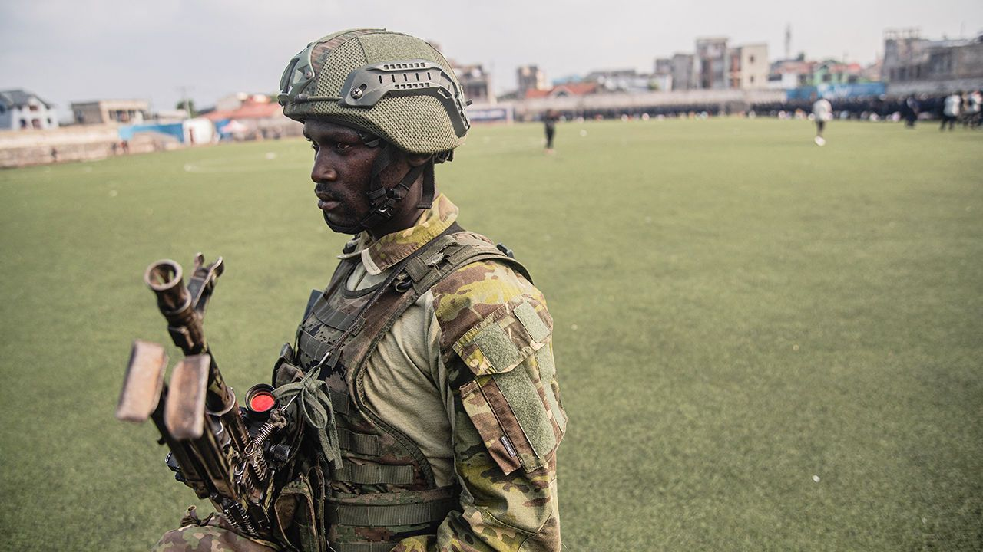Photograph: Getty Images
12 M23, a militia backed by Rwanda, continued its advance on Uvira, a city in eastern Democratic Republic of the Congo. Soldiers from Burundi, which is allied with DRC, manoeuvred to fend off M23, which has already captured the Lake Kivu region and its two main cities. Britain paused most bilateral aid to Rwanda, with which it has hitherto had good relations. It said aid flows would remain suspended until “significant progress” had been made to end the fighting. repousser
13 Taiwan’s coast guard claimed that it had caught a Chinese-owned ship cutting undersea cables and had detained the vessel. Taiwan has previously accused China of several such non-military “grey zone” actions against the island. China retorted that the episode was being “deliberately exaggerated” by Taiwan.
14 In Pakistan at least ten militants were killed in an operation by the security forces near the border with Afghanistan. The region is used as a base by the Pakistani Taliban.
15 South Korea’s fertility rate rose last year for the first time since 2015. But the average number of children per woman among all reproductive females is still just 0.75, according to official statistics. The country has already declared a “national demographic crisis”.
16 Argentina’s president, Javier Milei, overrode opposition in the Senate to his two judicial nominations to the Supreme Court by appointing them temporarily by decree instead. Mr Milei says the constitution allows him to do this when Congress is in recess. Critics say he has weakened the court’s independence. En vacances parlementaires
17 The candidates running to replace Justin Trudeau as leader of Canada’s Liberal Party, and thus prime minister, held a debate. Relations with America took up a large part of the proceedings. Chrystia Freeland, who is running second in the polls behind Mark Carney, described Donald Trump as “the greatest threat to Canada since world war two”.

That’s not dandruff pellicules
18 It emerged that a Colombian man was arrested for trying to smuggle cocaine under his toupée onto a flight bound for Amsterdam. The drugs were valued at $10,500. It is not the first time that drug-traffickers have used hair-raising schemes to smuggle their wares. In 2019 a man was caught at Barcelona’s airport with half a kilo of cocaine under his wig. False buttocks, breast implants, nuns’ habits and pineapples have all been used to traffick the drug. Postiche , perruque, postérieur prothèse mammaire, habit de religieuse

KAL

