Durée : 3 heures

Rappel des consignes
Merci de sauter des lignes, de soigner la graphie et de laisser un espace pour l’appréciation.
Rédiger en anglais et en 400 mots une synthèse des documents proposés, qui devra obligatoirement comporter un titre.
Vous indiquerez impérativement le nombre total de mots utilisés (titre inclus) et vous aurez soin d'en faciliter la vérification en mettant un trait vertical (discret) tous les vingt mots. Des points de pénalité seront soustraits en cas de non-respect du nombre total de mots utilisés avec une tolérance de ± 10 %.
Concernant la présentation du corpus dans l'introduction, vous n'indiquerez que la source et la date de chaque document. Vous pourrez ensuite, dans le corps de la synthèse, faire référence à ces documents par
« doc.1 », « doc. 2 », etc.
Ce sujet comporte les 4 documents suivants, qui sont d'égale importance:

- Document 1 : Leaders at the Global Climate Summit Highlight the Rising Toll of Warming
(extrait et adapté de The New York Times, David Gelles and Brad Plumer, November 7, 2025)

- Document 2: Explainer-What is climate finance and why does it matter?
(extrait et adapté de uk.finance.yahoo.com, Simon Jessop, November 11, 2025)
- Document 3 : Thousands March for Climate Action as U.N. Talks Enter Second Week
(extrait et adapté de The New York Times, Lisa Friedman, Brad Plumer and Max Bearak, November 17, 2025)

- Document 4: Climate finance to poor nations
(Cagle Cartoons, Paresh Nath, November 2021)

1/4
Document 1 - Leaders at the Global Climate Summit Highlight the Rising Toll of Warming
In Spain, intense heat waves and floods have claimed thousands of lives in recent years.
In Namibia, higher temperatures have resulted in drought and widespread hunger. And in Haiti, Hurricane Melissa, which was made more violent by global warming, last week killed more than 40 people.
World leaders shared vivid stories about the increasingly severe effects of a warming planet on Friday, the second day of the United Nations climate summit in Belém, Brazil.
“Forests are vanishing, water levels are rising and, in turn, peoples’ livelihoods are being disrupted,” Salah Jama, the deputy prime Minister of Somalia, said. “In a nutshell, we are living on a planet in crisis.”
Politicians, diplomats, scientists and business executives are gathering for the event, known as COP30, during another year of record heat and extreme weather that scientists say is being worsened by human-caused climate change.
This week, the United Nations announced that the world was far off-track from keeping global warming well below 2 degrees Celsius, or 3.6 degrees Fahrenheit, compared with preindustrial levels. That was a goal that virtually every country agreed to 10 years ago as part of the Paris climate agreement.
Instead, with heat-trapping emissions from the burning of fossil fuels and deforestation continuing to rise, the world is on track to warm by 2.8 degrees Celsius. Scientists have said that every additional fraction of a degree of warming brings greater risks from heat waves, wildfires, drought, storms and species extinction.
The United States is one of the few countries in the world not attending the summit. President Trump routinely dismisses the threats posed by climate change and is promoting fossil fuels like coal, oil and gas, while penalizing the renewable energy industry. [...]

At a time when international cooperation is flagging and many countries are more focused on issues like trade and energy security, officials are hoping to use the U.N. summit to direct global attention to the dangers of climate change and the benefits of switching to cleaner forms of energy.
“There’s a real focus in these first few days on going back to basics, that climate change is real and it matters,” said Kaysie Brown, the associate director for climate diplomacy and geopolitics at E3G, a European research and advocacy group. “That basic message can’t be taken for granted.”
In between the warnings were calls to overhaul the modern economy, Prime Minister Pedro Sánchez of Spain said his country was working with other nations to place additional taxes on premium-class air travel and the use of private jets. “This is only fair,” he said. “Everyone needs to pay their due.”
He added that he hoped to stop using public funds to finance new fossil fuel projects.
Many leaders also called for rich nations to make more money available to developing countries.
“We must reform the current global financial architecture to make capital more accessible and affordable for climate action in the developing world,” Mr. Kindiki, the Kenyan vice president, said.
The pleas for more money come at a time when aid is tough to come by.
The amount of financial assistance that rich nations give to poor ones to adapt to storms, heat waves and other perils of climate change dropped 7% in 2023, according to the United Nations Environment Program.

David Gelles and Brad Plumer, The New York Times, November 7, 2025

Document 2: What is climate finance and why does it matter?

WHAT IS CLIMATE FINANCE?
This describes all funding from governments, development banks, private investors and philanthropies aimed at helping countries ‌cut greenhouse gas emissions or adapt to climate impacts, for example through projects in renewable energy or for flood defenses.
2/4
WHY DOES IT MATTER?
Without climate finance, poorer countries will struggle to decarbonize their economies and protect vulnerable populations. Because these ‌countries contributed the least in emissions, the 1992 U.N. climate treaty determines they should carry less of the burden of addressing the problem today.
WHAT ARE THE MAIN DISPUTES?
Countries today disagree about who should pay climate finance, how much is needed and how it should be distributed. Historically, only industrialized countries like the U.S., Japan and nations in Europe have contributed, but pressure is mounting on fast-developing,⁠ high-polluting countries such as China, India and the ‌Gulf states to pitch in.
Beijing insists it should continue to be treated as a developing nation under the U.N. climate treaty.
Developing nations, many already burdened with high debt levels, are also pushing for more grants rather than loans. A World Bank report in December showed external debt held by ‍low- and middle-income countries had risen by more than $205 billion in 2023 to a record $8.8 trillion.
HOW MUCH MONEY IS INVOLVED?
For developing countries, nations at COP29 in Baku agreed to work on boosting annual funding to at least $1.3 ⁠trillion, with dozens of finance ministers producing a "Baku-to-Belem Roadmap" of recommendations for how ​to do so. This still falls far short of the $7.4 trillion that Climate Policy Initiative, an independent organisation, estimates is needed annually through 2030 ​to meet global climate targets.
WHAT NOW AS COUNTRIES SCALE BACK?
Rich nations have scaled back on development aid in recent years,‍ as they juggle concerns about energy security, ⁠economic stability and competing bills for war and AI development. Last year's overseas development aid totaled $212.1 billion, a drop of more than 7 percent from the previous year, according to preliminary OECD estimates.
This is shifting focus toward ways to attract more private money, through changes in financial regulations, credit ratings and multilateral bank lending ⁠practices and the creation of new financial instruments.
Simon Jessop, uk.finance.yahoo.com, November 11, 2025

Document 3 : Thousands March for Climate Action as U.N. Talks Enter Second Week
Thousands of climate activists flooded the Brazilian city of Belém this weekend, marching with a giant inflatable Earth, singing, dancing and demanding that nations gathered for a global climate summit at the edge of the Amazon rainforest take action to protect the planet.
But inside the negotiating halls where the United Nations conference, known as COP30, is entering its second week, the mood was less festive. Numerous issues remain unresolved as government officials confront the gap between the pledges they have made to reduce their greenhouse gases and the ambition required to stave off rising global temperatures.
“We know the world is off track,” said Manish Bapna, the president of the Natural Resources Defense Council, an environmental group. “Now it’s all about how we get back on track and how we translate promises into real change on the ground,” he said.
Ten years ago in Paris, nearly 200 nations agreed to keep the average increase in global temperature to “well below” 2 degrees Celsius (3.6 degrees Fahrenheit), and preferably closer to 1.5 degrees, compared with preindustrial levels. But emissions have increased significantly since then.
Carbon dioxide from the burning of oil, gas and coal — the main driver of climate change — is on track to hit a record high this year.
The world has already warmed about 1.3 degrees Celsius since the 19th century, and scientists have estimated that current policies will likely lead to around 2.8 degrees Celsius of warming by the end of the century. […]
2/4
Among the topics of debate: How to make more funding available for developing nations so that they can protect themselves against the effects of climate change and how to handle trade barriers on clean energy technologies.
Small island nations, which are disproportionately vulnerable to rising sea levels and other climate-fueled disasters, are also pushing for COP30 to formally address the weakness of nations’ targets and hold countries accountable for not doing more.
Some officials, fearing that the talks could end up delivering a thin response on climate, are urging their colleagues to confront even more contentious issues.
Foremost among them is whether countries will build on an ambitious but vague promise made two years ago at a summit in Dubai, United Arab Emirates, to begin “transitioning away” from oil, gas and coal.
A group of countries — including Britain, Colombia, Denmark, France, Germany, and Kenya — are proposing that the summit create a detailed “road map” for how that transition might happen. It could, for instance, suggest that governments reduce subsidies for drilling and gasoline consumption.
But any effort to get more specific about phasing out fossil fuels is almost certain to face opposition from major oil and gas producing countries at the summit, including Saudi Arabia and Russia.
President Luiz Inácio Lula da Silva of Brazil had suggested the fossil fuel road map in a speech at the beginning of the summit, although his country is a case study in how difficult that transition can be. Brazil recently granted a license to its state oil company to explore for new sources of oil near the mouth of the Amazon River.
And the United States, while not participating in the talks, is moving quickly under the Trump administration to produce more fossil fuels. It is also pressuring other nations to buy them.
Lisa Friedman Brad Plumer and Max Bearak, November 17, 2025

Document 4: Climate change to poor nations
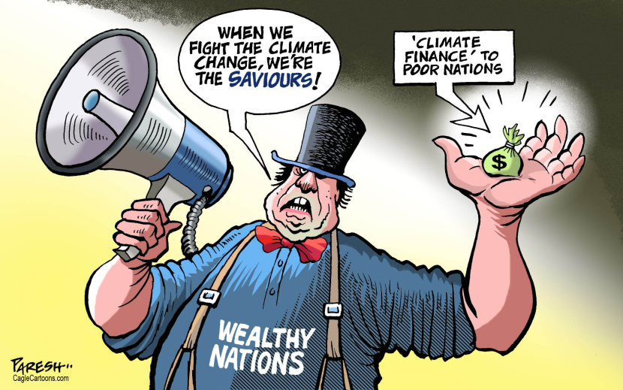
Paresh Nash, Cagle Cartoons, November 2021
FIN
4/4

