Politics

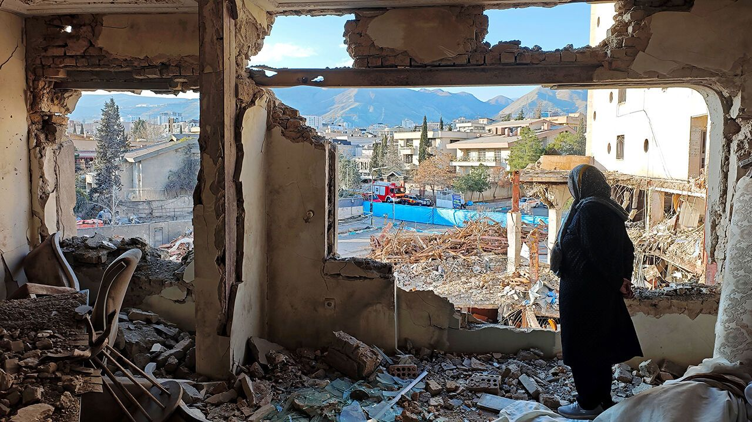Photograph: Getty Images
Mar 26th 2026|6 min read

1 Various countries, including Egypt, Pakistan and Turkey, said they were willing to mediate between America and Iran, with Pakistan saying it was ready to host talks. Donald Trump had earlier backed down from a threat to strike Iran’s energy facilities. He claimed several times that talks were under way with Iran and producing results. Iran denied that any such dialogue was taking place, but that messages were being “conveyed via friendly countries”. America has reportedly put forward a 15-point peace plan. The Pentagon ordered additional troops to the Gulf, according to reports; thousands of Marines are already en route to the region. The Strait of Hormuz remained largely closed to shipping, though Iran said it would allow vessels from friendly countries to pass.

2 Iran executed three young men in connection with the demonstrations that swept the country earlier this year. They are thought to be the first formal executions of any protesters detained during the unrest; more are expected. Observers said it was a sham trial. De façade
3 Israel announced that it would establish a security zone in southern Lebanon policed by Israeli troops in order to curtail Hizbullah’s activities. Soldiers blew up bridges crossing the Litani river, around 20km (12 miles) north of the Israeli border, to secure the area. Hizbullah, which is backed by Iran, agreed on paper to a ceasefire in 2024, but launched missiles at Israel again recently. Many observers think Israel will now be seen as an occupying force in the south. Meanwhile, the Iranian ambassador was ordered to leave Lebanon, a few days after the Lebanese prime minister said that Iran’s Revolutionary Guards were directing Hizbullah’s operations in the south. limiter
3 The Asian Development Bank announced a financial-support package for member countries to help mitigate the economic impact of the Iran war. Sri Lanka became the first country to tap the programme. The Philippines declared a national energy emergency; the country gets almost all of its oil from the Gulf. The president, Ferdinand Marcos junior, said that “nothing is off the table” as the government seeks new sources of oil and imposes measures to ensure economic stability. atténuer
4 Chad deployed more troops to its border with Sudan after a drone attack launched from across the border killed 17 people. Both sides in Sudan’s civil war blamed each other for the incident. Chad has said it is ready to respond to any further acts of aggression.

Don’t forget the war
5 Russia attacked Ukraine with 948 drones, its biggest assault on the country over a 24-hour period since the conflict began four years ago. Volodymyr Zelensky, Ukraine’s president, said Russia had been emboldened by America’s conflict with Iran. Meanwhile, Russia reportedly suspended operations at its oil-export hubs at Primorsk and Ust-Luga on the Baltic Sea after they were struck by Ukrainian drones. enhardir
6 Several weeks of coalition negotiations loom in Denmark after an indecisive general election. Mette Frederiksen, the prime minister, and her Social Democrats won the most votes but fell short of a majority. She will try to form a government with a left-wing bloc of parties but will also need backing from the Moderate party. Greenland featured as an issue in campaigning, but voters expressed most concern about immigration and welfare.

7 A proposal in Italy to introduce minor changes to the judicial system was roundly rejected by voters at a referendum. The proposed changes sought to separate the career structure for judges and prosecutors and rejig the bodies that oversee them. The right-wing government backed the reforms, claiming they would make the judiciary more independent. The opposition turned the vote into a plebiscite on Giorgia Meloni, the prime minister; it was her first big defeat since taking office in 2022. redéfinir
8 In France the candidate backed by the populist-right National Rally won the mayor’s office in Nice, the fifth-biggest city, in local elections, but the party failed to win its prized targets of Marseille and Toulon. The Socialists kept control of the mayoralty of Paris, where their candidate, Emmanuel Grégoire, defeated Rachida Dati, a conservative former minister of culture. During the campaign Mr Grégoire kept his distance from the far left, which faces accusations of antisemitism.

9 In Belgium soldiers began patrolling Jewish areas following several antisemitic attacks, including the explosion of a device outside a synagogue in Liège. Two men were arrested in London for setting fire to ambulances operated by a Jewish charity. The vehicles were set ablaze in Golders Green, an area with a large Jewish population. The ambulances served the whole community. incendier

Modern times
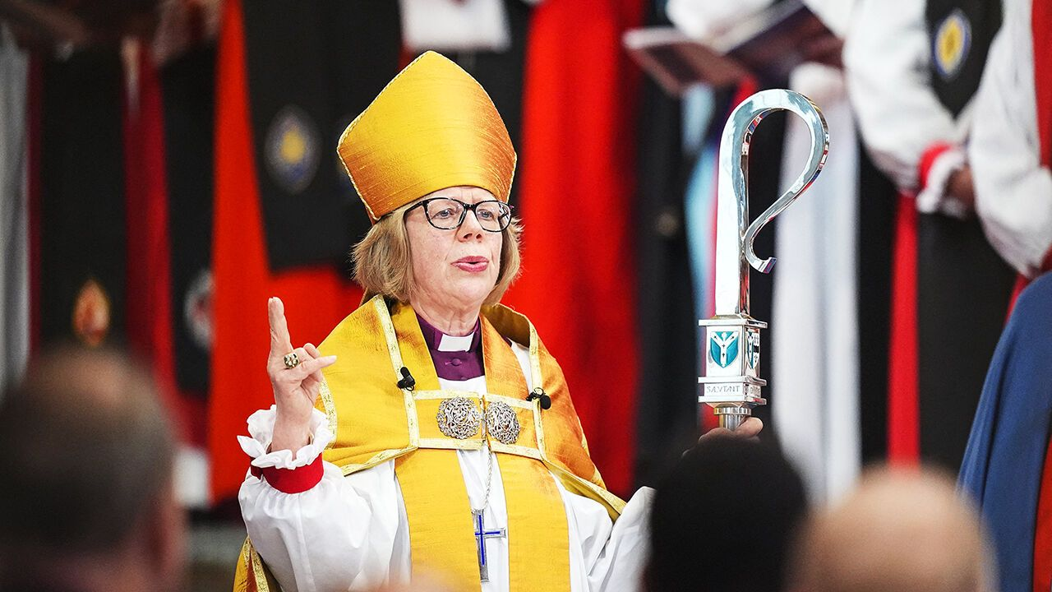Photograph: Getty Images
10 Sarah Mullally was installed as the Archbishop of Canterbury, becoming the first female primate of the Church of England and ceremonial head of the worldwide Anglican community. In another first, the BBC appointed someone from the world of big tech as its new director-general. Matt Brittin is a former executive at Google. He takes over from Tim Davie, who resigned over allegations of editorial bias at the BBC, including selective editing of a documentary to show Donald Trump in a worse light. primat
11 The Taliban government in Afghanistan released an American it had held in captivity for over a year. Dennis Coyle lived in the country as a language researcher. His family say he was not charged with any crime. Earlier this month America’s State Department designated Afghanistan as a “state sponsor of wrongful detention”. Iran was given the same designation shortly before America launched its attack on the country. État soutenant les détentions illégales

12 A military plane carrying 128 passengers crashed on take-off in Colombia, killing at least 69 people. Gustavo Petro, the president, seemed to suggest that “bureaucratic problems” were partly to blame for holding up his plans to modernise the armed forces, though he gave no actual cause of the accident.

13 Venezuela’s interim president, Delcy Rodríguez, shook up the country’s senior military ranks and sacked the defence minister, who had been close to Nicolás Maduro, ousted as president in an American operation in January. The new defence minister is Gustavo González López, who led the intelligence services when Mr Maduro was in power and is loyal to the socialist regime.

14 The Senate confirmed Markwayne Mullin as secretary of homeland security, as Congress continued to haggle over a funding deal to end a partial shutdown of the department. The impasse has left airport-security workers unpaid, leading to staff shortages and long queues at airports. Immigration and Customs Enforcement officers have been sent to help ease the disruption. Marchander

15 The Democratic candidate won a special election in the Florida state-legislature district that includes Donald Trump’s Mar-a-Lago home in Palm Beach. A Republican had carried the district by 19 percentage points just two years ago. The swing underscores Democrats’ growing strength ahead of November’s midterm elections. souligner
Matt Wuerker - Politico



