Politics

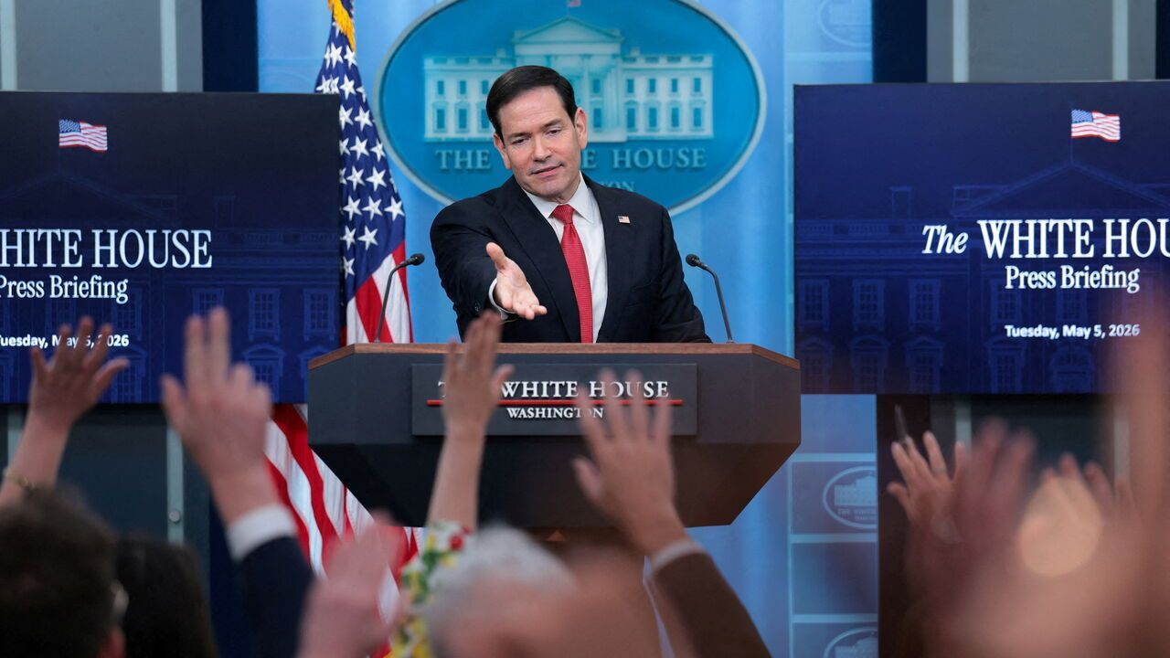Photograph: Reuters
May 7th 2026|
1 Iran said it was reviewing a proposal from America to end their conflict. Reports from Iranian media suggested that many issues were still unresolved, but Donald Trump said “great progress” had been made towards reaching a “final agreement”. Earlier, America and Iran exchanged fire in the Strait of Hormuz, threatening their ceasefire. The United Arab Emirates and South Korea reported strikes on their ships. Mr Trump announced, and then paused, Project Freedom, an operation to guide commercial ships out of the strait. The UAE intercepted missile and drone attacks from Iran, including one on an oil facility.

A matter of urgency
2 Iran’s foreign minister, Abbas Araghchi, travelled to Beijing for a meeting with Wang Yi, his Chinese counterpart. The official Chinese statement on the meeting called for the restoration of safe passage in the Strait of Hormuz. homologue
3 Israel struck Beirut for the first time since agreeing to a ceasefire in Lebanon in mid-April. It was targeting a Hizbullah commander; the Iranian-backed militia continues to fire missiles and drones at Israel. The UN said that at least 380 people have been killed in Israeli strikes on Lebanon since the ceasefire began. Its figures do not break down the casualties into civilian and combatant deaths.
4 Several drone strikes hit Khartoum, including its airport. The assaults end a months-long period of relative calm in the Sudanese capital, which the regular army retook from the paramilitary Rapid Support Forces last year. They also show that the RSF, which continues to advance in south-eastern Sudan, can now inflict damage on most of the country.
5 Zambia cancelled a long-planned conference organised by an international NGO promoting digital rights, reportedly because Chinese diplomats had complained about the presence of Taiwanese civil-society activists at the event. The decision underlines China’s determination to use its power over other countries, especially poor ones, to further its political goals when it comes to Taiwan. ONG
6 Taiwan’s president, Lai Ching-te, visited Eswatini in an unannounced trip. In late April Mr Lai was forced to cancel plans to attend the 40th anniversary of King Mswati’s accession to the throne because Madagascar, Mauritius and the Seychelles refused to allow his flight through their airspace owing to pressure from China. Eswatini is the only African country that recognises Taiwan. An angry China said that Mr Lai had “stowed away” to get to Eswatini. Separately, Marco Rubio, America’s secretary of state, said Mr Trump would discuss Taiwan with Xi Jinping during their summit in Beijing on May 14th and 15th. Voyager clandestinement
7 The Pentagon confirmed that it intends to withdraw 5,000 troops from the 36,000 it has stationed in Germany. Mr Trump had announced the drawdown as a retaliation for remarks made by Friedrich Merz about the Iran war; the German chancellor said America had been “humiliated”. Mr Trump is also considering troop withdrawals from Italy and Spain. And he has threatened to raise American tariffs on EU vehicle imports to 25%. retrait
8 Romania’s centrist government was brought down by a vote of no confidence in parliament. The vote was initiated by the Social Democrats, which recently pulled out of the governing coalition, and supported by the hard right. Talks are to be held about forming a new government. The Social Democrats say they are willing to join a fresh pro-EU coalition, as long as it is not led by Ilie Bolojan, the ousted prime minister.
9 At least 27 people were killed in eastern Ukraine in a wave of Russian attacks on the region. That included 12 people who died during an aerial bombardment on the city of Zaporizhia. Ukraine said it had initiated a ceasefire and accused Russia of breaking it. Russia announced its own ceasefire for May 8th and 9th to coincide with its commemorations marking the defeat of Nazi Germany in the second world war. Volodymyr Zelensky described Russia’s ceasefire as “utter cynicism” and propaganda.
10 Marco Rubio went to Rome for a meeting with Pope Leo amid increasingly strained relations between the Vatican and the White House over the Iran war. Mr Rubio was also scheduled to meet Giorgia Meloni, Italy’s prime minister, who has also fallen out with Mr Trump over the war and his criticisms of the pope. Tendu se brouiller
11 A ban on advertisements related to fossil fuels and meat came into force in Amsterdam. The city council is dominated by greens and an assortment of other progressive leftists.
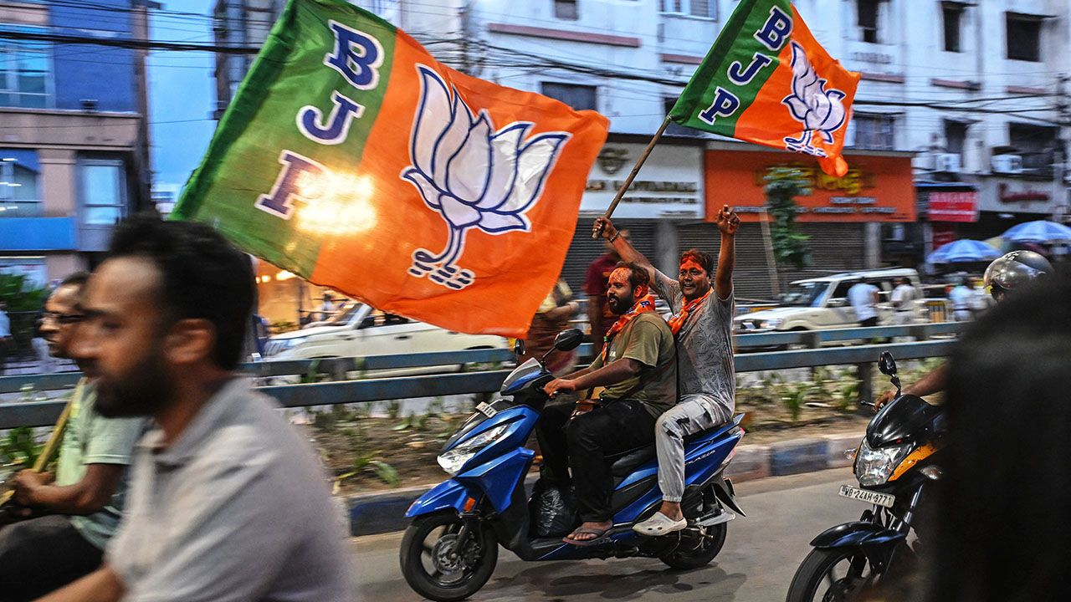Photograph: Getty Images
12 The Bharatiya Janata Party, which runs India’s federal government, won a landslide in West Bengal’s state election. It has never held power before in West Bengal, which includes the city of Kolkata (formerly Calcutta). The result was a big victory for Narendra Modi, the Hindu-nationalist prime minister, who had campaigned in the state. Incumbents also suffered in other state elections. M.K. Stalin resigned as chief minister of Tamil Nadu after a party led by a former actor gained the most seats there. In Kerala the ruling communists were ejected from power by a coalition led by the Congress party. Candidats sortants
13 Sir Keir Starmer, Britain’s prime minister, described the recent spate of antisemitic attacks in the country as a crisis, and explicitly blamed Iran for seeking to foment violence and hatred. “It will not be tolerated,” he said. One of the measures he announced would compel universities to track antisemitism on campus and take action to tackle it. fomenter
14 Australia is also contending with a rise in antisemitism. A commission began hearings into the attack on a Hanukkah event at Bondi Beach last December, which killed 15 people. One expert described antisemitism as a “virus” and that it had become “fashionable” to adopt anti-Jewish views. Etre aux prises avec enquêtes
15 Separatists in the Canadian province of Alberta said they had gathered enough petition signatures to start the process for a referendum on independence, which could take place as early as October. Polling suggests the separatists would have a hard time persuading their fellow Albertans of the merits of breaking away from Canada if the ballot proceeds. Avoir des difficultés à scrutin se dérouler
16 The International Court of Justice held a hearing on a long-running border dispute. Guyana says that Venezuela’s claim to a large area in the Essequibo river region, which includes substantial offshore reserves of oil and gas, is illegal. Venezuela said the court had no jurisdiction in the matter and only negotiations would solve the issue. audience

It wouldn’t be a friendly visit
17 Donald Trump announced another batch of sanctions against government officials in Cuba. Speaking in Florida, the president said that America would take over Cuba “almost immediately”, and suggested that the American navy would drop anchor off the Cuban coast on its way back from Iran.
Jeter l’ancre

Attribution: ‘Charles Message To Donald Translated’ by Ingrid Rice, British Columbia, Canada
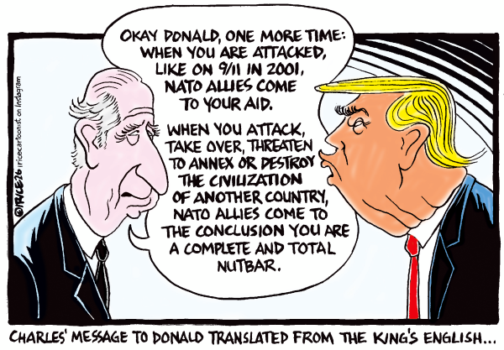

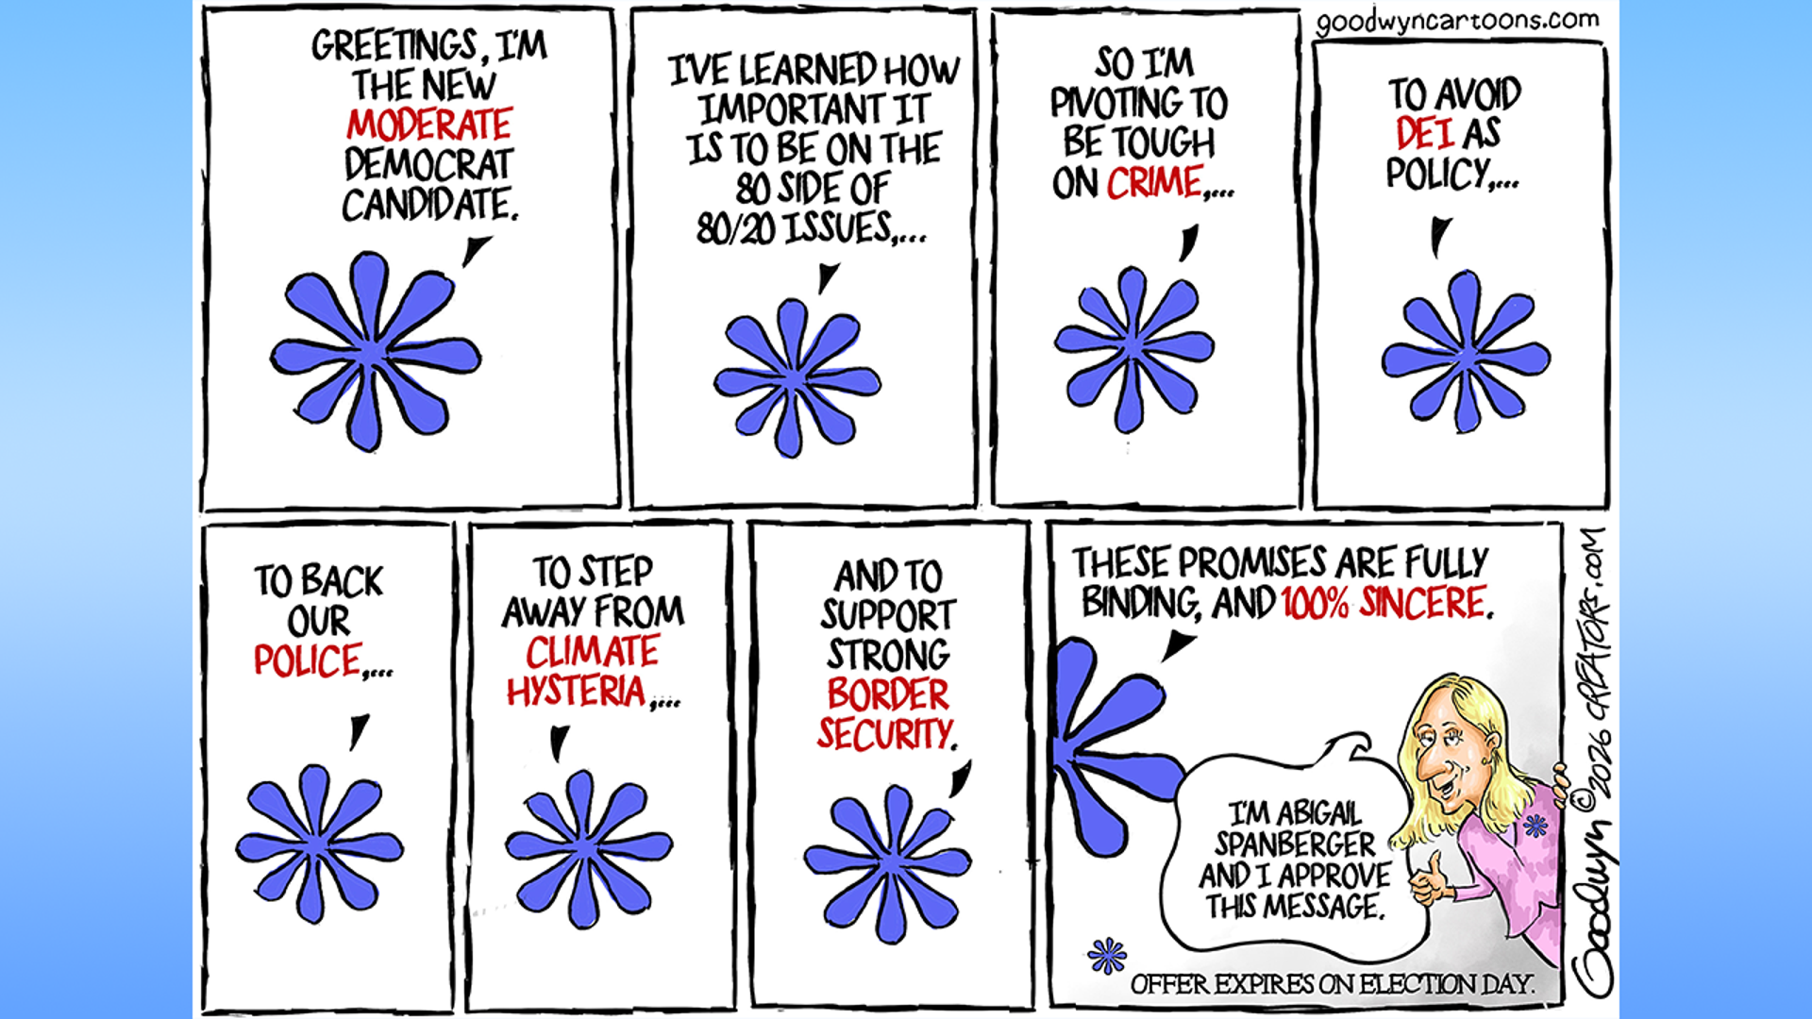

Fox News political cartoons

