**Entraînement au choix**

**1. CCINP 3hrs**

- Rédiger en anglais et en 400 mots une synthèse des documents proposés, qui devra obligatoirement comporter un titre.

- Indiquer avec précision, à la fin du travail, le nombre de mots utilisés (titre inclus), un écart de 10% en plus ou en moins sera accepté.

- Vous aurez soin d'en faciliter la vérification, soit en précisant le nombre de mots par ligne, soit en mettant un trait vertical tous les vingt mots.

- Veillez à bien indiquer, en introduction, la source et la date de chaque document. Vous pourrez ensuite, dans le corps de la synthèse, faire référence à ces documents par "document 1", "document 2", etc

- Ce sujet comporte les 4 documents suivants :

document 1 - un article paru dans The Economist du 14 décembre 2023

document 2 - un article paru dans The Atlantic du 3 novembre 2023

document 3 - des graphiques du Pew Research Centre du 24 octobre 2023

document 4 - un dessin de Chris Madden du 16 novembre 2016

- Les documents ont une égale importance.

**2. Centrale 4hrs**

*Rédiger en anglais et en 500 mots une synthèse des documents proposés, qui devra obligatoirement comporter un titre. Indiquer avec précision, à la fin du travail,*

*le nombre de mots utilisés (titre inclus), un écart de 10% en plus ou en moins sera accepté.*

Ce sujet propose les 4 documents suivants :

document 1 - un article paru dans The Economist du 14 décembre 2023

document 2 - un article paru dans The Atlantic du 3 novembre 2023

document 3 - des graphiques du Pew Research Centre, du 24 octobre 2023

document 4 - un dessin de de Chris Madden du 16 novembre 2016

document 5 - un extrait d'un livre par Neil Postman *Amusing Ourselves to Death:* *Public Discourse in the Age of Show Business* (1985)

*L’ordre dans lequel se présentent les documents est aléatoire.*

**3. Polytechnique /ENS 4hrs**

**PREMIERE PARTIE (A)**

**SYNTHESE DE DOCUMENTS**

*Contenu du dossier : deux articles et deux documents iconographiques, qui sont numérotés 1, 2, 3 et 4.*

*Sans paraphraser les documents proposés dans le dossier, le candidat réalisera une synthèse de celui-ci, en mettant lairement en valeur ses principaux enseignements et enjeux dans le contexte de l'aire géographique de la langue choisie, et en prenant soin de n'ajouter aucun commentaire personnel à sa composition.*

*La synthèse proposée devra comprendre entre 600 et 675 mots et sera rédigée intégralement dans la langue choisie. Elle sera en outre obligatoirement précédée d'un titre proposé par le candidat.*

**SECONDE PARTIE (B)**

**TEXTE D'OPINION**

*En réagissant aux arguments exprimés dans cet éditorial (document numéroté 6), le candidat rédigera lui-même dans la langue choisie un texte d'opinion d'une longueur de 500 à 600 mots.*

**Document 1. Leaders, The Economist, 14/12/2023**

**Can you have a healthy democracy without a common set of facts?**

**The media and the message**

**America’s presidential election is a test of that proposition**

Journalists should not spend much of their time writing about journalism. The world is more interesting than the inky habits of the people who report on it. But this week we are making an exception, because the discovery and dissemination of information matters a lot to politics. Don’t take our word for it: “A popular government,” wrote James Madison in 1822, “without popular information, or the means of acquiring it, is but a prologue to a farce or a tragedy; or, perhaps both.” Were Thomas Jefferson offered a choice between a government without newspapers and newspapers without a government, he said that he would choose the press (though that is probably going a bit far).

As the turmoil at America’s elite universities over antisemitism shows, creating a political culture in which people can argue constructively, disagree and compromise is not something that happens spontaneously. In media, business models, technology and culture can work together to create those conditions. They can also pull in the opposite direction. Our analysis of over 600,000 pieces of written and television journalism shows that the language of the mainstream American media has drifted away from the political centre, towards the Democratic Party’s preferred terminology and topics. That could lower the media’s credibility among conservatives.

As the country braces for next year’s election, it is worth thinking about the internal forces that deepened this rift. You can take comfort from the fact that the industry has been buffeted time and again during its long history, yet somehow survived. The worry is that today’s lurch may prove worse than any before.

One of those forces is technological disruption. From printing to the mobile web, new media tend to disrupt authority. That is good news if you live in an autocracy. In America, though, technologies have often brought trouble. Father Charles Coughlin, a pioneering demagogue in the 1930s, used radio to reach a mass audience before Republicans and Democrats got the hang of it. Cable news helped foment a revolution in the Republican Party. It is hard to see how Donald Trump could have become the party’s nominee in 2016 without the ability to speak directly to tens of millions of Americans in messages of 140 characters. Artificial intelligence (AI) will up-end media once again, for good or ill. It may feed mind-scrambling fakery to anyone who hankers after conspiracy. But, for anyone who wishes to know what is really going on, AI may put a greater premium on filtering out the nonsense.

Disruption powers fragmentation. The American media have passed through narrowcast ages and broadcast ages. In Madison’s and Jefferson’s day, narrowcasting was the norm: small-circulation partisan journals spoke to different factions of a small elite. Later, the spread of the telegraph and the penny press created mass media. Narrow partisanship was no longer good business. Advertisers wanted to reach as many people as possible and scarce electromagnetic spectrum, which limited the numbers of radio and television stations, led to a system of regulation. All that favoured objectivity: journalists should try to put their opinions aside and stick to the facts.

Today, however, the smartphone has caused fragmentation and American media are back in a narrowcast age. As much of the advertising revenue that once paid for reporters has flowed to Google and Meta, this has created new business models. There is a lot to like about the subscription-based outfits that now rule: what better test of the quality of the work than whether people will pay for it? But such businesses can also be built on pandering to people’s prejudices. [...]

This is not just happening on the fringes. Our package this week also contains an essay by James Bennet, our Lexington columnist, a former editorial-page editor of the New York Times who was fired for publishing a piece by a Republican senator that sparked a newsroom revolt. He argues that the Times increasingly affirms its readers’ leftish bias even as it reassures them that it is independent. Unlike the right-wing media, the mainstream lot do not routinely peddle falsehoods or conspiracy theories. But their bias undermines their ability to put the record straight. They used to be like the best public broadcasters in other Western democracies, establishing common facts and setting the boundaries for debate; today, less so.

Why does this matter? Although most Americans do not regularly read a newspaper or watch cable news, elites matter in democracies. When different political camps exist in separate information universes, they tend to demonise each other. If you are told Joe Biden is in the grip of a cabal of antisemitic socialists, then voting for Mr Trump makes perfect sense. If Trump supporters are anti-democratic racists, why bother trying to win them over? As a result, the parties will find it even harder to reach the compromises that are essential for sustained good government. If the elites cannot see the world as it is, they will make bad decisions.

As well as being a problem for politics and journalism, this is also a threat to core liberal ideas: that arguments need to be strength-tested, that insights can be found in unusual places and that encountering opposing views and uncomfortable facts is usually a good thing. These ideas will be challenged by newsrooms that see “objectivity” as a sleight of hand which privileged groups use to embed their own power. Old-style liberals may have to adapt to AI-powered business models that reward those who tell people everything they already think is true is true.

America progressed from narrowcast media and a limited franchise in the early days of the republic to broadcast media and universal suffrage. It has never had narrowcast media and universal suffrage at the same time. As a newspaper founded to promote classical liberalism, The Economist would like to think they can coexist happily. Next year’s election will be the test. ■

**Document 2. Charlie Warzel The Atlantic 3/11/23**

**Social Media Broke Up With News. So Did Readers.**

**The Great Social Media–News Collapse**

**Big Tech’s relationship with journalism is much more complicated than it appears.**

[...] After the 2016 election, news became a bug rather than a feature, a burdensome responsibility of truth arbitration that no executive particularly wanted to deal with. Slowly, and then not so slowly, companies divested from news. Facebook reduced its visibility in users’ feeds. Both Meta and Google restricted the distribution of news content in Canada. Meta’s head of Instagram, Adam Mosseri, noted that its newest social network, Threads, wouldn’t go out of its way to amplify news content. Elon Musk destroyed Twitter, apparently as part of a [reactionary political project](https://www.theatlantic.com/technology/archive/2022/12/elon-musk-twitter-far-right-activist/672436/) against the press, and made a number of decisions that resulted in its replacement, X, being flooded with garbage. As *The New York Times* [declared](https://www.nytimes.com/2023/10/19/technology/news-social-media-traffic.html) recently, “The major online platforms are breaking up with news.”

Trust in the media has fallen sharply in the past two decades, and especially the past several years, though much more so among Republicans. Some of this is self-inflicted, the result of news organizations getting stories wrong and the fact that these mistakes are more visible, and therefore subject to both legitimate and bad-faith criticism, than ever before. A great deal of the blame also comes from efforts on the right to [delegitimize mainstream media](https://www.cjr.org/analysis/breitbart-media-trump-harvard-study.php). Local-news outlets [have died](https://www.washingtonpost.com/magazine/interactive/2021/local-news-deserts-expanding/) a slow death [at the hands](https://www.theatlantic.com/magazine/archive/2021/11/alden-global-capital-killing-americas-newspapers/620171/) of hedge funds. A generational shift is at play as well: Millions of younger people look to [influencers and creators](https://www.theverge.com/23836187/gen-z-news-creator-sourcing-tiktok-instagram-lil-tay) on Instagram and especially [TikTok](https://nymag.com/intelligencer/2023/07/the-2024-election-will-be-an-informational-nightmare.html), along with podcast hosts, as trusted sources of news. In these contexts, consumer trust is not necessarily based on the quality of reporting or the prestige and history of the brand, but on strong parasocial relationships. [...]

From 2013 to 2017, news content was arguably the grist for the social-media mill. Political news did numbers on the platforms, which created a new kind of toxic political engagement. [Massive, hyperpartisan Facebook pages](https://www.nytimes.com/2016/08/28/magazine/inside-facebooks-totally-insane-unintentionally-gigantic-hyperpartisan-political-media-machine.html) sharing aggregated news stories designed to provoke users became, for a moment, some of the most influential media services on the planet. At some point, an argumentative, trollish style of posting became the default language of social media. Throughout the 2010s, activists, journalists, propagandists, politicos, white nationalists, and conspiracy theorists converged in these spaces, and the platforms curdled into battlegrounds where news stories were the primary ammunition. As the researcher Michael Caulfield has [written](https://hapgood.us/2023/06/22/the-open-argument-must-be-fed-the-peculiar-case-of-fox-news-and-the-pleasant-smoke/), a tragic mass shooting or even just a story about a submarine disaster became evidence to fit an ideological position—a way to attack an enemy. This toxicity made [public spaces hostile](https://www.nytimes.com/interactive/2019/08/15/opinion/gamergate-twitter.html) to reasonable discourse and marginalized audiences.

Consuming news might always have exacted an emotional toll, but by 2020, the experience of picking through the wreckage of social media to find out about the world was particularly awful. It’s telling that during the darkest days of the coronavirus pandemic, the very act of reading the news was rebranded as “doomscrolling,” and people have long called Twitter a “hellsite.” It is no wonder, then, that people—and platforms—started opting out of news. The experience was miserable! Likewise, it makes sense that some of the decisions to deprioritize algorithmic news curation was seen by users as a positive change: A recent Morning Consult survey [found](https://pro.morningconsult.com/instant-intel/facebook-favorability-increase-news) that “People Like Facebook More Now That It’s Less Newsy.”

It would be wrong to suggest that news—and especially commentary about the news— will vanish. But the future might very well look like slivers of the present, where individual influencers command large audiences, and social networking and text-based media take a back seat to video platforms with recommendation-forward algorithms, like TikTok’s. This seems likely to coincide with news organizations’ continued loss of cultural power and influence.

In a recent *New York* essay, John Herrman [suggested](https://nymag.com/intelligencer/2023/07/the-2024-election-will-be-an-informational-nightmare.html) that the 2024 presidential campaign might be “the first modern election in the United States without a minimum viable media” to shape broad political narratives. This might not be a bad development, but it’s likely to be, at the very least, disorienting and powered by ever more opaque algorithms. And although it is obviously self-serving of me to suggest that a decline in traditional media might have corrosive effects on journalism, our understanding of the world, and public discourse, it is worth noting that a creator-economy approach to news shifts trust from organizations with standards and practices to individuals with their own sets of incentives and influences.

Should this era of informational free-for-all come about, there will be an element of tragedy—or at the very least irony—to its birth. The frictionless access and prodigious distribution of social media should have been a perfect partner for news, the very type of relationship that might bolster trust in institutions and cultivate a durable shared reality. None of that came to pass. Social media brought out the worst in the news business, and news, in turn, brought out the worst in a lot of social media.

**Document 3. Naomi Forman-Katz, Pew Research Centre, October 24, 2023**

**Americans are following the news less closely than they used to**

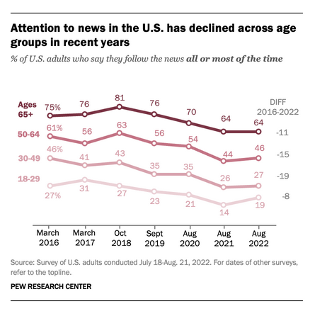

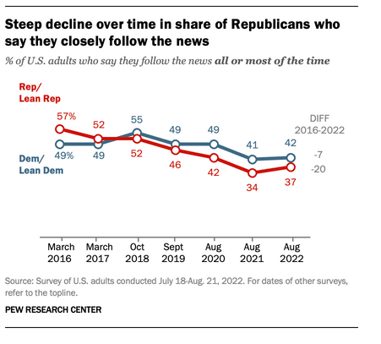

**Document 4**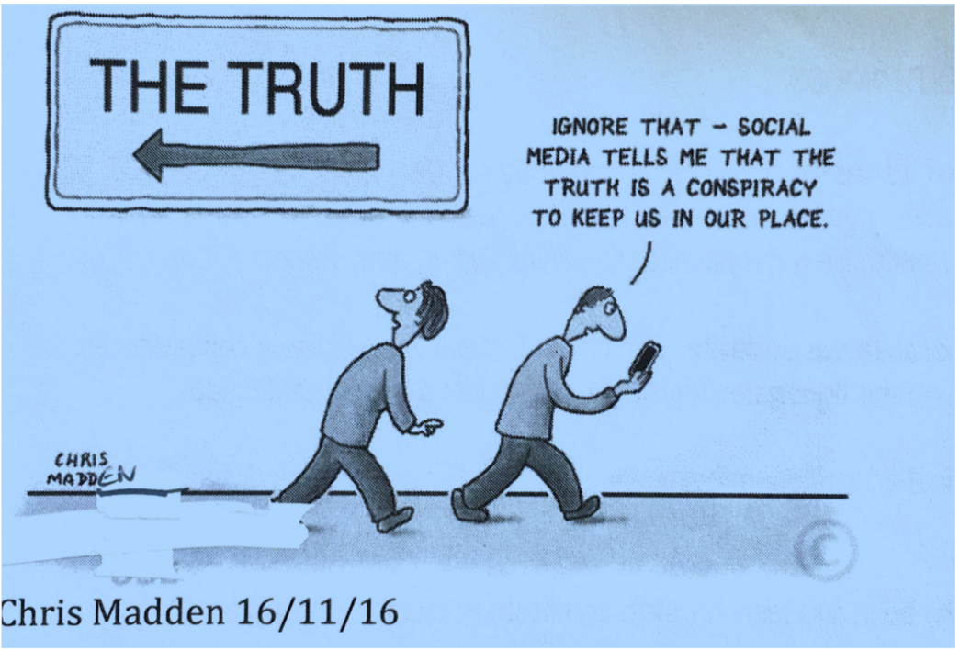

**Document 5. Excerpt from Neil Postman’s *Amusing Ourselves to Death:* *Public Discourse in the Age of Show Business* (1985)**

We were keeping our eye on *1984*. When the year came and the prophecy didn’t, thoughtful

Americans sang softly in praise of themselves. The roots of liberal democracy had held. Wherever else the terror had happened, we, at least, had not been visited by Orwellian

nightmares. But we had forgotten that alongside Orwell’s dark vision, there was another -

slightly older, slightly less well known, equally chilling: Aldous Huxley’s *Brave New World*. Contrary to common belief even among the educated, Huxley and Orwell did not prophesy

the same thing. Orwell warns that we will be overcome by an externally imposed oppression.

But in Huxley’s vision, no Big Brother is required to deprive people of their autonomy, maturity

and history. As he saw it, people will come to love their oppression, to adore the technologies

that undo their capacities to think.

What Orwell feared were those who would ban books. What Huxley feared was that there

would be no reason to ban a book, for there would be no one who wanted to read one. Orwell

feared those who would deprive us of information. Huxley feared those who would give us so

much that we would be reduced to passivity and egoism. Orwell feared that the truth would be

concealed from us. Huxley feared the truth would be drowned in a sea of irrelevance.

**Document 6. Financial Times, Tuesday, May 16, 2023, Anika Collier Navaroli**

**Disinformation dangers lurk in the EU's media freedom act**

Twitter has recently come under fire for changes in its verification system which attached the labels "state-affiliated media" and "government-funded media" to accounts managed by US public service broadcasters PBS, NPR and the UK's BBC. After an uproar regarding press freedom, the social media company was forced to update the label to "publicly funded media".

This furore not only drew ridicule (one former BBC editorial director commented that it looked as if "the work-experience guy" had been left doing the labelling) — it also showed the pitfalls of amateur content-moderation policy. The system of self-regulation with no accountability or transparency has taken the US on a dangerous path. By contrast, Europe's efforts at regulation, put forth in the Digital Services Act, look promising. But the DSA's attempt to address systemic risks such as disinformation may be undermined before they have a chance to work: amendments proposed in the EU's draft European Media Freedom Act would grant full exemption of any content moderation obligation for any organisation categorised as "media".

I know the problems this could cause, because I used to work inside Twitter's trust and safety department, writing and enforcing moderation policies. During my time there, from 2019 to 2021, I had a unique vantage point on momentous world events. I saw first hand the devastating impact of social media in stoking the violent attacks on the US Capitol and I later gave evidence as a whistleblower to the US Congress.

The danger is that Article 17 of the EMFA could create a potentially limitless category of bad actors who can simply self-declare themselves as "media" entities. It would be a cheap and easy way for disinformation campaigns to legitimise themselves. At a time when deepfake news outlets are being established, generative artificial intelligence is running rampant in news, and hostile states are actively exploiting social media features such as Twitter's recent verification changes, we should not create new weapons for information warfare.

If the media exemption in the EMFA passes, content moderators like me will also have our hands tied by law. For example, when Vladimir Putin invaded Ukraine, the Russian state broadcaster RT opened a Twitch account. Inside Twitch, where I worked at the time, conversations immediately began about how to implement the company's new policy on harmful misinformation. RT's account was quickly banned.

Under the EMFA, companies will no longer have this freedom. Disinformation outlets claiming to be legitimate "media" would be exempt from swift action and their propaganda amplified.

Instead, regulators need to work with the moderators who have spent years wrangling with the issue of how to verify news outlets and defining concepts such as newsworthiness. They have developed metrics and made mistakes. Their knowledge and experience are the key to getting this right. Through the DSA's transparency requirements, we can start to fix platforms, make them accountable, and ensure that redress mechanisms are effective.

If there is one thing I learnt in my career, it's that you can write down any words you want and call them "policy". But if you cannot evenly enforce those policies in a principled manner, then they are meaningless.

The whole world is watching to see how the DSA works — the EU's institutions must focus on ensuring this landmark regulation is a success. Allowing the EMFA to create a dangerous and unworkable loophole, on the other hand, is a sure-fire route to failure.

*The writer is a practitioner fellow at Stanford University's Digital Civil Society Lab and a former senior content moderator at Twitter*