**ÉPREUVE COMMUNE - FILIÈRES MP - PC - PSI - TSI - TPC**

____________________

LANGUE VIVANTE A ANGLAIS

____________________

*N.B. : le candidat attachera la plus grande importance à la clarté, à la précision et à la concision de la rédaction. Si un candidat est amené à repérer ce qui peut lui sembler être une erreur d’énoncé, il le signalera sur sa copie et devra poursuivre sa composition en expliquant les raisons des initiatives qu’il a été amené à prendre.*

L'usage d'un dictionnaire et de machines (calculatrice, traductrice, etc.) est strictement interdit.

**Rédiger en anglais et en 400 mots une synthèse des documents proposés, qui devra obligatoirement comporter un titre.** Indiquer avec précision, à la fin du travail, le nombre de mots utilisés (titre inclus), un écart de 10 % en plus ou en moins sera accepté.

Vous aurez soin d'en faciliter la vérification, en mettant un trait vertical tous les vingt mots. Toute fraude sera sanctionnée.

Vous indiquerez, en introduction, au minimum, la source et la date de chaque document. Vous pourrez ensuite, dans le corps de la synthèse, faire référence à ces documents par « doc.1 », « doc. 2 », etc.

Ce sujet comporte les 4 documents suivants qui sont d'égale importance :

**-** **Document 1: The Metaverse Is Coming and It’s A Very Big Deal** (extrait et adapté de Forbes.com -July 5, 2020)

**-** **Document 2: The Hidden Danger of Virtual Worlds** (extrait et adapté de medium.com -August 21, 2018)

**-** **Document 3: Facebook eyes a future beyond social media** (extrait et adapté de the Economist -July 27th, 2021)

**-** **Document 4: “I’m on to this new thing called make-believe”** (extrait du magazine PDX-Parent, publié en avril 2019)

**\*\*\***

**Document 1: The Metaverse Is Coming and It’s A Very Big** Deal | Forbes.com* | Cathy Hackl |July 5, 2020

Imagine walking down the street. Suddenly, you think of a product you need. Immediately next to you, a vending machine appears, filled with the product and variations you were thinking of. You stop, pick an item from the vending machine, it’s shipped to your house, and then continue on your way.

Next, imagine a husband and wife. The husband offers to go to the store but the wife can’t remember the name and type of product she needs. Her brain-computer interface device recognizes it for her and transmits a link to her husband’s device, along with what stores and aisles it’s located in.

Welcome to the metaverse, alternate digital realities where people work, play, and socialize. You can call it the metaverse, the mirror world, the AR Cloud, the Magicverse, the Spatial internet, or Live Maps, but one thing is for certain, it’s coming and it’s a big deal.

Google the term metaverse and you’ll find several definitions. Wikipedia defines it as a collective virtual shared space, created by the convergence of virtually enhanced physical reality and physically persistent virtual space, including the sum of all virtual worlds, augmented reality, and the Internet. The word "metaverse" is a portmanteau of the prefix "meta" (meaning beyond) and "universe"; the term is typically used to describe the concept of a future iteration of the internet, made up of persistent, shared, 3D virtual spaces linked into a perceived virtual universe.

Marketing and communications professionals need to pay attention to the metaverse because it’s the next frontier for online interaction. Just like social media revolutionized the online marketing landscape, so too will the metaverse. While we don’t have one shared metaverse at this time, there are companies working on creating it.

Fortnite, Minecraft, and Animal Crossing are games now but they already have big user bases, detailed worlds, and user-generated content. Facebook is also positing itself towards the metaverse with its virtual reality social media platform, Horizon (currently in beta), and Live Maps. Niantic, Magic Leap, Microsoft and many others are working on it too.

The pandemic too has shifted culture online. Family reunions on Zoom, weddings relocated to Animal Crossing, graduations on Minecraft and virtually trying on clothes have all become common practices. With online social gatherings becoming more mainstream and online video games increasing their world-building, it’s inevitable that brands will play a significant role in the metaverse.

A new iteration of the internet is being worked on and this will have massive implications for society. Marketing, communications, and branding professionals will face new challenges but also new opportunities. This new era of the metaverse will unleash amazing creativity and open up new frontiers and horizons for brands and businesses. Now the question is, how are you getting ready?

*\* Forbes is an American business magazine*

**Document 2: The Hidden Danger of Virtual** Worlds | medium.com* | Lizzie Davey | August 21, 2018

On a summer afternoon, a number of Microsoft employees were invited to attend a training seminar.

But, instead of grabbing a pen and heading to the boardroom, they plugged themselves into a set of headphones and fired up *Second Life*.

This online social “game” was huge for a number of years in the early 00s, mainly because it offered average, everyday citizens an escape from the monotony of real life. Through a digitized landscape, users could create new “lives” that were as hedonistic as they chose. For all intents and purposes, *Second Life* was real life — except you could enjoy it from the comfort of your own home.

The “game” (a term which should be used loosely in this context because, well, there’s actually no way to win at Second Life) was inspired by *Snow Crash*, the 1992 novel by Neal Stephenson. In the book, citizens navigate around a digital world created and run by independent entrepreneurs — a concept that’s becoming more and more real by the day.

The purpose of *Second Life* isn’t to gather as many gold coins as possible or figure out a mission set by a wiry old wizard. Instead, it is simply a digital escapist fantasy that allows users to be whoever they want and do whatever they want away from the restrictions of the real world.

The Metaverse, a term that dates back to Stephenson’s sci-fi novel, was the name given to the virtual world in which the characters interacted and lived, and it’s now the term being given to a blockchain project that essentially aims to replicate the real world in a digitized format. The goal of the Metaverse project is to build an entire universe where digital assets and digital identities are the basis of transactions to create a new kind of ecosystem that has the potential to completely change human society.

Even back in 1992, Stephenson had an insightful eye into what the future might hold for humanity. Today, our lives resemble those of the characters in the book — our work and lives are becoming more and more digitized, with people spending more time online than offline.

The way we communicate has undergone a complete transformation, where we now send clipped messages via the internet rather than having to face talking to real people. Soon, we might see even more transfers — both human and asset based — taking place on the blockchain which will shift the entire economic world.

In the real world, we don’t have to enter a username and a password to wake up in the morning and, when we pass people on the street, our full names and addresses aren’t typed out in a bubble above our heads. Online it’s a different story. And, in fact, with social platforms like Twitter and Facebook, users seem to be actively willing to hand over their information to access their feeds.

This raises the question of whether privacy will soon be regarded as an outdated social need or whether it will evolve into something else entirely. At the moment, the rules of the online world are considerably more open and vague than those in the real world, but this might have to change when the Metaverse comes into play.

So far, most virtual reality games and landscapes are built in a “walled garden” format. They run behind corporate firewalls and aren’t interconnected in any way. When you enter one world, you’re essentially caged in and avatars can’t travel between two different digital worlds. In this case, security isn’t necessarily a priority, because data isn’t being transferred from the hands of one corporation to another.

The problem arises when virtual worlds are built on open-source software. This means avatars can travel between different virtual landscapes. For now, it seems, the Metaverse is an experimental place to dabble in the future of humanity. The fresh excitement of it and the relatively unknown future it holds means security isn’t necessarily a priority for developers.

But soon, when more and more people start venturing into their online lives, we’ll have to sit down and seriously think about what data privacy means in this new landscape, particularly when it comes to things like authentication, content protection, and secure communications. If *Second Life* is anything to go by, the population of people who are ready and willing to escape reality and immerse themselves in an online parallel universe are more concerned with who they will be there than who will take their information.

*\* Medium is an American online publishing platform offering a hybrid collection of amateur and professional publications.*

**Document 3: Facebook eyes a future beyond social media** | the Economist | Jul 27th, 2021

FACEBOOK HAS always had two faces. One is the grimace of a company that many people, in particular politicians, love to hate. The other face is a happy one of a firm that users, advertisers and investors cannot live without. Analysts predict it will be grinning again on July 28th, when it presents second-quarter results. Revenues are expected to rise by nearly 60%, year on year.

How can a firm with such political baggage be so successful? The answer is two sides of the same coin. With more than 2.7bn daily global users, Facebook’s main offerings—its flagship social network (known internally as Blue), photo-sharing on Instagram and messaging on WhatsApp and Messenger—are a digital magnifying glass of human nature. This glass amplifies the good (neighbourly help amid the pandemic) as well as the bad (conspiracy theories and quack cures). It also serves as a remarkable lens for advertisers to focus in on the world’s consumers.

At its core Facebook is a giant advertising machine. Adverts generate 98% of its revenue. Blue remains a dominant ad platform internationally, raking in perhaps $55bn last year, according to estimates. Debra Aho Williamson of eMarketer, a data provider, praises Facebook’s ability to target ads as “incredibly precise”. Advertisers value this highly: Facebook observes what its users do not only on its own services, but almost everywhere else online. This lets it pick what products to flog to a given user, identify others with similar interests and find out whether they bought something after seeing the ad.

Covid-19 has turbocharged Facebook’s machine. Confined to home, the average American user spent nearly 35 minutes per day on Blue and Instagram in 2020, according to eMarketer, two minutes more than the year before. That adds up to thousands of additional years of collective attention. While some firms went belly-up or cut advertising spending amid last year’s recession, others were created: 6.6m in America alone since the start of the pandemic. Many want a slice of that extra attention. These days it is unimaginable to run an online consumer business without targeted ads, notes Mark Shmulik of Bernstein, a broker, just as it was once unthinkable to run a business without a bricks-and-mortar shop.

Mr Zuckerberg’s next gamble concerns the metaverse. When he spent $2bn in 2014 to buy Oculus, a maker of virtual-reality (VR) gear, many thought he was buying himself a toy. But in recent years Facebook has made further VR-related acquisitions, most recently BigBox VR, the developer of “Population: One”, a shooter game similar to “Fortnite”. This gives Facebook control of a hardware platform for VR and its sibling, “augmented reality” (AR), which serves users digital information as they survey the real world through smart spectacles and the like.

Mr Zuckerberg doesn’t see the metaverse, which now has its own division within the firm, merely as a place to enjoy games or other immersive entertainment. Instead, he envisages it as a virtual space where people live and work, in keeping with a dream that geeks have harboured since 1992, when the term metaverse was coined by Neal Stephenson, a science-fiction author. In five years’ time, Mr Zuckerberg has said, he would like Facebook no longer to be seen primarily as a social-media company but as a metaverse company.

That would make Facebook cool again. It would no doubt also invite more scrutiny from critics worried about the firm’s power. Should users look on course to spend 35 hours a week immersed in its virtual world, rather than 35 minutes a day, this could invite regulation that actually bites. For now, the metaverse is encouraging something Mr Zuckerberg fears more: competition. Others sizing up the field include video-game firms like Roblox and Epic Games, as well as tech giants Apple, which is reportedly planning its own AR glasses, and Microsoft, which already sells AR goggles. If Facebook beats them to metaverse supremacy, it will have plenty to grin about. Otherwise, expect serious grimacing.

**Document 4:** cartoon by Tom Toro, originally published in the April 2019 issue of PDX-Parent magazine*

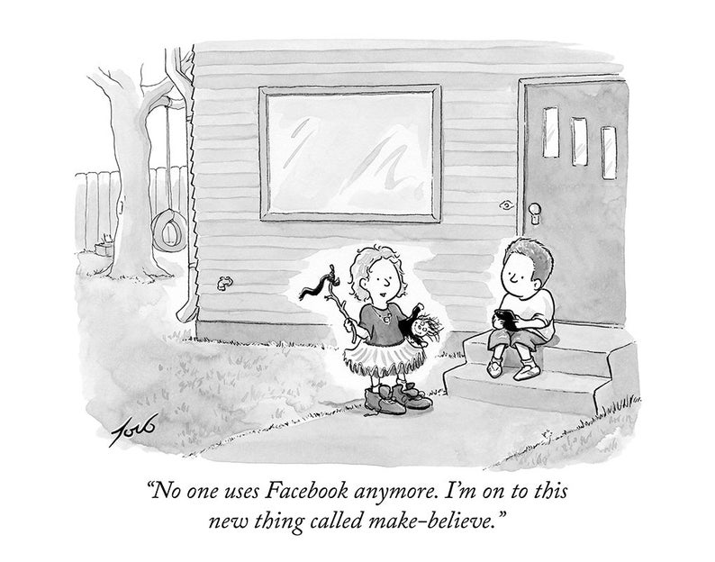

*\* Issued in Portland, Oregon, PDX Parent offers Portland’s most widely-read resources for all things families, from the best tips on where to play, eat and shop with your kids to well-researched stories on the health and education issues that matter to you.*