Dossier de synthèse Vacances de Toussaint
Type Centrale (4 premiers documents) ou X- ENS (5 documents)
Document 1
‘One inch from a potential civil war’ – near miss in Trump shooting is also a close call for American democracy
With an assassination attempt on Donald Trump at a rally in Pennsylvania on July 13, 2024, the U.S. experienced another violent episode in its increasingly polarized politics. Former President Trump, who’s about to formally become the GOP nominee for president in the 2024 election, survived the attempted assassination when, initial reports said, a bullet grazed his ear. But one rally attendee was killed, more spectators were injured and the suspected gunman is also dead. The Conversation’s politics editor, Naomi Schalit, spoke with University of Massachusetts, Lowell, scholar Arie Perliger after the event. Perliger offered insight from his study of political violence and assassinations. Given the stark political polarization in the U.S., Perliger said, “it’s not a surprise that eventually people engage in violence.”
Schalit: When you heard the news, what was the first thing you thought?
Perliger: The first thing that I thought about is that we were basically one inch from a potential civil war. I think that if, indeed, Donald Trump would have suffered fatal injuries today, the level of violence that we witnessed so far will be nothing in comparison to what would have happened in the next couple of months. I think that would have unleashed a new level of anger, frustration, resentment, hostility that we haven’t seen for many, many years in the U.S.
This assassination attempt, at least at this early stage, may validate a strong sense among many Trump supporters and many people on the far right that they are being delegitimized, that they are on the defensive and that there are efforts to basically prevent them from competing in the political process and prevent Trump from returning to the White House.
What we’ve just seen, for many of the people on the far right, fits very well into a narrative that they’ve already been constructing and disseminating for the last few months.
Political assassination attempts don’t aim only to kill someone. They have a larger goal, don’t they?
In many ways, assassination attempts bypass the long process of trying to downgrade and defeat political opponents, when there is a sense that even a long political struggle will not be sufficient. Many perpetrators see assassinations as a tool that will allow them to achieve their political objectives in a very quick, very effective way that doesn’t demand a lot of resources or a lot of organization. If we are trying to connect it to what we’ve seen today, I think that many people see Trump as a unicorn, as a unique entity, who in many ways really consumed the entire conservative movement. So by removing him, there’s a sense that that will or may solve the problem.
I think that the conservative movement changed dramatically since 2016, when Trump was first elected, and a lot of the characteristics of Trumpism are actually now fairly popular in different parts of the conservative movement. So even if Trump will decide to retire at some point, I don’t think that Trumpism – as a set of populist ideas – will disappear from the GOP. But I can definitely understand why people who see that as a threat will feel that removing Trump can solve all the problems.
In a study of the causes and impacts of political assassination, you wrote that unless electoral processes can address “the most intense political grievances … electoral competition has the potential to instigate further violence, including the assassinations of political figures.” Is that what you saw in this attempted assassination?
Democracy cannot work if the different parties, the different movements, are not willing to work together on some issues. Democracy works when multiple groups are willing to reach some kind of consensus through negotiations, to collaborate and to cooperate.
What we’ve seen in the last 17 years, basically since 2008 and the rise of the Tea Party movement, is that there’s increasing polarization in the U.S. And the worst part of this polarization is that the American political system became dysfunctional in the sense that we are forcing out any politicians and policymakers who are interested in collaboration with the other side. That’s one thing. Second, people delegitimize leaders who are willing to collaborate with the other side, hence, presenting them as individuals who betrayed their values and political party.
The third part is that people are delegitimizing their political rivals. They transform a political disagreement into a war in which there is no space for working together to address the challenges they agree are facing the nation.
When you combine those three dynamics, you create basically a dysfunctional system where both sides are convinced that it’s a zero-sum game, that it’s the end of the country. It’s the end of democracy if the other side wins.
If both sides are hammering into people again and again that losing an election is the end of the world, then it’s not a surprise that eventually people are willing to take the law into their hands and to engage in violence.
The Conversation, by Thomas Klassen, July 14, 2024
Document 2
How the Attempted Assassination of Donald Trump Fits Into America’s Violent History
American society was formed from violence, and it has remained violent ever since. From settlement to independence to nationhood, the United States has required force to build its institutions. Americans have always owned guns and used them to project strength and vigor—think of the gun-slinging cowboy or the gun-carrying lawman immortalized in Hollywood. And guns have been central to our politics, including the settlement of native peoples’ lands across the United States, the importation of slavery, a civil war, and the rise of America as a global superpower. Guns have influenced the politics of every era—from the death of Alexander Hamilton to the assassinations of Abraham Lincoln, John F. Kennedy, and Martin Luther King, Jr., among many other figures. The attempted assassination of former President Donald Trump on July 13 was part of this long history. Understanding this can help us to make sense of this horrific event, and find a way forward.

Violence is persistent in American society, but its targets vary over time. For the first 150 years of U.S. history, Americans directed violence primarily against those who challenged the expansion of the nation and the growth of slavery. President Andrew Jackson, the most popular political figure of the early 19th century, was famous for his prowess as a fighter of Indians and a defender of slavery. He was a brawler, beloved by rural settlers, Southern plantation owners, and urban immigrants—all trying to get ahead with the help of righteous force. Jackson fought for them, they believed.
During the Civil War and in the decades after, violence was much more controlled by the state. The Union Army was the largest land army in the world, and the first national military organization in the United States to conscript citizens to carry guns against an enemy. The Union Army destroyed large parts of the South, killed tens of thousands of citizens, and eventually ended slavery. The United States experienced what some historians call a “Second American Revolution” from the barrels of breechloaders and other weapons.
The Union Army was not, however, the only American organization to harness violence for political purposes. States, especially in the former Confederacy, created militias to enforce their rules and protect power for their favored populations. The Ku Klux Klan, founded in Tennessee in the aftermath of the Civil War, was one of many state-supported paramilitaries that systematically attacked former slaves, immigrants, and others who tried to open businesses, buy property, and vote in various communities. The Constitution granted all citizens certain legal rights, but violent groups —often operating with support from local and state governments—determined what those rights meant in practice. That dynamic still applies in some communities, especially for poor and disadvantaged citizens.
John Wilkes Booth, the actor and Confederate sympathizer who shot Abraham Lincoln, was the first presidential assassin, but not the last. As the federal government became effective at using violence to force changes throughout the country, men like Booth resisted by targeting the commander-in-chief. Booth believed he was slaying a tyrant, and his dastardly act was glorified in Southern newspapers. He became the first martyr for countless men in later decades who believed they could defend principle and find glory by using violence against the figure who commanded the most force in the country.
None of these assassins were part of violent militia groups; they all acted alone. They were, however, symptoms of the larger history of violence in the country. They attained their weapons easily, they echoed others around them who glorified violence, and they had reason to believe that their violent actions would be greeted with approval in some quarters. The vigilante assassin, like the cowboy and the lawman, is part of the fabric of American culture—a figure that appeals dangerously to individuals seeking to boost themselves and their cause.
In recent years, our partisan politics have promoted this violent tendency in American society. Political candidates and elected officials frequently call their adversaries “traitors” and “threats to America.” In 2016 then-candidate Donald Trump advocated violence against his opponent, Hillary Clinton. On Jan. 6, 2021, President Trump called on his supporters to “fight much harder” and “fight like hell” as they marched to the Capitol and tried to disrupt the certification of President Joe Biden’s election. Trump refused to call off or condemn the violence perpetrated by his supporters on that day, and since then he has treated the men and women convicted for law-breaking as heroes.
In October 2022 David DePape, a Trump supporter, broke into then House Speaker Nancy Pelosi’s home and assaulted her husband. He told police that he was responding to Pelosi’s alleged stealing of the election from Trump: "I was going to hold her hostage and get her to tell the truth. If she didn't tell the truth, I'd break her kneecaps."
That is the language of violent bullying (and male misogyny) long glorified in American history. DePape believed he was a courageous vigilante for principle and people like him. That is the defiant and violent message that Trump and his supporters send every day. It makes them popular because it resonates, and it encourages attacks and shootings, especially by young men seeking to boost themselves in the eyes of their peers. They just want to be heroes, like the gunfighters before them.
We don’t yet know why Thomas Matthew Crooks fired multiple shots at Donald Trump on July 13. This assassination attempt has been condemned by political leaders from all sides in the United States. That is necessary, but also easy. The real question is whether we are willing to see how extreme rhetoric, particularly from Trump himself, has encouraged this pre-existing tendency to violence in our society.
We have inherited a very violent culture in the United States. Moving forward, we have a choice. We can continue to encourage violence, or, we can step back and actively discourage personal attacks, bullying, and intimidation, knowing all too well where they can lead. This glorification of violence threatens us all. But we can push against our history.
Time, By Jeremi Suri, July 14, 2024 5:24 PM EDT
Document 3
Attack on Trump reopens a chilling chapter in American politics
The attempted assassination of Donald Trump, which opens a dark new chapter in America’s cursed story of political violence, shook a nation already deeply estranged during one of the most tense periods of its modern history.
The targeting of a former president at a campaign rally just days before he accepts the Republican nomination is, by definition, an attack on democracy and the right of each American to choose their leaders.
The pop, pop, pop of gunfire and the sight of a political leader tumbling to the ground – with Secret Service agents rushing to throw themselves on top of him to shield him – awoke grave historic traumas.
While Trump is not currently serving as president, his wounding underscores the ever-present threat that always hangs over the office and those who run for it – and especially for those who claim it. President Joe Biden is the 46th president – and four of his predecessors have been killed while in office, most recently John F. Kennedy in 1963. The fact that Trump was attacked ends a 40-year-period in which many have assumed that the Secret Service’s expertise had greatly reduced the potential for such outrages – and will cast a pall that will last for years.
But political violence hasn’t stopped since then. In 2011, then-Rep. Gabrielle Giffords, an Arizona Democrat, was left with brain damage after she was shot in the head at an event in which six people were killed. In 2017, a gunman opened fire at a Republican congressional baseball practice, shooting then-House Majority Whip Steve Scalise and three others. The nation is also still processing the attack on the US Capitol by Trump supporters on January 6, 2021.
Most leaders and political actors from both sides of the aisle quickly sent prayers to Trump and called for calm.
Biden, who has spent days trying to shore up his campaign, swung into his role as the nation’s chief executive after learning of the shooting while he was at mass in Rehoboth Beach, Delaware. He released a paper statement and then spoke to the nation on camera.
“There is no place in America for this kind of violence – it’s sick, it’s sick, it’s one of the reasons why we have to unite this country. We cannot allow for this to be happening. We cannot be like this. We cannot condone this,” Biden said.
Many politicians on both sides of the aisle are already bemoaning the heat of political rhetoric – after yet another chilling indication of what it can produce in a nation in which guns are so easily accessed. It remains to be seen if the shock of Saturday’s events, which could have been a lot worse, will do anything to tame a toxic political culture in which Trump is an enthusiastic participant.
In one of the most poignant reactions, Giffords said in a statement, “Political violence is terrifying. I know.” She added: “I’m holding former President Trump, and all those affected by today’s indefensible act of violence in my heart. Political violence is un-American and is never acceptable – never.”
Unfortunately, history suggests that violence, while indefensible, is also a quintessential scar on American politics.
Analysis by Stephen Collinson, CNN, July 14, 2024

Document 4

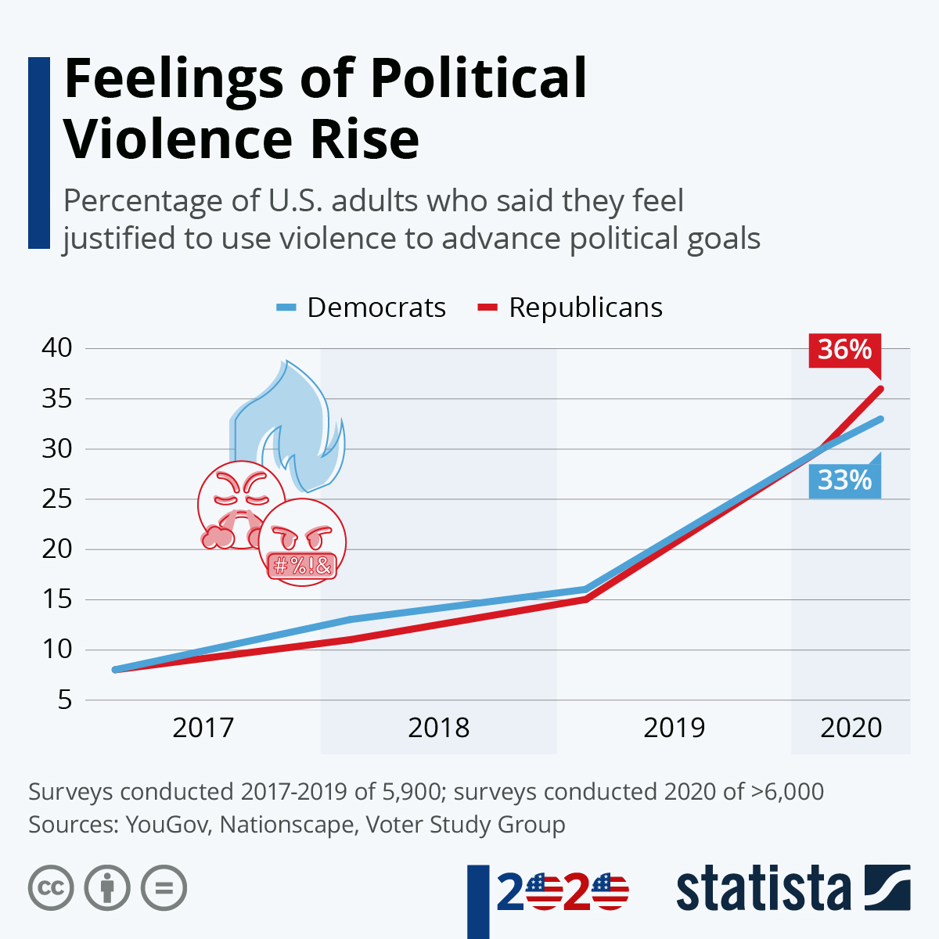

DOCUMENT 5 Texte d’opinion pour format X/ENS

Rising violence against politicians is an attack on democracy itself – The Observer, June 15, 2024
The response of Mette Frederiksen, Denmark’s centre-left prime minister, to being physically assaulted in a Copenhagen street was dignified and very human. “I’m not doing great, and I’m not really myself yet,” she admitted last week. The attack, in which she escaped serious injury, had left her feeling shocked and intimidated, she said.
Frederiksen suggested her experience was the culmination of some broadly familiar trends: proliferating social media threats, increasingly aggressive political discourse, a divisive Middle East war. “As a human being, it feels like an attack on me. But I have no doubt it was the prime minister that was hit. In this way, it becomes a kind of attack on all of us.”
This idea that elected politicians – and the democracies they represent – are everywhere endangered by rising personalised violence is backed by plenty of evidence.
With contentious elections fast approaching in France, the UK and the US, it seems only too probable that there will be more outrages and more victims, some possibly high profile. The root causes of this phenomenon include anger at and distrust of “ruling elites”, deliberate polarisation and fearmongering, anti-migrant racism, sectarian bigotry, economic distress and digital provocations by malign state actors. Yet there is no obvious pattern. Political violence, mostly random, is coming from both right and left.
Robert Fico, Slovakia’s hard-right populist prime minister, was shot several times last month and was fortunate to survive. He believes he was attacked because of his views, and blames the influence of political opponents on the left. “It’s evident he [Fico’s assailant] was only a messenger of evil and political hatred,” he said.
In Germany, the boot is on the other foot after a series of attacks by far-right thugs reminiscent of the Nazi era. In May, Matthias Ecke, a Social Democrat MEP, was brutally beaten up in Dresden. On the same evening in the city, a Green party campaigner was also assaulted.
The notorious 2019 murder of Walter Lübcke, a centrist politician, by a neo-Nazi now looks like a turning point. Attacks have doubled in Germany since then. Provisional figures show 234 physical assaults on politicians and political activists last year. “We are experiencing an escalation of anti-democratic violence,” said the interior minister, Nancy Faeser.
It would be easy to blame the divisive policies and rhetoric of Germany’s surging far-right party, the Alternative for Germany (AfD), and many do. But AfD members suffered more violent criminal attacks in 2023 than any other party, mostly from people with a leftist ideology. The Greens were the second biggest victims.
Last week’s decision by France’s president, Emmanuel Macron, to challenge the far right in a snap parliamentary election, which will take place in two rounds on 30 June and 7 July, is a big political gamble. But it may prove a personal gamble, too. Macron was attacked with eggs, tomatoes and assorted vegetables in previous campaigns. In 2021, he was slapped in the face.
The potential risks to his and other French politicians’ safety in the current climate are obvious, yet difficult to defend against. “Extreme-right violence – motivated by nationalism and authoritarianism – is on the rise in France,” warned the University of Oslo extremism expert Anders Ravik Jupskas, writing in Le Monde.
Like democratic politicians elsewhere, unpopular Macron puts his life on the line when he goes on the stump. It’s plainly dangerous, and raises basic questions about how long this style of face-to-face politics can realistically continue. It’s worth noting that authoritarian leaders such as Russia’s Vladimir Putin, while claiming to be popular, rarely expose themselves to the public in this way.
Similar concerns are growing in Britain, where memories of the unconnected murders by extremists of Labour MP Jo Cox and Conservative MP David Amess are still fresh. Last week, the Jo Cox Foundation joined in condemning two attacks on the hard-right Reform UK party leader, Nigel Farage, one with a milkshake, another with a takeaway cup.
Who knows what may be thrown next and at whom? There’s a tendency among the more feckless English to view such episodes as harmless knockabout. This attitude dates back to at least the 1970 election, when Labour prime minister Harold Wilson was repeatedly pelted with eggs at public meetings, to a disrespectful nation’s general amusement.

