SYNTHESIS – GROUP WORK – DOCUMENT 4

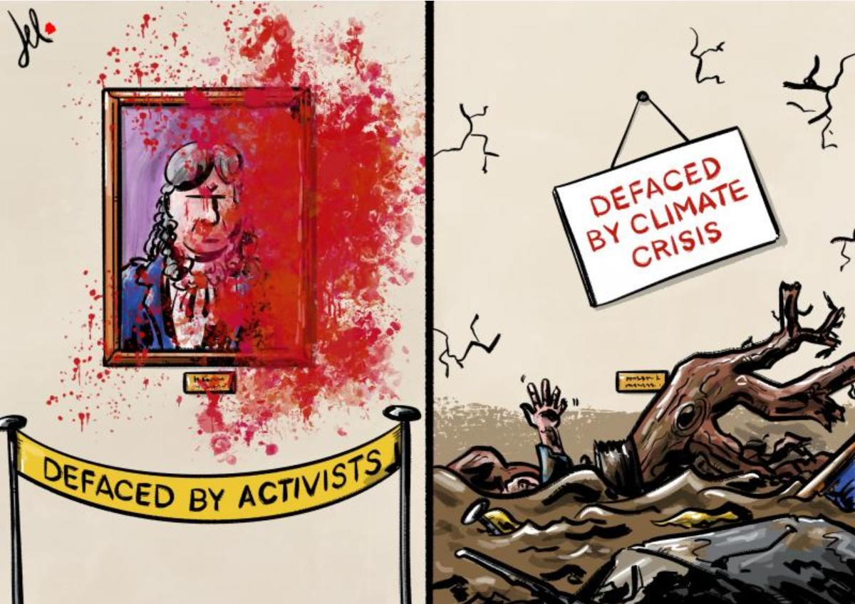

Emanuelle Del Rosso, May 30th 2023

