Topic 1: Work
Problem-based learning
Main arguments recap

• Digitisation

- 47% of US jobs are threatened [= menacés] by computerization/digitization/automation
35% of UK jobs are at high risk
60% of jobs are at risk in rural and regional [= provincial, outside the main economic centres] areas in Australia.

- The least skilled [= les moins qualifiés] jobs will be more affected => people with the lowest diplomas and the lowest wages.
! superlatif (cf Wooflash)
=> This will widen [= creuser (1er sens : élargir)] inequalities

- One of the solutions lies in education:
∅ People should be able to work with machines rather than [=plutôt que] like machines.
∅ Education is a key element in this transition towards computerization and it should take advantage of technology to reach as many people as possible (MOOCs etc.). (revoir the vs ∅ sur Wooflash)
=> ∅ Education should focus on developing ∅ creativity, ∅ social intelligence and the capacity to interact with complex objects
[See the film Modern Times: Charlie Chaplin works like a machine, his job can easily be replaced].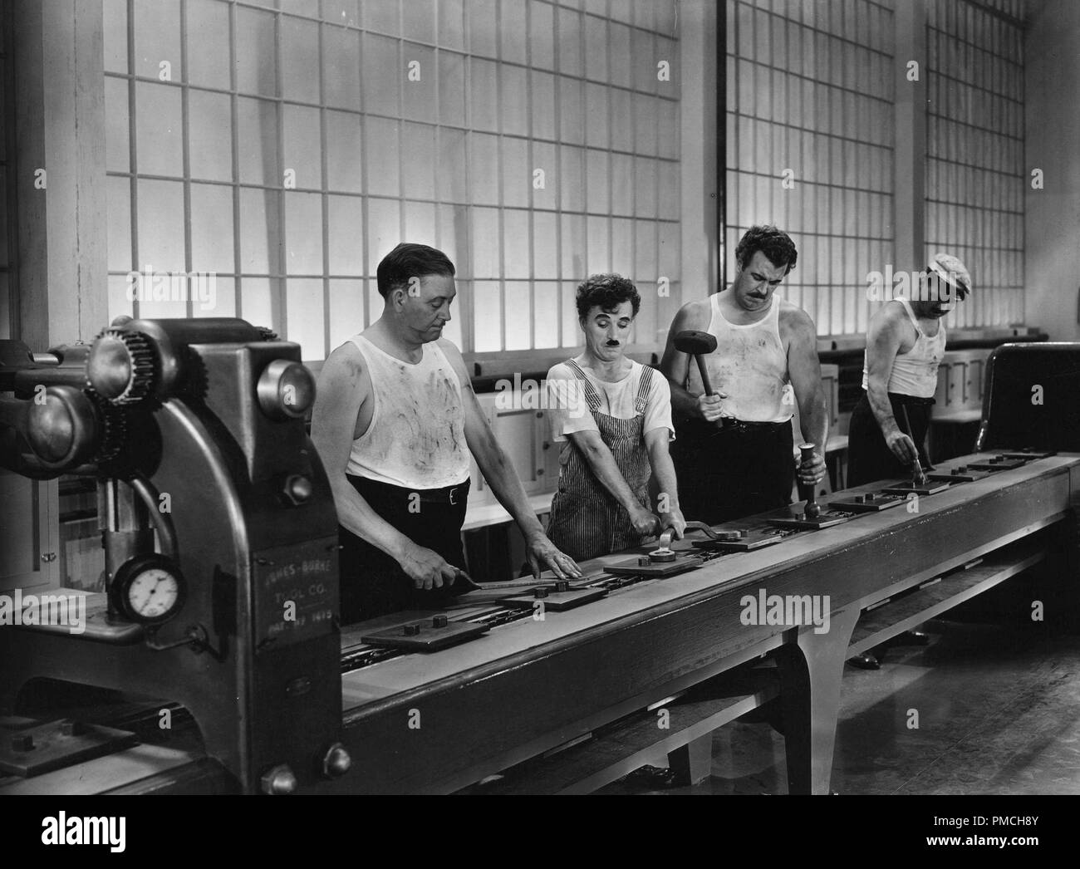

- To avoid deep inequalities, the wealth [= les richesses + "en particulier" => the] generated by digitisation could be redistributed through a tax system, so that every individual can benefit from it (see the idea of the Universal Basic Income (Revenu de base universel) : Wooflash => Food for Thought => Topic 1)
=> Pr Osborne (Oxford University) is in favour of a strong welfare state.

According to Pr Rosmond (Queensland University of Technology, Australia), all jobs might not be eliminated but redefined
=> Every job is not going to disappear
! (Re)voir : Grammaire Each et Every (Wooflash) => each et every sont toujours suivis d'un SINGULIER
=> new jobs [des métiers] could emerge.
Job elimination might also mean that people have more time
=> To him, this is very exciting news: in this extra time, people will want to be educated, entertained etc., which might generate new jobs.

• Technological unemployment
The irony of the cartoons:
- The secretary's job has become obsolete: the CEO's smartphone has replaced her.
- Robots don't need to get paid, they don't need food, they don't need holidays, they don't need to be motivated etc. That's why they are likely to replace humans.
- Computerization could create a lot of free time for humans. What are they going to do with that free time?

=> Question: But what do you do for money? => work may not be a core value anymore. People will be involved in the community in different ways (taking time to raise their children, volunteering, helping their friends and family, learning new things etc.).

• The gig economy, the uberization of the economy
The people who denounce the "uberization" of the economy say that companies and government should fight to enable people to get decent jobs, instead of letting them rent their car or their apartment to survive (62% of them say putting their apartment on Airbnb helped them keep it).
Independent workers (like Uber drivers) don't get paid holidays, sick leave, worker's protection/insurance, pensions, or a fixed income.
The gig economy offers more flexibility, but there's been a shift in the workers' status.
[c'est comme si l'Etat ne faisait plus son travail de protection et laissait les citoyens se débrouiller tout seuls dans une société où ils sont de plus en plus précaires. Et comme si les entreprises ne protégeaient plus leurs employés avec des contrats].

However, there have been recent class actions (= recours collectifs en justice) and the creation of trade unions (= syndicats) to demand (= exiger) more rights and security.

• The Great Resignation
After the Covid crisis, many people have resigned because they are rethinking the place of work in their lives. They want to have more free time, more flexibility, more room for personal development and human relations.
=> see the idea of the Universal Basic Income (UBI), favoured by young people in the USA.

Esquisse de synthèse de documents :

Key question: What evolutions of the world of work are workers confronted to? (Gr : Posez une question en anglais)

Detailed outline:
Un exemple de plan détaillé :

I. Social changes
• Women's place in male-dominated sectors (doc 3) => how to have more balance? (to fight prejudices and stereotypes, social constructs etc.)
• the place of work in people's life is evolving => towards more balance between personal life and work (The Great Resignation doc. 6, a gap year to become more mature doc. 1, UBI, doc 7)
• the workers' status is evolving too => the gig economy: from destruction of social rights to a social safety net (due to workers' pressure) (doc. 4)

II. Technological changes
• the benefits of digitization, automation (physical and repetitive tasks, working 24/7, investment) (doc. 5, doc 1 radio podcast)
• the threat of technological unemployment (47% jobs could be at risk in the USA, some jobs have already become obsolete) (doc 1 video)
• beyond automation => more free time for humans? new markets, new needs, new habits. (doc. 5, doc 1 radio podcast)

