Topic 2: One language to rule them all?

After watching/reading all the following documents, write a paragraph to answer the question of the difficulty of having only one world language.
Then type up this paragraph into Chat GPT and ask it to correct the grammar/vocabulary and to give you tips.

1. Video: Being bilingual makes you smarter (2014)
https://www.youtube.com/watch?v=RXeDNkVauh4


2. Whatever Happened to Globish?

The end of Babel is one of mankind's oldest ambitions, and Globish is its most recent expression. Just over ten years ago, the Globish phenomenon seemed to be on the verge of taking the world by storm. The word was created—and protected with a trademark—by a Frenchman, Jean-Paul Nerrière. A former senior manager at IBM, Peugeot, and Digital, Nerrière held a number of international posts in a career spanning over three decades. In his extensive travels, Nerrière observed that non-native English speakers with a limited command of this language would still be able to effectively communicate with their non-native-Anglophone counterparts by using a simplified form of English, which he called Globish at the end of the 1990s.
Globish consists of 1,500 words and it’s claimed to compare favorably with the 3,500 words that some experts say are used by native English speakers in everyday conversations (7,500 for well-educated individuals.).
Nerrière claimed that "[Globish is] the worldwide dialect of the third millennium.". He was promoting Globish as a “decaffeinated” form of English with a bare-bones vocabulary. His aim was to create a natural language (as opposed to constructed languages such as Esperanto) and decouple it from its underlying culture. “Globish is correct English without the English culture”, he claimed.
What is the state of the Globish revolution ten years later, in 2021? The impression I get is that it never really took off. This quest for a “simpler English” is mainly driven by the fact that this language contains an immense number of words (over one million, by some count), a high percentage of which consists of slang and neologisms. The native Anglophone will have a hard time speaking English without making some use of idiomatic expressions, while understanding the very same expressions is the main problem faced by non-native speakers. In Globish you could never say, for example, 'This erstwhile buddy of yours is a weird duck who will probably put the kibosh on all our good deeds.'
Language is a living thing for the very reason that there’s a cultural context acting as its lifeblood. Globish as Nerrière designed it is, instead, an inanimate object of very limited use. The “international version” of English, or Business English, is only adequate for communicating basic ideas, usually with a distinctive foreign accent.
While Globish may be adequate for basic communication with other non-Anglophones, it is seriously below par if you aspire to an international career or want to become a journalist—or just perfectly fluent in English!

Stefano Sarao, www.linkedin.com, March 2021.
Stefano Sarao is a consultant and professor in sales and marketing.

- 3. English proficiency index for 2023

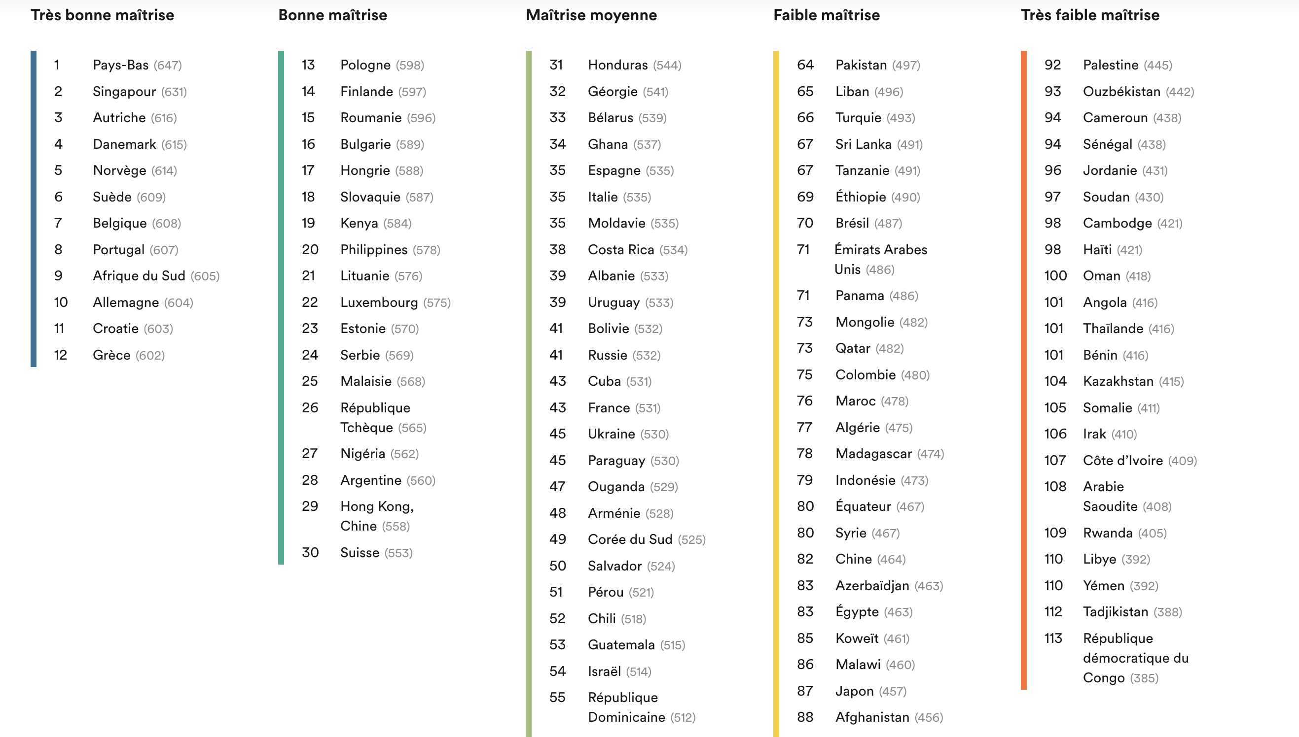
Education First, 2023.

4. "English or Hinglish - which will India choose?"

Today's aspirational Indians want their children to go to a school where lessons are taught in English. But often the pupils leave speaking a language that would not be recognised in London or New York. Could this Hinglish be the language of India's future?
Why, half a century after Indian independence, does English remain the language of higher education, national media, the upper judiciary and bureaucracy and corporate business?
The answer is that India, unlike its rival Asian giant China, has no truly national language of its own. Hindi, the official language of central government, is an artificial and largely unspoken 20th Century construct.
Even the colloquial Hindustani of Bollywood films is spoken by only 40% of the population, concentrated in the "cow belt" of northern India. The rest of the subcontinent speaks hundreds of regional vernaculars. Amid this Babel, English remains the country's only lingua franca.
India now claims to be the world's second-largest English-speaking country. The most reliable estimate is around 10% of its population or 125 million people, second only to the US and expected to quadruple in the next decade. The most vocal demands for English teaching now come from India's most disadvantaged communities. That is because English is now, more than ever, an essential passport to white-collar jobs.
"The profile of the first generation English learner is a bit schizophrenic, because they think and feel in their maternal language but need to use English in their professional world," she said.
This linguistic schizophrenia presents a huge commercial opportunity for hundreds of new language centres offering English to young, white-collar workers, who pay as much as half their monthly salary for evening classes.
With teachers whose own English is poor, places like these create people whose English may be barely comprehensible, as many of us discover when we speak to Indian call centres.
What is emerging from this jungle of poor teaching is not so much English as Hinglish. What makes Hinglish especially quaint is its love of the continuous tense and the way it dispenses with articles like "the" and "a". "The new Indian elite is a very diverse, first generation elite, and they don't have that old snobbery about the Queen's English," says novelist Namita Devidayal. "One finds a growing ease in recreating the language to suit one's culture, and one that's also comfortable in its own dysfunctionality."
Hinglish, for all its occasional breakdowns of communication, is an authentically Indian hybrid. The trouble with dysfunctional Hinglish is that it can cause problems when clear and precise communication is required, whether on a simple taxi ride or in more serious situations like hospitals and law-courts. Young Indians still need better quality, standardised English teaching if they want to access the global knowledge economy and stay ahead of eager new English-speakers in China or Argentina.
Zareer Masani, BBC news, November 2012.

5. "How the internet is changing language"

Online, English has become a common language for users from around the world. In the process, the language itself is changing.
When America emerged from the ashes of a bruising war with Britain in 1814, the nation was far from united. Noah Webster thought that a common language would bring people together and help create a new identity that would make the country truly independent of the British.
Webster's dictionary, now in its 11th edition, adopted the Americanised spellings familiar today - er instead of -re in theatre, dropping the u from colour, and losing the double l from words such as traveller. It also documented new words that were uniquely American such as skunk, opossum, hickory, squash and chowder.
An American Dictionary of the English Language took 18 years to complete and Webster learned 26 other languages in order to research the etymology of its 70,000 entries. The Internet is creating a similar language evolution, but at a much faster pace. There are now thought to be some 4.5 billion web pages worldwide. And with half the population of China now on line, many of them are written in Chinese.
Still, some linguists predict that within 10 years English will dominate the Internet - but in forms very different to what we accept and recognise as English today. That's because people who speak English as a second language already outnumber native speakers. And increasingly they use it to communicate with other non-native speakers, particularly on the Internet where less attention is paid to grammar and spelling and users don't have to worry about their accent.
Users of Facebook already socialise in a number of different "Englishes" including Indian English, or Hinglish, Spanglish (Spanish English) and Konglish (Korean English). While these variations have long existed within individual cultures, they're now expanding online. "On the Internet, all that matters is that people can communicate - nobody has a right to tell them what the language should be," says Baron. Some words are adaptations of traditional English: In Singlish, or Singaporean English, "blur" means "confused" or "slow": "She came into the conversation late and was blur as a result." Others combine English words to make something new. In Konglish, "skinship" means intimate physical contact: handholding, touching, caressing.
Technology companies are tapping into the new English variations with products aimed at enabling users to add words that are not already in the English dictionary.
And most large companies have English websites, while smaller businesses are learning that they need a common language - English - to reach global customers.
"While most people don't speak English as their first language, there is a special commercial and social role for English driven by modern forms of entertainment," says Robert Munro, a computational linguist and head of Idibon, a language technology company in California.
"The prevalence of English movies in regions where there is not much technology other than cell phones and DVDs makes English an aspirational language. People think it's the language of the digital age."
"Most people actually speak multiple languages - it's less common to only speak one," says Mr Munro. "English has taken its place as the world's lingua franca, but it's not pushing out other languages." Instead, other languages are pushing their way into English, and in the process creating something new.
Jane O'Brien, BBC News, December, 2012.

6. "Dans l’Utah, une passion stratégique pour l’apprentissage du français"
L’Utah, c’est l’Amérique version western. De vastes étendues désertiques, des grands parcs nationaux, des pick-up qui filent le long des routes à dix voies, la chaîne des montagnes Rocheuses en toile de fond. Dans ce décor de grands espaces, une curiosité inattendue : un millier de jeunes Américains parlent ici le français au quotidien.
« Pour moi, ça a été un choc », se souvient Claire Tocaven, une Française installée à Salt Lake City, la capitale de l’Etat, depuis cinq ans. « Je venais d’arriver, je discutais avec une voisine, et elle me dit : “Mon fils parle français !” L’enfant de 7 ans arrive, il entame la conversation avec moi, avec un bon accent. »
Le mystère a été vite résolu. Depuis 2008, l’Utah développe des classes d’« immersion en deux langues » dans ses écoles et collèges publics. La méthode est radicale : à partir du CP, les élèves suivent la moitié de leur journée dans une langue étrangère (espagnol, chinois, français, portugais) – dans la plupart des cas avec un professeur natif de la langue – et l’autre moitié en anglais, avec un second enseignant.
« Le résultat est extraordinaire », juge Sophie Clairet, professeure des écoles arrivée en 2021 en Utah. Les élèves acquièrent des facultés de compréhension et une aisance à l’oral dès le plus jeune âge. L’enseignement mise sur la participation, l’utilisation du français entre enfants, la répétition, le jeu, la manipulation d’objets, la récompense et les chansons.
Aux Etats-Unis, le modèle de « l’immersion en deux langues » a commencé à se développer dans les années 1980 en Californie avec l’espagnol, pour répondre à la demande d’une population immigrée, et en Louisiane, avec le français. Depuis les années 2010, le mouvement connaît une accélération, notamment grâce à l’Utah, qui a multiplié les ouvertures de classes et formalisé les méthodes pédagogiques adoptées ailleurs, devenant une référence. Dans cet Etat, près de 65 000 jeunes de milieux sociaux très divers suivent leur scolarité en immersion dans deux langues, dont 9 000 en français.
Dans un Etat pro-business et républicain de trois millions d’habitants, l’apprentissage intensif des langues est avant tout stratégique, poursuit Gregg Roberts. Il s’agit de rendre les jeunes plus compétitifs sur le marché du travail. De multiples recherches américaines documentent les « bienfaits cognitifs » de l’exposition à une seconde langue dès le plus jeune âge. Une étude a aussi montré que les enfants inscrits dans le programme d’immersion avaient de meilleurs résultats que ceux qui suivent le programme simplement en anglais. « Le monolinguisme, c’est l’illettrisme du XXIe siècle », poursuit l’ancien cadre de l’USBE.
En Utah, ces classes d’immersion sont considérées comme un argument pour attirer des entreprises et pour accompagner la croissance de l’Etat, dont le PIB a bondi de 6,7 % en 2021. « Il y a aussi en Utah tout un tas d’entreprises qui peuvent avoir intérêt à recruter des jeunes parlant le français », poursuit Anne Lair, professeure de français à l’université de l’Utah, qui cite Rossignol, Danone, les laboratoires Mérieux, ou encore l’entreprise de matériel de montagne Petzl.
Outre l’argument économique, le développement de ces classes rencontre un écho particulier en Utah, en raison de la forte présence de l’Eglise mormone, qui encourage ses fidèles à effectuer une mission de deux ans dans un pays étranger. Une bonne partie d’entre eux effectuent ce séjour dans un territoire francophone, c’est pourquoi de nombreuses familles n’hésitent pas à orienter leurs enfants vers ces pratiques pédagogiques.
La France espère tirer parti de cette révolution bilingue inespérée, en faisant de ces jeunes francophones des ambassadeurs de la culture française. « Pour nous, l’Utah, c’est un laboratoire, un modèle qui pourrait être mis en place ailleurs. Pour la France, c’est un véritable levier de soft power », se félicite Mathieu Ausseil, attaché de coopération éducative à l’ambassade de France aux Etats-Unis.
Jessica Gourdon, Le Monde, 1er août 2022.

Corrigé (sur Chamilo (PTSI)/Cahier de prépa (PCSI)) à travailler :
• observer la construction des phrases (où est le sujet ? où est le verbe ? à quel temps est ce verbe ? pourquoi ? utilisation de "of" ou " 's" ? pourquoi ? many/much ? some/any/no ?) => points de grammaire à revoir (Wooflash)

• faire une liste (papier ou Wooflash) avec le vocabulaire nouveau vu dans cette activité, l'apprendre... et le réviser régulièrement (apprentissage/acquisition sur le long terme) !

proficiency = compétence, maîtrise (d'une langue, d'un sujet etc.)

