Problem-Based Learning
(learning things through a problem/situation)

Tip: When you work in a group, think about organizing your group => possible roles:
time keeper

 secretary

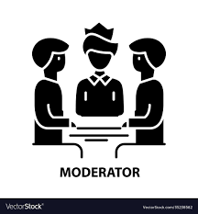 facilitator/moderator

Topic 4: What education for the 21st century?

Problem/situation

Jim has come across the Sudbury Valley School website while doing some research for a school presentation. He is very excited about what he has read and talks about it with his classmate Jill.

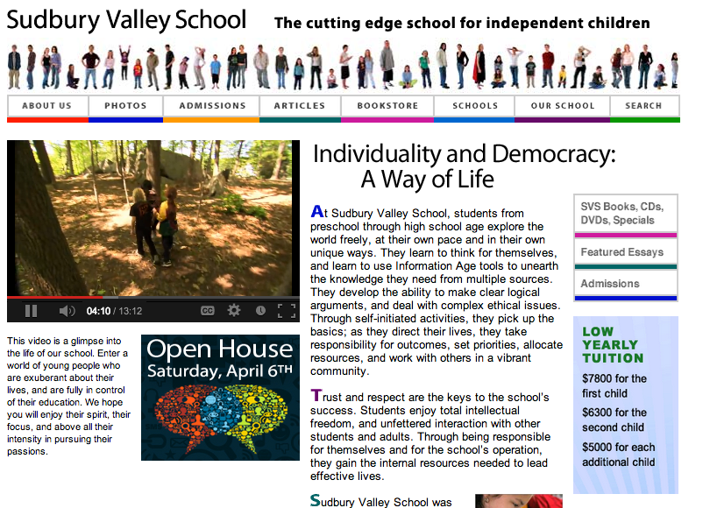

Jim — Jill! Have you heard of this school in Massachusetts? It's extraordinary!!
Jill — Oh yeah? What's so good about it?!
Jim — Well, apparently it's a school where there are no classes, no teachers and kids from all ages from 5 to 19 are mixed together in this big beautiful house. And they can do whatever they want all day!!
Jill — No classes?! Do whatever they want?! That's the stupidest idea I've ever heard! If you let kids do whatever they want, they will play all day and learn nothing!
Jim — So, what's so bad about playing all day? You actually learn a lot by playing: social interaction, motricity, even geometry (think about all those Lego you played with as a kid!) or language skills. That reminds me: all the school rules are also voted by the adults and students, in a democratic way: the student's voice counts as much as the adults.
Jill — This sounds like chaos to me! Kids will want to allow things like all-day video games and candy for lunch!
Jim — I don't know... This school has been opened since the 1960s and many students say they have learnt a lot during their schooling there: self-confidence, living together, knowing who you are and what you want in life, responsibility, autonomy... These are very important skills. And when you choose to learn something yourself, you tend to learn it faster and better. Think about all those years spent learning French in class...and you can't say more than "Bonjour, je m'appelle Jill"!
Jill — You're right about that: I hate French classes! I don't understand why they make us learn languages. I'm more interested in sciences.
Jim — Then imagine a school where you could study what you wanted at your own pace!!

What are the key issues raised by this situation?

