Problem-Based Learning
(learning things through a problem/situation)

Tip: When you work in a group, think about organizing your group => possible roles:
time keeper

 secretary

 facilitator/moderator

To do list:

Step 1. (around 10 minutes)
Read the presentation of the situation/problem.

Production: make a list of the questions the problem/situation raises.

Step 2. (around 30 minutes)
Read the documents => highlight key words. To select them, think about whether they help answer the questions raised by the situation/problem.

Production: write one general key question (= une problématique) that is answered by ALL the documents.

Step 3. (around 40 minutes)
Production: write a detailed outline (= un plan détaillé) to answer the key question. In it, sum up what you have learnt in the documents.

Tip: use your "Basics Buddy" to help with your writing skills.

Topic 6: The Internet, Privacy, New Media

Problem/situation



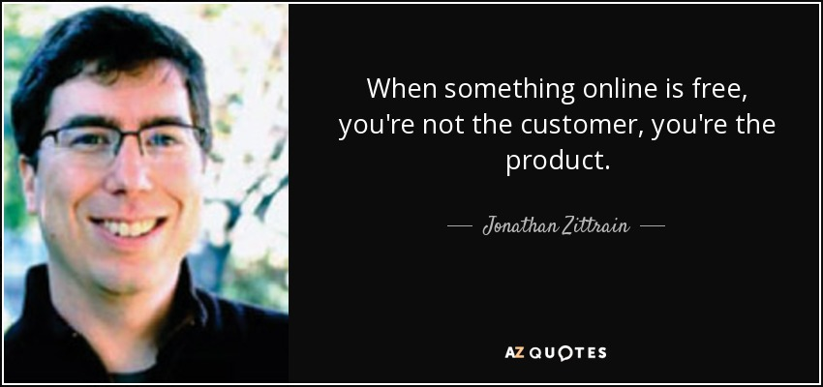

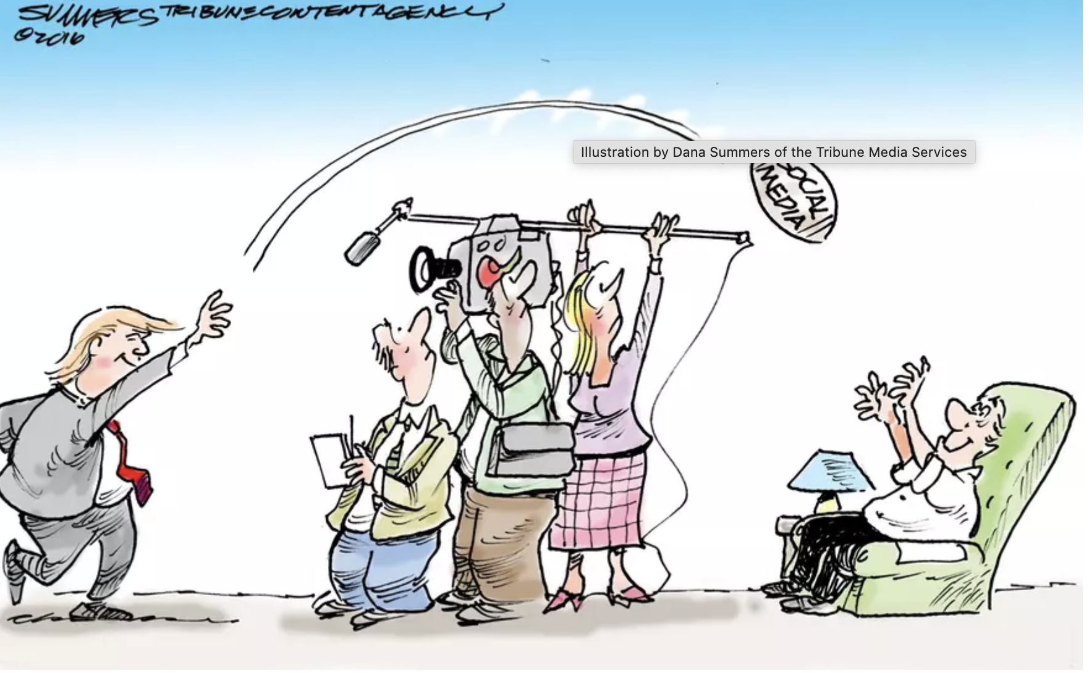

What are the key issues raised by those situations?

