Problem-Based Learning
(learning things through a problem/situation)

Tip: When you work in a group, think about organizing your group => possible roles:
time keeper

 secretary

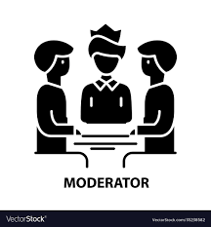 facilitator/moderator

Topic 7: The Environment

Problem/situation

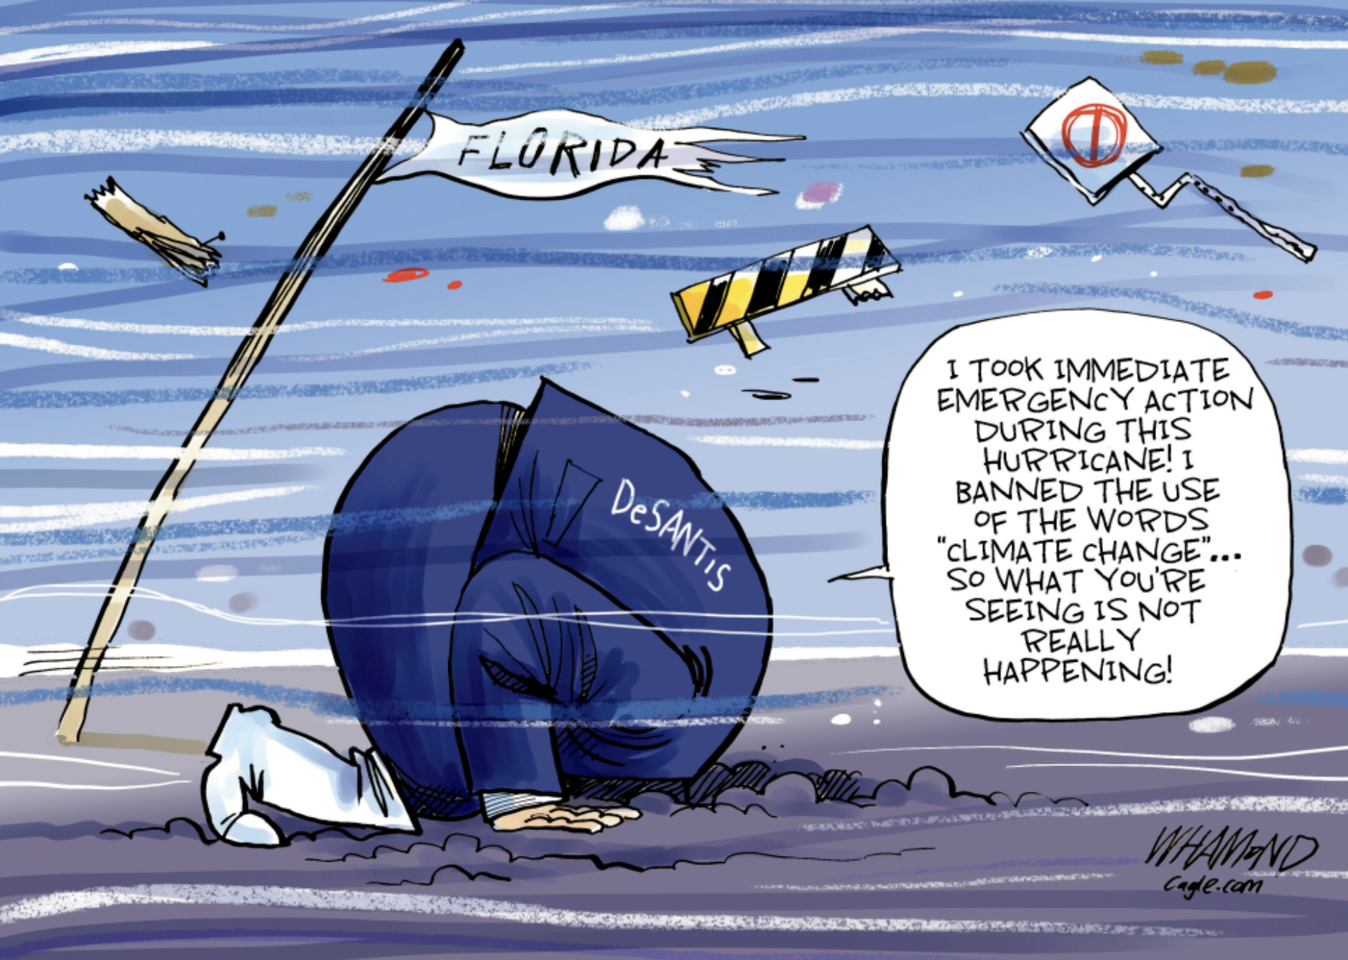
Dave Whamond, Cagle cartoons, September 2024

What are the key issues raised by this situation?

