Topic 9: Playing God

1. France’s National Assembly votes in favour of legalising assisted dying.
France’s parliament has voted in favour of a bill to legalise assisted dying, enabling caregivers to help patients end their lives under what would still be some of the strictest conditions in Europe.
After a sometimes emotional session, deputies passed the first reading of the bill by a vote of 305 to 199. They also unanimously backed a less debated law establishing a right to palliative care in specialist end-of-life institutions.
Both votes are the start of a long parliamentary process that will require the bills to move on to the Senate – the upper house – and then back to the lower house – the National Assembly – for a second reading, meaning they are unlikely to become law before next year.
The legislation would allow a medical team to decide if a patient is eligible to “gain access to a lethal substance when they have expressed the wish”. Patients would be able to use it themselves or have it administered by a nurse or doctor “if they are in no condition physically to do so themselves”.
Patients must meet a number of strict conditions: they must be over 18, hold French citizenship or residency and suffer from a “serious and incurable, life-threatening, advanced or terminal illness” that is “irreversible”.
The disease must cause “constant, unbearable physical or psychological suffering” that cannot be cured by medical treatment, and the patient must be capable of “expressing freely and in an informed manner” their wish to end their life.
The bill – referred to in France as a law on “end of life” or “aid in dying” rather than “assisted dying” or “euthanasia” – was backed by most of Emmanuel Macron’s centrist MPs and their allies and by the left, with most right and far-right deputies voting against.
Euthanasia is a highly sensitive subject in France, a country with a longstanding Catholic tradition, and the bill is also opposed by many health workers. Opponents said it was illusory to and even dangerous to even think of debating a legalisation of euthanasia without having first fully deployed proper access to palliative care.
President Macron said last year that France needed the legislation because “there are situations you cannot humanely accept”.
France currently allows passive euthanasia – such as withholding artificial life support – and deep sedation before death, but patients seeking active end-of-life options have no choice but to travel to other countries where euthanasia is legal.
“We’ve been waiting for this for decades. Hopefully France will steadily align itself with other European countries,” Stéphane Gemmani of the ADMD association said. “Forcing people to go to Belgium or Switzerland, pay €10,000 or €15,000 … The current situation is just wrong.”
Opinion polls show most French people are in favour of assisted dying, but France has been slower than many European neighbours to legalise it. Others are actively debating the issue, including the UK, where an assisted dying bill is before parliament.
Active euthanasia, where a caregiver induces death at the request of the patient, and assisted suicide, where doctors provide the patient with the means to end their life themselves, have been legal in the Netherlands and Belgium since 2002.
Both countries apply roughly similar conditions – a doctor and an independent expert must agree the patient is suffering unbearably and without hope of improvement – and have since extended the right to children under 12.
Luxembourg also decriminalised active euthanasia and assisted dying in 2009. Active euthanasia is outlawed in Switzerland, but assisted dying has been legal since the 1940s and organisations such as Exit and Dignitas have helped thousands of Swiss nationals, residents and others to end their lives.
Austria legalised assisted dying in 2022, while Spain adopted a law in 2021 allowing euthanasia and medically assisted dying for people with a serious and incurable illness, providing they are capable and conscious, the request was made in writing, reconfirmed later, and approved by an evaluation committee. Portugal decriminalised euthanasia in 2023 but the measure has not yet come into force after certain articles were rejected by the constitutional court.
In the UK, MPs approved the legalisation of assisted dying in England and Wales for adults with an incurable illness who have a life expectancy of under six months and are able to take the substance that causes their death themselves, in a first vote in November last year.
MPs must now vote on whether the text, amended in May to allow medics to opt out, is sent to the upper chamber for further scrutiny. The Scottish parliament has also passed its first vote on a bill to legalise assisted dying.
Jon Henley, The Guardian May, 2025.

- 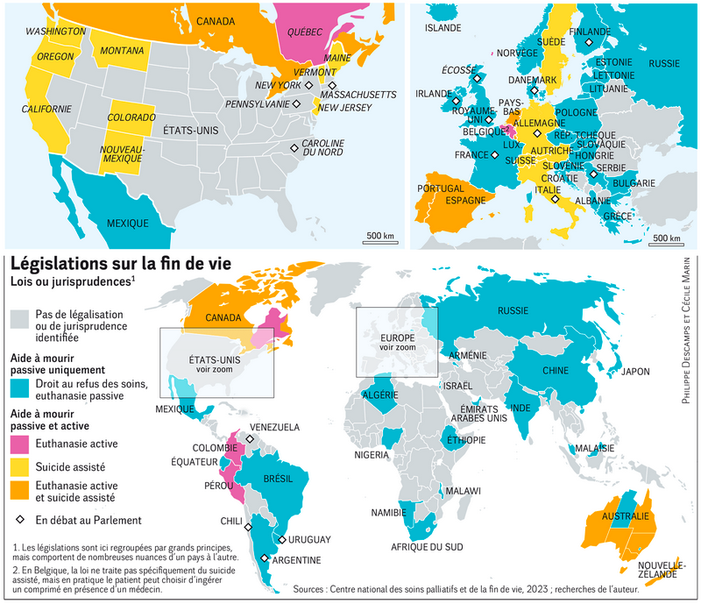

- 2. The End of Roe
- The Supreme Court has overturned the constitutional right to an abortion in America. The court’s decision issued yesterday is the culmination of a conservative campaign to strike down Roe v. Wade, the 1973 Supreme Court ruling that established abortion rights. The three conservative justices whom Donald Trump appointed to the court made it possible.
- Roe’s fall is a political and social earthquake, one that Americans alternately celebrated and denounced. “I cannot think of a precedent for this in our modern history, where you have an individual civil right that people depend on that has been erased after 50 years,” said my colleague Emily Bazelon, who writes about abortion access and the court.
- The ruling immediately transfered the political fight over abortion to the state level. That was, one of the court’s aims: “The authority to regulate abortion must be returned to the people and their elected representatives.” Roe’s fall immediately triggered abortion bans in Kentucky, Louisiana and South Dakota. Missouri, Arkansas and other states did the same within hours. In total, more than 20 states appear ready to outlaw all or nearly all abortions. Half of Americans live in those states. For them getting an abortion will become even more difficult. For women in Mississippi, for example, Illinois may become the closest state in which to legally obtain one. More liberal states began moving in the opposite direction. In Massachusetts, Gov. Charlie Baker, a moderate Republican, signed an executive order protecting medical providers who perform abortions for out-of-state residents. The Democratic governors of California, Oregon and Washington issued a joint statement promising to protect access to abortion and contraception.
- The ruling may have a less dramatic effect on overall abortion rates. Some experts estimate that overturning Roe could reduce the number of legal abortions in the U.S. by as little as 13 percent. That’s because abortion was already heavily restricted in red states and more people living in them oppose the practice. But Roe’s fall is likely to reduce abortion access most for lower-income women and Black and Hispanic women, because many of them lack the resources to travel out of state to obtain one.
- One is the question of medical abortion pills. About half of legal abortions in the U.S. occur by medication, which is generally safe and effective, rather than a surgical procedure. Texas and Louisiana have made it a crime to mail the pills in the states, and other states could follow. “Then the question is, what kind of penalties are they imposing, and how are they going to enforce that law?” Emily said. “Do they want to open people’s mail and start surveilling people?”
- The New York Times, Ian Philbrick, June 26th, 2022

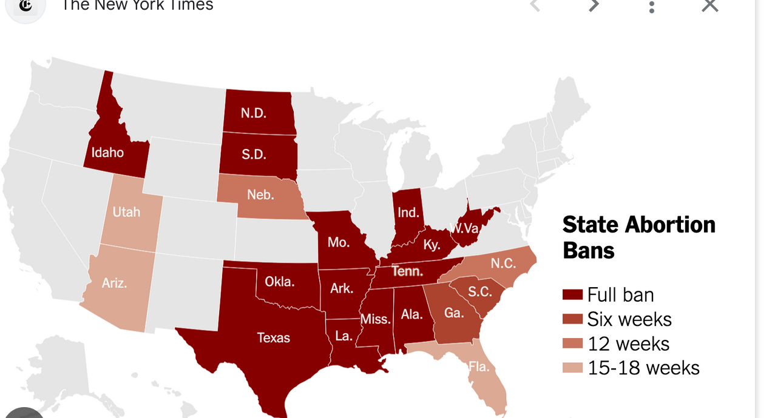

3. CRISPR-Cas9



4. Baby Is Healed With World’s First Personalized Gene-Editing Treatment

Something was very wrong with Kyle and Nicole Muldoon’s baby. The doctors speculated. Maybe it was meningitis? Maybe sepsis? They got an answer when KJ was only a week old. He had a rare genetic disorder, CPS1 deficiency, that affects just one in 1.3 million babies. If he survived, he would have severe mental and developmental delays and would eventually need a liver transplant. But half of all babies with the disorder die in the first week of life.
Doctors at Children’s Hospital of Philadelphia offered the Muldoons comfort care for their baby, a chance to forgo aggressive treatments in the face of a grim prognosis. “We loved him, and we didn’t want him to be suffering,” Ms. Muldoon said. But she and her husband decided to give KJ a chance.
KJ has made medical history. The baby, now 9 ½ months old, became the first patient of any age to have a custom gene-editing treatment, according to his doctors. He received an infusion made just for him and designed to fix his precise mutation.
The investigators who led the effort to save KJ are presenting their work on Thursday at the annual meeting of the American Society of Gene & Cell Therapy, and are also publishing it in the New England Journal of Medicine. The implications of the treatment go far beyond treating KJ, said Dr. Peter Marks, who was the Food and Drug Administration official overseeing gene-therapy regulation until he recently resigned over disagreements with Robert F. Kennedy Jr., the secretary of health and human services. More than 30 million people in the United States have one of more than 7,000 rare genetic diseases. Most are so rare that no company is willing to spend years developing a gene therapy that so few people would need.
But KJ’s treatment — which built on decades of federally funded research — offers a new path for companies to develop personalized treatments without going through years of expensive development and testing. Illnesses like KJ’s are the result of a single mutation — an incorrect DNA letter among the three billion in the human genome. Correcting it requires pinpoint targeting in an approach called base editing.
To accomplish that feat, the treatment is wrapped in fatty lipid molecules to protect it from degradation in the blood on its way to the liver, where the edit will be made. Inside the lipids are instructions that command the cells to produce an enzyme that edits the gene. They also carry a molecular GPS — CRISPR — which was altered to crawl along a person’s DNA until it finds the exact DNA letter that needs to be changed. The method, said Dr. Marks, who wrote an editorial accompanying the research paper, “is, to me, one of the most potentially transformational technologies out there.” In Berkeley, Dr. Urnov said “such speed to producing a clinic-grade CRISPR for a genetic disease has no precedent in our field. Not even close.”
David Liu of Harvard, whose lab invented the gene-editing method used to fix KJ’s mutation, said the speed was “astounding.” “These steps traditionally take the better part of a decade, if not longer,” he said. Within two weeks, KJ was able to eat as much protein as a healthy baby. But he still needed the medication to remove the ammonia from his blood — a sign that the gene editor had not yet corrected the DNA in every affected cell. The doctors gave him a second dose 22 days later.
KJ is now well enough for the team to start planning to discharge him from the hospital and live at home, and he is meeting developing well. They were able to halve the medication dose. He got a few viral illnesses in that time, which normally would have triggered terrifying surges in his ammonia levels. But, Dr. Ahrens-Nicklas said, “he sailed through them.” A week and a half ago, the team gave KJ a third dose.
It is too soon to know if he can stop taking the medication completely, but the dosage is greatly reduced. And he is well enough for the team to start planning to discharge him home from the hospital. But it is not yet known if he’ll be spared a liver transplant. The result “is a triumph for the American peoples’ investment in biomedical research,” Dr. Urnov said. The researchers emphasized the role government funding played in the development.
The New York Times, May, 2025.

5. Human Cloning

Last week, it was revealed that human cloning has been used for the first time to create embryonic stem cells from which new tissue – genetically identical to a patient's own cells – could be grown. But the announcement was greeted with horror. "Scientists have finally delivered the baby that would-be human cloners have been waiting for: a method for reliably creating cloned human embryos," said David King of Human Genetics Alert. "It is imperative we create an international ban on human cloning before any more research like this takes place. It is irresponsible in the extreme to have published this."
Several tabloid newspapers also carried banner headlines warning of the human cloning "danger". Such reactions have a familiar ring. When the cloning of Dolly the Sheep was revealed in 1997 there was an outpouring of hysteria about the prospect of multiple Saddam Husseins being created in laboratories.
"At the time the chances of these horrors occurring – when scientists had not even created a single clone of a human cell – were remote," said physiologist Professor Colin Blakemore of Oxford University. "Not that this worried the alarmists. The crucial point is that we should have spent the intervening time thinking about how we should react sensibly to the concept of a human clone when it does become possible. We have not done that and, although the science is still far off, it is getting closer. We need to ask, carefully and calmly: under what circumstances would we tolerate the creation of a human clone?"
At present such a creation is banned in Britain. No human embryo created by cloning techniques is allowed to develop beyond 14 days. "The research is very tightly regulated and I think there is little chance of a rogue laboratory creating a human clone," said James Lawford Davies, a lawyer who specialises in health sciences. "However, many US states which, ironically, banned therapeutic cloning work because of their strong anti-abortion stances have laws that would permit human clones to develop into foetuses."
Experts such as Professor John Harris, director of Manchester University's Institute for Science, Ethics and Innovation, see positive benefits in reproductive cloning which could have a place in society. He said: "If you take a healthy adult's DNA and use it to create a new person – by cloning – you are essentially using a tried and tested genome, one that has worked well for several decades for the donor. By contrast, a child born naturally has an 8% chance of succumbing to a serious genetic abnormality because of the random selection of their DNA. You can avoid that with a clone."
In fact, most arguments against human cloning are foolish, said Harris, adding: "It could be used in medically helpful ways. If a couple find they are carriers of harmful, possibly fatal recessive genetic illnesses, there is a one in four chance they will produce a child who will die of that condition. That is a big risk. An alternative would be to clone one of the parents. If you did that, then you would know you were producing a child who would be unaffected by that illness in later life.
"Or consider the example of a single woman who wants a child. She prefers the idea of using all her own DNA to the idea of accepting 50% from a stranger. But because we ban human cloning she would be forced to accept DNA from a stranger and have to mother 'his child'. I think that is ethically questionable. Just after Dolly the Sheep was born, Unesco announced a ban on human cloning. I think that was a mistake."
However, a note of caution was sounded by Ian Wilmut, who led the team that created Dolly the Sheep. He said: "The new work may encourage some people to attempt human reproductive cloning but the general experience is that it still results in late foetal loss and the birth of abnormal offspring." It would be cruel to cause this in humans until techniques had been vastly improved, he added.
Robin McKie, The Observer, May 2013.

Based on documents 4 and 5, make a list of arguments in favour of genome editing and human cloning and of the issues linked to these two techniques.

Corrigé (sur Chamilo (PTSI)/Cahier de prépa (PCSI)) à travailler :

• observer la construction des phrases (où est le sujet ? où est le verbe ? à quel temps est ce verbe ? pourquoi ? utilisation de "of" ou " 's" ? pourquoi ? many/much ? some/any/no ?) => points de grammaire à revoir (Wooflash)

• faire une liste (papier ou Wooflash) avec le vocabulaire nouveau vu dans cette activité, l'apprendre... et le réviser régulièrement (apprentissage/acquisition sur le long terme) !

a bill = une proposition de loi, une loi en attente d'être adoptée par le Parlement
a poll : a survey, a statistics study

