Addictive and compulsive behaviours

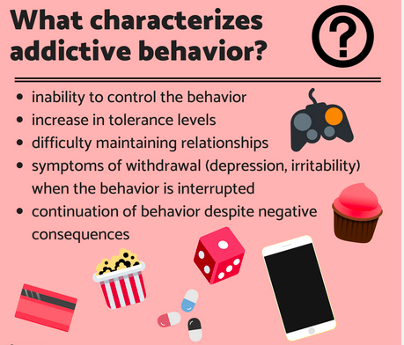

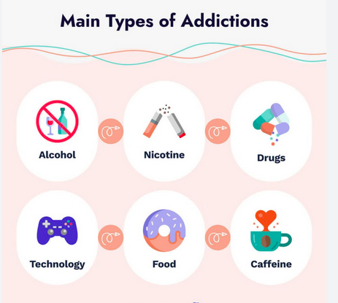

Vocabulary:
a drug
substance abuse : la toxicomanie
to be addicted to...
to be an addict/to be a junkie (familier)
to suffer from an addiction to...
to be in withdrawal : être en manque (d'une drogue)

Brainstorming:
Should sugar and fat be considered as drugs?
I eat junk food/fast food because...

a feeling of withdrawal

comfort food
but also arrival on the market of food delivery companies (did it answer a need? is it my personal responsibility?) + scrolling + Netflix => what degree of individual responsibility

processed foods are full of additives (flavours etc.) that make them addictive (see Nutella: its taste is unique)

access to junk food is limited in French schools + quantities limited in processed foods => limit //other legal drugs (alcohol, tobacco + drugs that used to be legal/prescribed but became illegal: cocaine, heroin etc.)
BUT sugar and fat are essential to a healthy diet, your brain needs them to function properly (! quality vs quantity)

