What is a healthy diet?

Department of Health and Human Services
vs
Harvard School of Public Health

Guidelines published by the Harvard School of Public Health

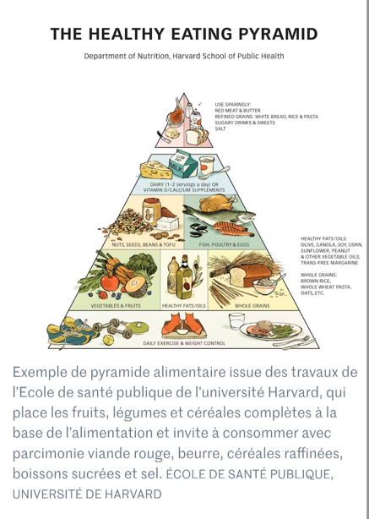

New guidelines released in January 2026 by Robert F. Kennedy Jr (D. Trump's Secretary of Health and Human Services)

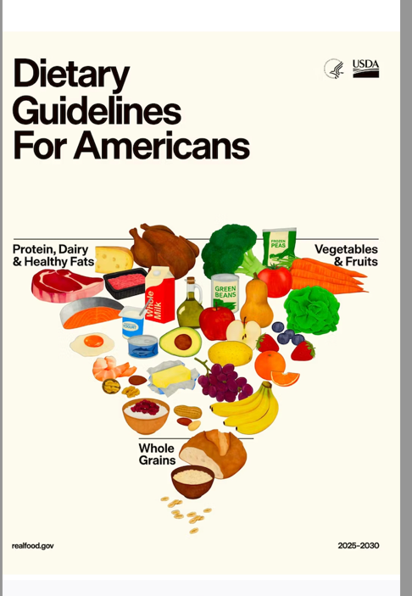

What differences do you spot?

To go further read, for example, Stanford University's reaction: https://med.stanford.edu/nutrition/news/press/2025_2030_Dietary_Guidelines

