Addictive behaviours

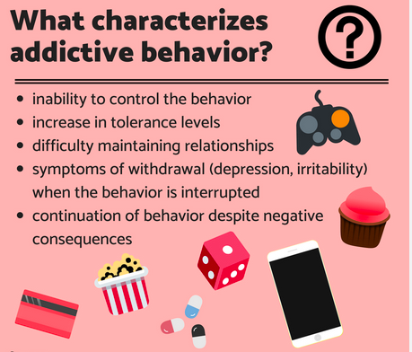

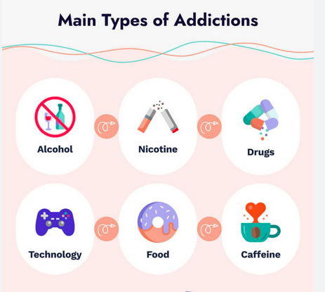

Vocabulary:
a drug
substance abuse : la toxicomanie
to be addicted to...
to be an addict/to be a junkie (familier)
to suffer from an addiction to...
to be in withdrawal : être en manque (d'une drogue)

Should sugar and fat be considered as drugs?

a feeling of withdrawal
comfort food

processed foods are full of additives (flavours etc.) that make them addictive (see Nutella: its taste is unique)

access to junk food is limited in French schools + quantities limited in processed foods => limit //other legal drugs (alcohol, tobacco)
BUT sugar and fat are essential to a healthy diet, your brain needs them to function properly (! quality vs quantity)

