**Some stereotypes about the USA and obesity**

*Look at the following images and say what kinds of stereotypes/clichés they convey.*

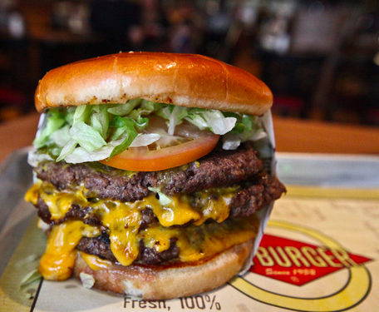 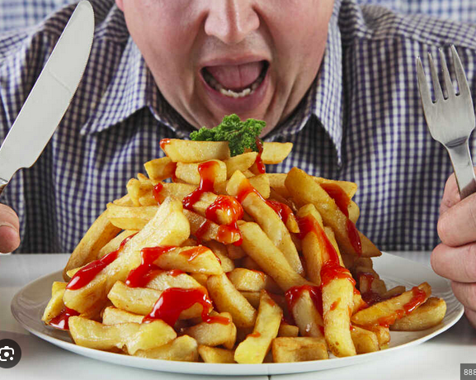

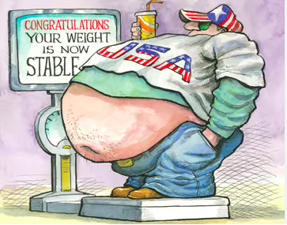

Supersize fast food => all the portions are huge => quantity

All you can find in the USA is junk food and fast food => quality

Coca Cola is cheaper than water => price

All Americans are overweight or obese (=> numbers, statistics) and don't want to change their eating habits (=> will)

=> The ultimate cliché : "if you are obese, it's your fault. You should stop eating and have more will power".