**Anglais LV1 – Synthèse de documents – Sujet proposé en 2018 par Mme Laurent**

**Consignes Centrale :**

Rédigez en anglais et en 500 mots environ une synthèse des documents proposés. Vous indiquerez avec précision à la fin de votre synthèse le nombre de mots qu’elle comporte. Un écart de 10% en plus ou en moins sera accepté. Votre travail comportera un titre comptabilisé dans le nombre de mots.

Ce sujet propose les 4 documents suivants :

1) une photographie d'un graffiti réalisé par l'artiste britannique Banksy en 2011 à Londres ;

2) un article intitulé ''Los Angeles's mural 'movement': 'It gives you a sense of pride and belonging' '' publié par le journal britannique *The Guardian* le 29 mars 2016 ;

3) un article intitulé ''The writing's on the wall'' publié par le magazine britannique *The Economist* le 9 novembre 2013 ;

4) un article intitulé ''Banksy’s refugee piece shows us how to protest – and grieve'' publié par le journal britannique *The Guardian* le 25 janvier 2016

----------------------------------------------

**Document 1 :**

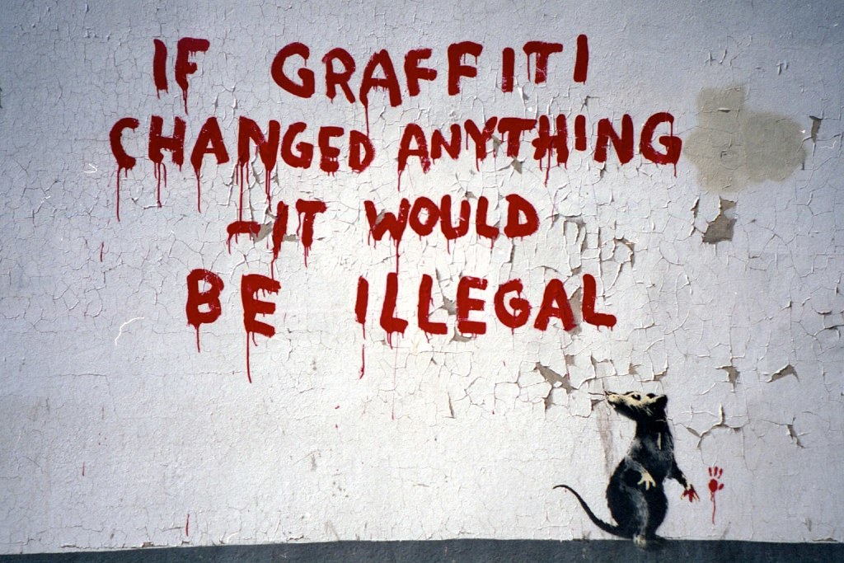

A graffito known as ''If Graffiti Changed Anything'', by British street artist Banksy. The graffito first appeared in Fitzrovia, central London, in April, 2011.

**Document 2 :**

**Los Angeles's mural 'movement': 'It gives you a sense of pride and belonging'**

**Colorful murals have brought street art to LA’s rundown back alleys. But amid gentrification, are they bringing people together or just painting over the cracks?**

**Jordan Riefe, *The Guardian*, Tuesday 29 March 2016**

In the shadow of downtown Los Angeles, adjacent to artsy enclaves of Silver Lake and Echo Park, is a rundown area called Historic Filipinotown, named for its once thriving post-war immigrant community. Until recently, it was gang territory, with tags wallpapering alleys where homeless people slept. But now the homeless people are gone and gang tags have been painted over by colorful murals – more than 110 of them by roughly 80 local and international artists. The gangs are still there, but they leave the art alone.

“One night, I get a knock on the door and there’s this big guy with tattoos all over his face and his arms,” remembers Jason Ostro, owner of Gabba Gallery, which sits on the corner of Beverly and Dillon.

“You the guys doing them murals?” he asked.

Ostro hesitantly responded, “Yeah.”

“I just want to tell you this is beautiful,” said the man who had lived in the neighborhood for 47 years. He told Ostro that he had always wanted to leave, but now he thought he’d stay and see what happened.

For Ostro, it was an epiphany: “I was like, ‘This is the right thing I’m doing, then.’”

What he was doing was curating the neighborhood. A street art connoisseur, he went door to door asking local residents if he could paint on their fences and garage walls in the back alley. Most said no, but when they saw the results at their neighbors’ homes, they began to change their minds. Pretty soon images were springing up by artists like the French-Spanish duo Dourone, who painted a black-and-white masked face staring provocatively from the side of a garage, and Swiss-born Raphael Grischa, who adorned the façade of the Beverly Boulevard building with an eagle in flight. Stormie Mills came all the way from Australia to paint a pair of cartoon skeletal figures playing dice amid murals by artists including Clinton Bopp, Skid Robot and perhaps even the legendary Invader, although Ostro doubts the authenticity of the mosaic artwork.

Using money he earned in music licensing and wardrobe, Ostro opened Gabba Gallery in 2013 just as the city lifted a 10-year ban on murals. As he built his artist network through social media, he spent money from his own pocket in addition to securing a five-figure contribution from the art supply store Blick. Another sponsor was the real estate developer Light Space & Shadow, which was renovating a building in the neighborhood. No one makes any money from the murals, but each gets free promotion, the artists get free space to paint, and the neighborhood moves from blight to bright, as Ostro is fond of saying.

It’s a win-win for everyone, although some would say the paradigm subverts the very nature of street art, a form that has generally thumbed its nose at the laws of the art market as well as the laws of the land. “This is kind of taking any illegality out of it,” Ostro says, adding that he places restrictions on religious, political and graphic sexual content. “Without being neighborhood-friendly, this project wouldn’t work.”

So far it’s worked for everyone but the neighborhood’s homeless population, who, despite the gallery paying them to pick up trash and providing information on nearby shelters, simply moved on when the murals went up and the cameras started to appear.

It’s just one of numerous creeping signs of gentrification. Real estate prices are climbing and new businesses are springing up, such as the soon-to-open café across the street, and the interior design store next to it. One of Ostro’s new neighbors is Alissa Walker, a journalist for Gizmodo who recently moved from Silver Lake with her husband and two kids, drawn to the area in part by the artwork. “The mural movement that is happening in a lot of different cities makes people feel like they should take care of their own cities. It gives you a sense of pride and a sense of neighborhood belonging.”

Talk of a movement is premature, though Ostro is eyeballing a fourth alley in the neighborhood and has plans for one in the San Fernando Valley as well as the West Adams district. He’s currently in discussions with like-minded people in other cities about taking “blight to bright” coast to coast and beyond. It may sound idealistic, but Ostro has no qualms about doubling down on humankind’s better nature. “I found there are a lot of people out there that really do want to see the betterment of man. They don’t need to be the richest, most successful person in the world so they can buy and sell you 10 times over. There are a lot of people who want happiness from seeing happiness.”

**Document 3 :**

**Graffiti**

**The writing's on the wall**

**Having turned respectable, graffiti culture is dying**

***The Economist,* November 9th, 2013**

LONDON'S fastest-changing art gallery is hidden in a sunken ball court on a housing estate in Stockwell, south London. On a sunny Sunday afternoon six or seven men, mostly in their 30s, are busy painting the walls with new designs. They have put up cartoons, names written in elaborate, multi coloured lettering and clever perspective tricks. Tins of spray paint and beer stand on the ground; ladders lean against the paintings. The atmosphere is not unlike that of a golf course: a mix of concentration and blokey relaxation.

Graffiti painting is traditionally a daredevil pursuit. Teenagers dodge security guards to put their names on trains and buses. But over the past decade that has all but disappeared from Britain's cities. Between 2007 and 2012 the number of incidents of graffiti recorded by the British Transport Police fell by 63%. A survey by the environment ministry shows that fewer places are blighted by tags than ever. Graffiti are increasingly confined to sanctioned walls, such as the Stockwell ball courts. In time the practice may die out entirely.

The most obvious reason for the decline in tagging and train-painting is better policing, says Keegan Webb, who runs The London Vandal, a graffiti blog. Numerous CCTV cameras mean it is harder to get away with painting illegally. And punishments are more severe. Once-prolific taggers such as Daniel Halpin, who painted his pseudonym “Tox” all over London, have been given long prison sentences. British graffiti artists who want to paint trains usually go abroad to do it these days, says Mr. Webb.

A generational shift is apparent, too. Fewer teenagers are getting into painting walls. They prefer to play with iPads and video games, reckons Boyd Hill, an artist known as Solo One, who in effect runs the Stockwell ball courts. Those who do get involved tend to prefer street art to graffiti proper (which purists define as letters and names, however elaborately drawn). Some have gone to art school and want to make money from their paintings. The internet means that painters can win far more attention by posting pictures online than they can by breaking into a railway yard.

Taggers and graffiti artists mostly grew up in the 1980s and 1990s. Those men—and almost all are men—are now older and less willing to take risks. “We can't run away from the police anymore,” says Ben Eine, who turned from tagging to street art. The hip-hop culture that inspired graffiti in the first place has faded. Video games and comic books provide more inspiration than music.

Graffiti may eventually disappear. But for now the hobby is almost respectable. Mr. Eine says he has lots of friends who used to paint trains. Now with wives and children, they paint abandoned warehouses at the weekend. It has become something to do on a Sunday afternoon—a slightly healthier alternative to sitting watching the football.

**Document 4 :**

**Banksy’s refugee piece shows us how to protest – and grieve**

**Stik and Stewy are other street artists addressing issues such as housing and the migration crisis. This isn’t antisocial – it’s deeply social**

**Suzanne Moore, *The Guardian*, Monday 25 January 2016**

To see interesting art you don’t have to go to a gallery, you just have to walk the streets. One of the most reproduced images of the past couple of weeks is a mural, commissioned in Brixton, of David Bowie, by the Australian street artist Jimmy C (James Cochran) which now acts as an unofficial shrine. There are critics who exist simply to say that if something is popular it is by implication bad. Those people like their art defined, refined and confined. All else is vulgar.

Along with Cochran, Banksy has also raised the street art bar with his new interactive piece opposite the French embassy. It shows the poster girl from *Les Misérables* with tears in her eyes. Next to her is a CS gas1 canister. There is a stencilled QR code2 (which can be read by smartphones) that takes the viewer to a video of teargas being used in a raid on the Calais refugee camps earlier this month.

The use of QR codes in street art is not new – in Berlin an artist called Sweza uses QR codes to take viewers to audio or sometimes images of what has now been “cleaned away”. What Banksy is doing is overtly political, as was his mural of Steve Jobs (the son of a Syrian immigrant), which has since been vandalised in Calais, as was his Raft of Medusa next to the town’s immigration office, as was his shipping of the leftover structures of Dismaland3 to help build emergency housing for the migrants there.

Street art reminds us both of what we have to fight for, and what we have lost. The use of street art for commemoration has been growing. Remember the Banksy and all those other images that appeared when Amy Winehouse died? She now, thankfully, had wings. Malcolm McClaren appeared at the end of my road (where he was born), in a brilliant stencil by Stewy, which was soon painted over by the council. Stewy's Mary Wollstonecraft still resides near me and makes me happy every time I see it, this charting of an alternative history.

The difference between street art and graffiti is one of aesthetics. Without permission, all of it is illegal. Graffiti is associated with tagging, gangs, out of control vandals. Those who make it can end up in prison. Britain is the only place in Europe that puts artists in prison. Between the ages of 17 and 24 the maximum sentence is two years. It’s more if you are older. This is for malicious mischief, vandalism, criminal damage. Quite who the victims are here is questionable. Graffiti is seen as essentially antisocial. And some is: the swastikas painted near a Jewish neighbourhood are, quite rightly, quickly removed.

Tagging is seen as something that has to be stopped. It represents an implicit breakdown of order, a marking of territory by gangs. The “broken windows” theory of urban decay comes into play.

The Home Office has launched a campaign against this type of graffiti and there is a national database of taggers. This zero tolerance approach is because they say graffiti creates fear. DC4 Colin Saysell, who helped to convict a gang of five graffiti writers for total sentences of 11 years, sees this as a deterrent. Some people, he admits, decide to go abroad where there is a radically different approach. Indeed, street art is an intrinsic part of Barcelona or Berlin.

Custodial sentences seem insane. As the artist Goldie says, what was once “a social menace” is now “subliminally making these cityscapes that bit more beautiful”. […]

Lately street art has been deeply social. Stik's Big Mother, showing a mother and child holding on to each other, was painted as a huge mural on the side of a west London tower block about to be demolished. The luxury flats are going up around this mother and child. Stik, who has been homeless himself, has talked about the basic need for affordable housing.

Hackney Wick, in east London, has seen battles over “graffiti gentrification”, where street art becomes commercialised and sponsored “pay-as-you-go” walls.

If our official artists don’t seem politically engaged it doesn’t matter, because our best ones already are. Next to the lovely new Bowie mural in north London's Turnpike Lane is a quote on a white wall in big letters: “Darling look, it’s a commission!”; “Don’t be silly my dear, that’s just some vandalism”; “Oh right. Yes, of course.” For under that quote used to be a Banksy. That has been removed. And then auctioned. Of course.