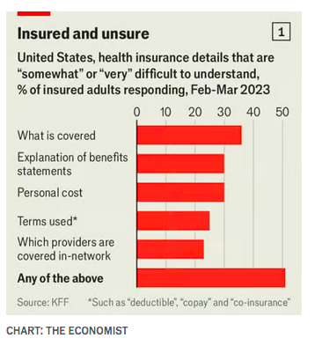
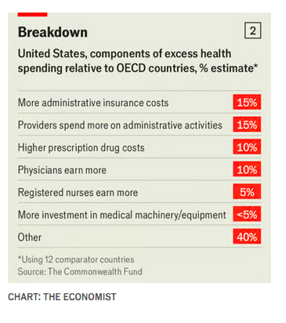
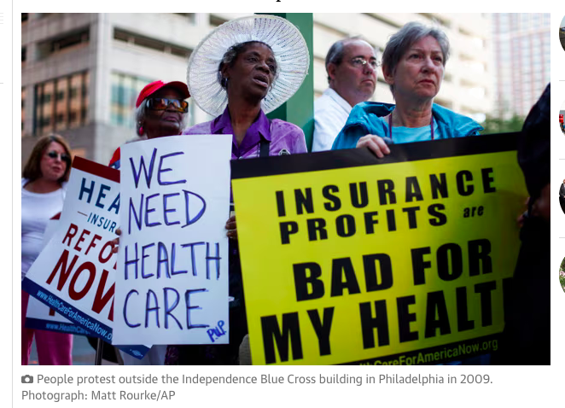
Document 1
Message in a bullet
Luigi Mangione’s manifesto reveals his hatred of insurance companies
The Economist, 12 December 2024

Homicide investigations are like bankruptcies: they come along gradually and then all at once. On December 9th, Luigi Mangione, a 26-year-old engineering graduate of the University of Pennsylvania, an Ivy League school, was arrested and charged with murdering Brian Thompson, the CEO of UnitedHealthcare, America’s biggest health insurer, in a predawn assassination in Manhattan on December 4th. [...]

What could have inspired the killing? Mr Mangione’s short note suggested a calculating desire to wreak revenge on America’s health-care system. America, he correctly noted, has the most expensive health care in the world, but life expectancy has stagnated. “Many have illuminated the corruption and greed” in the system, he wrote. “Evidently I am the first to face it with such brutal honesty."
If his goal was to get America discussing its health-care system, Mr Mangione seems sure to succeed. In the days leading up to his arrest, three words written on the casings of the bullets used to kill Mr Thompson—“deny”, “defend” and “depose”—seemingly intended to echo words used by insurance companies while rejecting claims, became a meme. On TikTok sympathisers made out the then mysterious killer was some sort of superhero, with influencers singing ballads to him and getting tattoos of his face.

Certainly frustration with insurers is growing. According to a survey conducted last year by the Kaiser Family Foundation, a health policy think-tank, in the preceding year 18% of Americans were refused care they thought would be covered, and 27% had insurers pay out less than expected. Two-fifths say that they have had to go without health care because of insurance limitations. In recent years denial rates have been rising, while insurers have adopted new tactics (such as the use of artificial intelligence to make determinations) that are deeply unpopular and have produced some shocking errors. Knowing what will be covered or denied is extraordinarily difficult, even for professionals. Around half of Americans say that they are unsure how their coverage works (see chart 1). The other half are overconfident.
The tricky thing is that insurers are hardly the only villains in this story. UnitedHealthcare’s net profit margin is about 6%; most insurers make less. Apple, a tech giant, by contrast, makes 25%. Insurers are forced to deny coverage in large part because the firms’ resources are limited to what patients pay in premiums, sometimes with the help of federal subsidies. Yet every other part of America’s health-care system incentivises providers to overdiagnose, overprescribe and overcharge for treatment, a lot of which is probably unnecessary. Many in-demand doctors refuse to accept insurers’ rates, leading to unexpected “out-of-network” charges. Hospitals treat pricing lists like state secrets. America’s enormous health administration costs (see chart 2) are bloated by the fact that almost any treatment can lead to a combative negotiation between insurer and provider.

America has fewer doctors per capita than almost all other rich countries, and over one in four doctors earns more than $425,000. Yet a tight federal cap on residencies stops more being trained. And much treatment offered to Americans (and either paid for or refused by insurers) simply would not be offered at all in more statist countries. Mr Mangione’s back surgery is in fact a revealing case in point. The details are unclear, including whether insurance paid for his treatment. But his Reddit account suggests that he shopped around doctors before persuading one to conduct a “spinal fusion” surgery. Elsewhere, the number of such surgeries has declined over the past decade because research shows them to be ineffective compared to simpler treatments. Yet in America the number has continued to rise.

Sadly, changing health-care policy is easier to talk about than to do. And one irony of Mr Mangione’s writing is that, while it is true that American health care is expensive and often ineffective, that is not clearly linked to America’s lagging life expectancy. Indeed, one notable contributor to shorter lifespans has nothing to do with doctors. That is, the 20,000 or so murders committed each year with guns. ■

Document 2
The Health-Care System Isn’t Hopeless
Annie Lowrey The Atlantic 14 December

Earlier this month, the chief executive officer of UnitedHealthcare was assassinated during morning rush hour on a busy block in Midtown Manhattan; the alleged killer’s confession went viral, in particular the line “the US has the #1 most expensive healthcare system in the world, yet we rank roughly #42 in life expectancy.”

The murder led to a mass airing of grievances with American insurers and, among those who felt that the industry had it coming, a haunting moment of collective glee. What it did not lead to is any focus on policies that could make health insurance and the broader health-care system work better. Both the horrid act of violence and the flippant reaction to it struck me as tragic, because there are, in fact, many ways to make things better. The system is broken. But its problems are not intractable. Nor are America’s politicians incapable of making common-sense, even bipartisan, improvements.

The problems are severe, to be clear. Americans spend more on health care than the citizens of any other country, and get less for it. Insurance does not really function as insurance here, in that it fails to shield policyholders from debilitating health-care costs. Premiums are obscene: The average family paid $23,968 for a private, employer-sponsored plan in 2023. So too are out-of-pocket costs. Nine in 10 workers who get health insurance through their job have a deductible, up from six in 10 15 years ago. The average deductible for single coverage is $1,735, meaning that workers need to pay $1,735 of their own bills before insurance kicks in. The government allows family plans to have deductibles as high as $16,100 a year.

As a result of the country’s high out-of-pocket costs and stingy coverage, 41 percent of American adults have medical debt. Hospital bills are a major driver of bankruptcy filings. And many Americans with coverage still skip visits to the doctor and forgo prescription medication because they cannot afford them.

Moreover, the country’s insurers drive up overall health spending, rather than holding it down, as they are meant to. Excess administrative overhead costs the country an estimated $248 billion annually, according to one estimate. The policy analyst Matt Bruenig has noted that in the United States, out of every $100 paid to a private insurance company, just $68 goes to health care. In a single-payer system, such as Britain’s National Health Service, the figure is $87. [...]

What to do? While condemning the murder, the progressive stalwarts Bernie Sanders and Elizabeth Warren acknowledged the pain insurers cause. Both have suggested the country make a radical policy shift to a single-payer system. Medicare for All and similar proposals would do away with private insurance, instead enrolling Americans in the popular, efficient program covering seniors today.

The benefits and perils of such proposals lie in their disruptiveness. On the one hand, Americans would never need to worry about losing coverage or have to negotiate with an insurance company again. Businesses would not need to manage their employees’ health policies, or pay their share of worker premiums. The government would have much greater capacity to hold down costs, negotiate drug prices, and invest in public health. On the other hand, Washington would recode one-sixth of the American economy, putting dozens of insurers out of operation and perhaps wiping out their shareholders. As popular as the proposal is—and it is not that popular—it is likely a nonstarter, particularly with a divided government or Republicans in charge.

There are many beneficial but less disruptive steps for politicians to consider. One would be allowing individuals to buy in to Medicaid, lowering the Medicare eligibility age, or automatically enrolling children in Medicaid, regardless of their parents’ income. Creating a public option, a popular provision struck from the Affordable Care Act, would be another possibility. Millions of Americans prefer Medicare to private insurance: There are out-of-pocket costs and premiums, but they are much lower than in private insurance. And Medicaid, provided to low-income Americans, has extremely limited out-of-pocket spending.
The country could also do what most European countries with private health insurers do: Regulate them much more strictly. Prescribe in greater detail and with greater force what insurers must cover. Set costs and reimbursement rates. Make the insurers compete—really compete—for consumers’ business, with wide provider networks, low overhead, and simple billing programs. Most Americans want to keep the private insurance system; they just want it to work better. [...]

Elected politicians have avoided making any of these changes—because of ideological reasons, fierce lobbying from insurers, or simple inertia. But many of them are popular across the political spectrum. Americans, apparently so fed up with the system that they’re willing to consider vigilante violence an appropriate response, should be calling their reps instead. There are better solutions than a gun, which left one man dead and no sick Americans any better off.
Document 3
Case Study, a short story
By Weike Wang, published in the Atlantic, October 26, 2024
The narrator's father has been in the ER (the emergency room) for ten days.

[...] Back on the road, she puts her parents on speaker and listens to her father complain about the pudding, the Jell-O, the bucket of ice chips they dump out and refill. He is nothing but pleasant with medical staff but demands to know from his daughter why, if no surgery, he can’t be discharged, and why, if no surgery, no one knows when he will be discharged. He’s already been in the ward for 10 days. Four different patients have been in the bed next to his. Two hundred and sixty-nine babies have been born. He worries about the bill.
“The medical team decides when you leave,” repeats the daughter. “They have to decide as a team. You are still not well.” Her father insists that he’s well enough. He raises his arm that’s hooked to four IVs, two for medication, two for nutrients. He hasn’t been allowed to shower because of these IVs. He laments getting old. He worries about the bill.
“Seventy-thousand dollars,” he says. The total amount a hospital had once charged someone he knows.
“But you don’t pay all of that.”
“For every five-minute visit, the doctor charged $150.”
“That’s just how it is.”
“Sounds like a scam.”
While her father talks, her mother says she also doesn’t like the American health-care system. “Why can’t they just send one doctor and one nurse? Why an army of people that changes every day? And why is each doctor only responsible for one thing? The human body is not a car.” [...]

Document 4 photo from 2009

