24/3
1. ONE OF THE superlative (-EST or MOST + ADJ) + plural noun + OF (general She's one of the best players of all the teams) or IN (singular word, place/ group She's one of the best players in the team) Translate:
1. L'un des plus grands défis de l'histoire.
2. L'une des avancées les plus innovantes des 20 dernières années.
3. L'une des entreprises les plus performantes au monde.

2. Prepositions
1. conjunctions ø IN OF ON TO WITH
a) in comparison .............. b) contrary ............... c) ............... the contrary
d) faced ............... the AI race e) in the face ............... the AI race,
f) instead ............... doing that g) regarding ............... the risks of climate change
h) ............... regard ............... this problem

2. Verbs ø FOR FROM ON TO WITH
i) to adapt ............... climate change j) address ............... the way k) benefit ...............
l) compared ............... this m) This could contribute ............... innovation
n) It deals ............... o) We discussed ............... the weather
p) It emphasises ............... the fact that q) Trump doubts ............... the impact of this
r) To hope ............... change s) to impose regulations ............... on tech companies
t) This will prevent ............... catastrophes ............... happening
v) tackle ............... something w) to waste your money ............... something
x) to withdraw ............... the Paris Agreement

3. Nouns and expressions FOR IN OF
y) His support ............... the Paris Agreement z) What are the consequences ............... the planet?
aa) It is ............... the hands ............... the government ab) ............... favour ............... the Paris Agreement

3. Verb / expression + TO + verb
- to afford to do something I can’t afford to go out tonight
to agree, to arrange, to ask, to attempt, to claim, to decide, to deserve, to be determined, to
expect, to fail, to hesitate, to intend, to manage, to need, to neglect, to offer, to plan, to prefer, to
promise, to refuse, to threaten, to try to do something
- It’s difficult to do something It’s difficult to work at the weekend
- the first to do something My sister is the first one to go to university
- It’s impossible to do something It’s impossible to talk to you
- I’d like to do something I’d like to go away
- There’s nothing to do There’s nothing to say about that
- the only one to do something My brother is the only one to stay in Paris
- to remember to do sth (penser à faire qqch) Remember to post the letter
- to stop to do sth (arrêter pour faire qqch) She stopped to post a letter
- to want someone to do something My mother wanted me to work hard
- I used to do something I used to play tennis when I was a child

1. “We'll go tomorrow” they said. They agreed.........................................................
2. “Will everyone please sit down” She asked.................................................................
3. “Let’s go on holiday in May”. They decided................................................................
4. If all goes well we’ll move houses in March. They expect..........................................
5. It would be nice to go away for a few days. I’d like.................................................
6. Don’t forget to write to me! Remember ..............................................................
7. When I was young, I was very good at swimming. I used.................................................
8. I don't have enough money to go on holiday. I can't afford......................................
9. "If you don't obey, you will be fired!" he told me. He threatened .........................................
10. "We don't have enough petrol and we need to get some" We need to stop ....................................
11. I refuse to accept that. I don't want .........................................
12. "I will definitely help you." He promised .........................................

Translate with one of the forms above:
13. Je m'attendais à ce que moins de gens viennent.
................................................................................................................................................................
14. « Veux tu que je ferme la fenêtre? » - « Non, laisse la ouverte. »
................................................................................................................................................................
15. J'aimerais qu'ils m'envoient leur photographie.
................................................................................................................................................................
16. Je n'ai pas les moyens de louer cet appartement.
................................................................................................................................................................
17. Tu es le seul à pouvoir le faire.
................................................................................................................................................................
18. N'oublie pas d'appeler ta grand-mère !
................................................................................................................................................................

Pourquoi Donald Trump lorgne les terres rares
Leur exploitation est au coeur des négociations de paix en Ukraine. Depuis plusieurs semaines, Donald Trump cherche, coûte que coûte, à obtenir un accord avec Kiev, afin que les entreprises américaines aient un accès privilégié aux minerais stratégiques ukrainiens, et surtout à ses « terres rares ». [...]

Ces métaux ont « des propriétés chimiques ou physiques, telles que la résistance à la chaleur ou à la corrosion, devenues incontournables dans les industries de pointe », explique Emmanuel Hache, économiste à IFP Énergies nouvelles. Moteurs de véhicules électriques, éoliennes, smartphones, ou encore certains missiles de haute précision... « Les terres rares sont très convoitées depuis une vingtaine d'années, car elles alimentent les transitions des industries bas carbone et numérique. Ce sont un peu les vitamines de l'ère moderne ou le pétrole du XXI e siècle », compare le spécialiste.

Les États-Unis ont longtemps été le premier producteur mondial de ces ressources, « jusqu'à la fin des années 1980 », rappelle-t-il, avant de se faire dépasser par la Chine, aujourd'hui leader du marché : elle en produit près de 70 %. Les États-Unis, eux, « en produisent (11 %) mais n'ont pas d'usine de raffinage. C'est un problème pour les Américains, puisqu'ils sont de facto très dépendants de Pékin, et ça, Trump l'a bien compris. »
Aujourd'hui en France, 26/2/25

Why Donald Trump Is Eyeing Rare Earths
Their exploitation is at the heart of the peace negotiations in Ukraine. For several weeks, Donald Trump has been seeking — at all costs— to reach an agreement with Kyiv so that American companies would have privileged access to Ukrainian strategic minerals, and especially to its "rare earths." [...]

These metals have "chemical or physical properties, such as resistance to heat or corrosion, which have become essential in high-tech industries, such as electric vehicle engines, wind turbines, smartphones, and even certain high-precision missiles..." explains Emmanuel Hache, economist at IFP New Energies (Énergies nouvelles). "Rare earths have been highly sought after for about twenty years because they fuel the transitions of low-carbon and digital industries. They're a bit like the vitamins of the modern era or the oil of the 21st century," adds the specialist.

The United States was long the world's leading producer of these resources, "until the end of the 1980s," he recalls, before being overtaken by China, now the market leader: it produces nearly 70% of them. The United States, for its part, "produces them (11%) but has no refining plants. This is a problem for the Americans, since they are de facto/ actually/ in reality very dependent on Beijing, which Trump understands very well."
Aujourd'hui en France, 2/26/25
17/3
King's College London, 05 March 2025
Gen Z men and women most divided on gender equality, global study shows
The gender divide in views is greater than for any other generation surveyed.
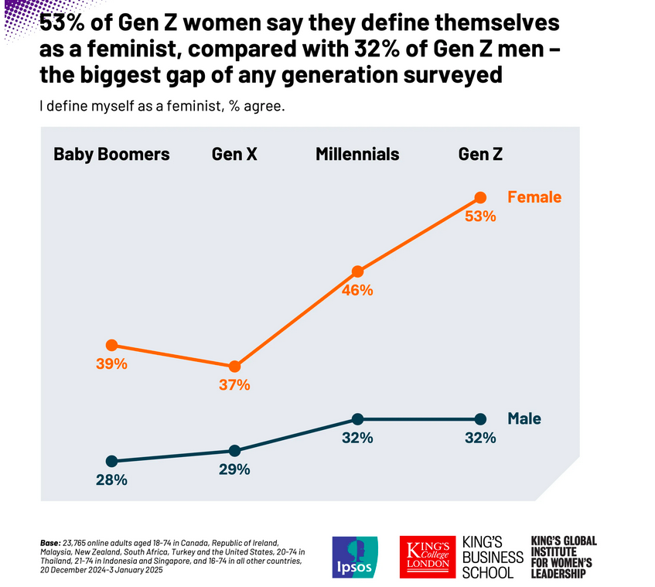
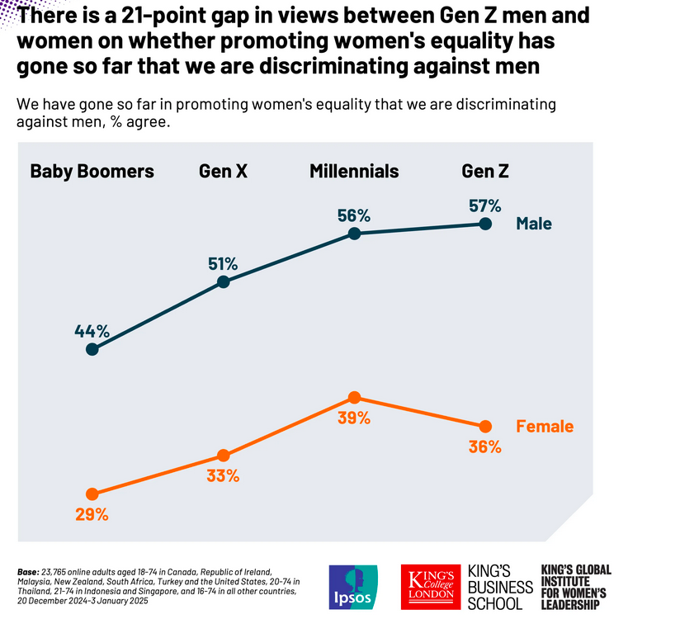

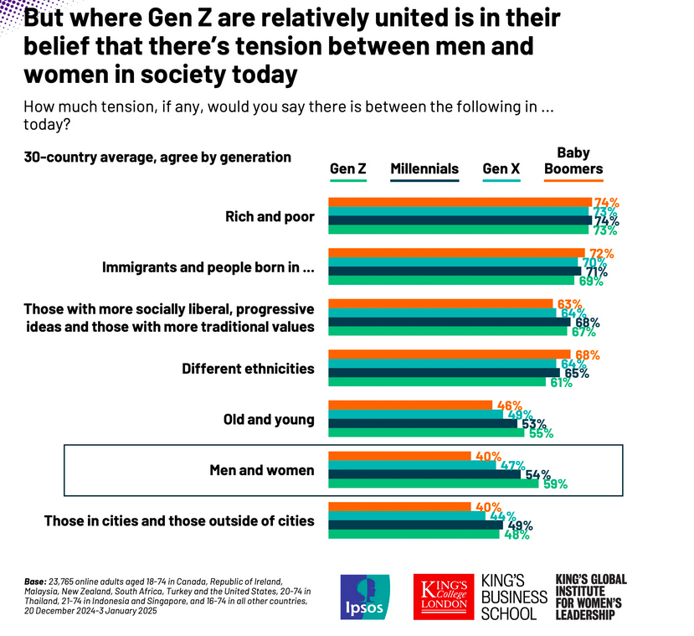

Gen Z men and women most divided on gender equality, global study shows
King's College London, 05/03/2025
Study of 24,000 people across 30 nations

Complete these sentences with the following words (which can be repeated)
BIGGEST FAR IN LEAST LESS LOWEST MOST MUCH PERCENTAGE SLIGHTLY SMALLER THAT THOSE

Men and women belonging to Gen Z are more divided than ....................... of any other generation on key questions about feminism, gender roles and women’s rights,
Who defines themselves as a feminist?
53% of Gen Z women say they define themselves as a feminist, compared with 32% of Gen Z men – a gap of 21 ....................... points.
This is the ....................... gender split among generations surveyed: Millennials are next most divided, with a 16-point gap between men and women, while the gap between Baby Boomers and Gen X is 11 points and 8 points respectively.
And Gen Z men (32%) are only ....................... more likely than men from older generations such as Baby Boomers (28%) and Gen X (29%) to see themselves as feminists.
By contrast, Gen Z women are considerably more likely to identify this way: over half (53%) see themselves as feminists – ....................... higher than the share of Baby Boomers (39%), for example.
Have we gone so far in promoting women’s equality that we are discriminating against men?
Around six ....................... 10 (57%) Gen Z men also say we have gone so far in promoting women's equality ....................... we are discriminating against men, compared with around a third (36%) of Gen Z women who hold this opinion.
This gap of 21 percentage points is larger than among any other generation surveyed, with the next biggest divide among Gen X, where the split in agreement is 18 points (51% for men vs 33% for women).
And once again, the oldest generation surveyed is in fact ....................... progressive on this question: Baby Boomers are the only cohort where ....................... than half (44%) of men think efforts to promote women’s equality have led to discrimination against men, while 29% of women in this group feel the same – the ....................... of any generation.
But where Gen Z are relatively united is in their belief that there’s tension between men and women in society today
While tension between several other groups in society – such as between rich and poor – is felt equally across generations, there is a ....................... clearer age divide in perceptions of tension between men and women in society.
Six in 10 (59%) members of Gen Z across the 30 countries surveyed say there is tension between men and women today – the most of any generation surveyed, followed by Millennials (54%). This compares with 40% of Baby Boomers, who are ....................... likely to feel such tension exists.
And majorities of both Gen Z men (55%) and women (62%) agree this is this the case, with this gap in views the same or slightly smaller than ....................... seen among older generations, indicating greater consensus between genders.

Translate these acronyms:
AI BA BSc
CEO COP DEI
DNA EU GDP
GMO GP GPU
ICC IMF IPCC
NATO NDC NGO
OPEC PhD UFO
UN WHO WTO

Quantifiers. Add the right word to complete the sentence:
AMOUNT EVERY FAR FEW ITEMS ONES
MANY MUCH NEWS NUMBER PLATFORMS
PROPORTION THESE THIS
a) A large …….....… of society uses social media.
b) …….....… politician has a social media account.
c) Fake news spreads six times faster than real …….....…
d) Seven fake news …….....… were found.
e) The…….....… of information available is incredible.
f) The …….....… of followers she has is incredible.
g) This can be found on all social media …….....…
h) There are …….....… more sociological factors.
i) There is so …….....… fake news.
j) These networks have more privacy options than the other …….....…
k) …….....… three factors are more important than anything else.
l) Fake news spreads …….....… faster than anything that is true.
m) Suprisingly, …….....… people actually use Twitter.
n) …….....… information is untrue.

2. Verb / expression + verb + ING
- to acknowledge, to avoid, to be busy, to consider (envisager de), to contemplate (envisager de)
to delay, to feel like (avoir envie de), to give up, to go on, to keep, to postpone, to regret, to resent (ne pas apprécier), to resist, to risk, to spend (time doing)
- to apologise for doing something He apologised for speaking to me like that
- to devote time to doing something He devotes too much time to studying
- I can’t help / stand / bear doing sth I can’t stand working at weekends
- to have trouble doing something I have trouble concentrating
- to insist on someone doing something I insist on you speaking in English
- to like (hate / enjoy / fancy etc) doing sth I like playing tennis
- to look forward to doing something I’m looking forward to going on holiday
- to need doing (passive meaning) This shirt needs washing
- to not mind doing something I don’t mind going to school
- to object to someone (object) doing something His mother objected to him going out
- to prevent someone from doing something They prevented me from going in
- to remember doing sth (se souvenir d’avoir fait qqch) I remember doing my homework
- to reproach someone for doing something She reproached me for going out
- to stop doing something (arrêter de faire qqch) Stop singing!
- there’s no point (in) doing something There’s no point working now
- it’s no use doing something It’s no use complaining now
- to be used to doing something I am used to working hard

1. “I’m sorry I did that.” She apologised................................................................
2. My friend didn’t want to face his problems. He avoided.....................................................
3. I can’t wait to go on holiday. I’m looking forward...............................................
4. “Please don’t smoke here,” she told them. She objected ...................................................................
5. “Your hair is too long” Your hair needs...................................................................
6. I wish I hadn’t told you that. I regret..........................................................
7. We found it hard to concentrate. We had trouble................................................
8. “You shouldn’t spend so much time on social media!” He reproached me......................................
9. They listened to music all the time. They spent their time...................................................
10. It’s stupid to doomscroll. There’s no point....................................
11. It's not a problem for me to work in a noisy environment. I don't mind .......................................
12. Can you imagine moving to another country? Would you consider ..............................................?

Translate with one of the forms above:
13. J'attends avec impatience d'avoir de tes nouvelles.
................................................................................................................................................................
14. Ils ne sont pas habitués à s'exprimer en public.
................................................................................................................................................................
15. Je ne me rappelle pas lui avoir téléphoné avant de partir.
................................................................................................................................................................
16. Ils regrettent de n'avoir pas vendu leur appartement en Espagne.
................................................................................................................................................................
17. Il est inutile d'en parler.
................................................................................................................................................................
18. Est-ce que cela te gêne de fermer la fenêtre?
................................................................................................................................................................
10/3
little / a little / few / a few?
1. They had ............................. hope of success; yet they persevered.
2. "Are there any chocolates left?" "Only ............................."
3. Only .............................of the students like math.
4. We have got ............................. meat.
5. ............................. people understand philosophy.
6. Only ............................. of us are really honest.
7. Could I try ............................. soup?
8. Could I try ............................. of your soup?
9. Only ............................. children in the class passed the test.
10 They arrived ............................. late.
11. An average politician has ............................. real power.
12. ............................. people can speak a foreign language perfectly.

3/3
1. Verb and preterite, past (and present) perfect + verb
Preterite
- I’d rather + subject + preterite I’d rather you didn’t do that
- It’s high time + subject + preterite (subjunctive) It’s high time you left home
- I wish + were (subjunctive) I wish I were rich
Present Perfect (has/have + pp)
- It’s the first/only time It’s the first time I’ve done that
Past Perfect (had + pp)
- No sooner + had + sujet + pp...than No sooner had I come in than I saw her
- If only : Why didn’t I work harder? If only I had worked harder
- I wish : regret: Why didn’t I work harder ? I wish I had worked harder
Verb + Verb
- to let someone do something My mother let me go out last night
- to make someone do something My mother made me clean my room
- modals You must go / She might have been there
- I’d rather I’d rather go to the cinema than watch tv
- to suggest someone do (subjunctive) something I suggested he listen to me carefully
- why Why go? Why not stay?

1. This issue needs to be resolved. It’s high time...................................................................
2. It would be great to know the answer. I wish I..................................................................
3. Presidents acted this way before. It's not the first time presidents.....................................................
4. “Why didn't the other party win? ” If only ..................................................................
5. "I'd prefer this not to happen." I'd rather ..................................................................
6. "You should smoke less! " she told him. She suggested..................................................................
7. "Could I leave early?". "Will you let...................................................................?"
8. "If only you were here!" I wish you ..................................................................
9. Nobody forced you to buy cryptocurrency. Nobody made ..............................................................
10. It is possible that they were here last night. They might..................................................................
11. We should regulate social media. Why ..................................................................?
12. Many Britons regret voting for Brexit. They wish..................................................................

Translate with MAKE SOMEONE V or MEAN THAT
13. Cela peut nous faire penser au troisième document.
................................................................................................................................................................
14. Il a plusieurs raisons qui font que cela ne soit pas possible.
................................................................................................................................................................
15. Donald Trump fait parler de lui.
................................................................................................................................................................
16. Les réseaux sociaux ont fait augmenter les problèmes de dépression chez les jeunes.
................................................................................................................................................................
17. Elle m'a fait relire la lettre.
................................................................................................................................................................
18. La crise de la dette a fait que certaines promesses n'ont pas été tenues.
................................................................................................................................................................

A Chinese AI startup, DeepSeek, has released an open-sourced problem-solving model, R1, that’s wowed Silicon Valley. The model uses far less computing power and far fewer chips – therefore far less money, roughly 3-5% of the development costs for ChatGPT – to achieve the same or better results as its US counterparts.

The model is open-source, which has allowed engineers outside of China to audit its parent company’s claims. Venture capitalist Marc Andreessen, who is advising the Trump White House, called R1 “AI’s Sputnik moment”, a bona fide breakthrough. The global AI community widely considered the US the leader in AI, but R1 has called that dominance into question.

DeepSeek’s training, done with tens of thousands of Nvidia’s chips, may also undermine the effectiveness of the US’s AI-focused trade embargoes on China. The sale of the company’s products in China are strictly regulated, but DeepSeek was able to secure about 50,000 graphics processing units (GPUs) anyway, per VentureBeat. That’s a far cry from the roughly 500,000 that OpenAI is reported to use, though. Another complicating factor: trade restrictions take effect over long periods of time, so they may not have impinged on DeepSeek’s work.

Since DeepSeek was able to create such a promising product with a fraction of the resources other AI companies use, perhaps demand for chips will not be as sky-high as investors once believed. Nvidia, the greatest beneficiary of the AI boom, saw its stock slide by multiple percentage points on Monday, which erased hundreds of billions in market cap.

The tech sector saw its share prices decline, giving rise to fears of a wider sell-off. Utility companies are tied up in the AI boom as power demands for data centers grow. If a company can achieve the same result with fewer chips and therefore fewer data centers, demand for electricity may not rise so much that nuclear power plants need to be restarted. [...]
Techscape, The Guardian, 28/1/25

1. According to the text, how does the release of DeepSeek threaten American dominance of AI?
2. In your opinion, what challenges does AI pose in terms of international relations?

Cela faisait cinq ans qu'elles ne s'étaient pas vues. Jusqu'à leur dernier déjeuner. Il était à peine huit heures, Alice sortait de sa douche quand le téléphone avait sonné. Elle avait jeté un regard distrait sur l'écran et hésité à répondre en voyant s'afficher un numéro qu'elle ne connaissait pas.
- Alice? C'est Cécile.
Elle ne disait plus : « C'est moi », mais « Cécile ». Un prénom qu'Alice avait retiré de son répertoire. Aurait-elle répondu si elle avait su qui appelait ?
- Il faut que je te voie, que je te parle, c'est très important, enfin ça l'est pour moi. Aujourd'hui, si tu as un moment.
- Qu'est-ce qui se passe ? C'est grave ? Je ne peux pas aujourd'hui.
- Tu ne peux pas t'arranger ?
Alice s'arrangea. Elles avaient convenu de se retrouver pour le déjeuner dans un restaurant que Cécile avait choisi. Alice était paisible en se rendant au rendez-vous et s'en étonna. Elle ne put s'empêcher d'alerter ses sœurs, comme si leur dire allégeait la rencontre, en faisait une anecdote parmi d'autres. Elle ne prévint pas son mari. David était déjà parti au bureau et lui aurait conseillé de ne pas y aller. Kéthévane Davrichewy Davrichachvili, Les Séparées, 2011.

They ....................................... (not see) each other for five years. Not until they ....................................... (have) that last lunch together. It ....................................... (be) only just eight when the telephone ....................................... (ring) and Alice ....................................... (just get out) of the shower. She ....................................... (glance) casually at the screen and ....................................... (hesitate) before answering the call, seeing an unfamiliar
number on display
“Alice? It’s Cécile.”
She no longer ....................................... (say), “It’s me” but “It’s Cécile”, a name Alice ....................................... (remove) from her contact list. ....................................... (she answer) the phone if she ....................................... (know) who was calling?
“I must see you, talk to you. It’s vitally important. At least it is for me. Today, if you have a moment
“What’s up? Is it serious? Today I can’t.”
“Can’t you manage it?"
It turned out Alice could. They had arranged to meet for lunch in a restaurant
that Cécile ....................................... (choose). Alice ....................................... (feel) relaxed as she made her way to her appointment, which ....................................... (surprise) her. She could not help informing her sisters about it, as though telling them would make the meeting easier, just a topic among others. She ....................................... (not tell) her husband though. David ....................................... (already leave) for the office or else, he would have advised her not to go.

