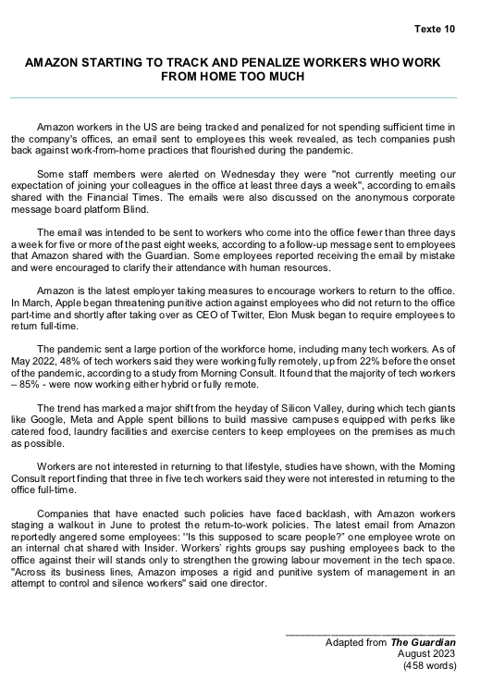
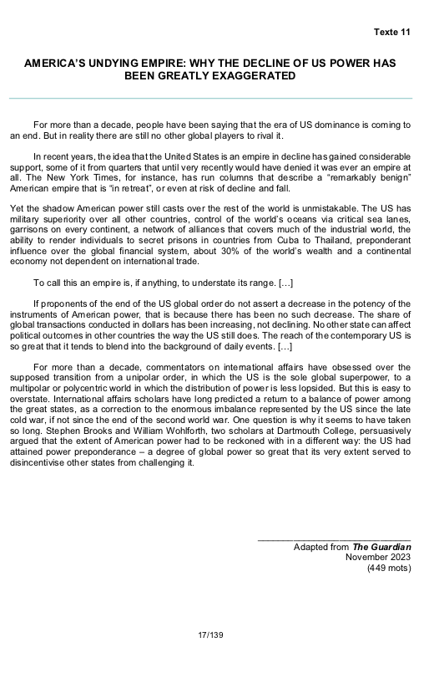
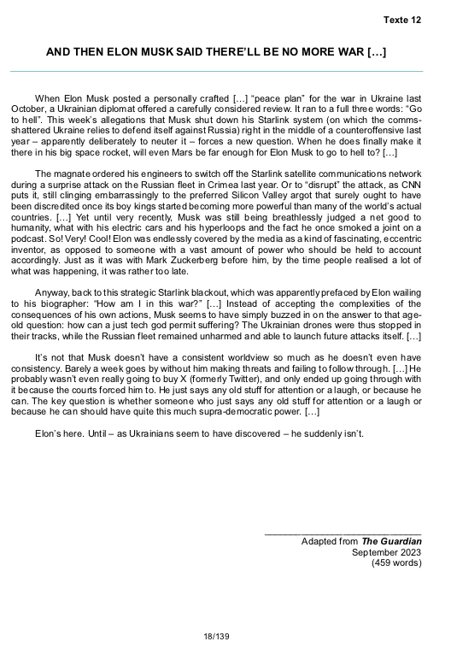
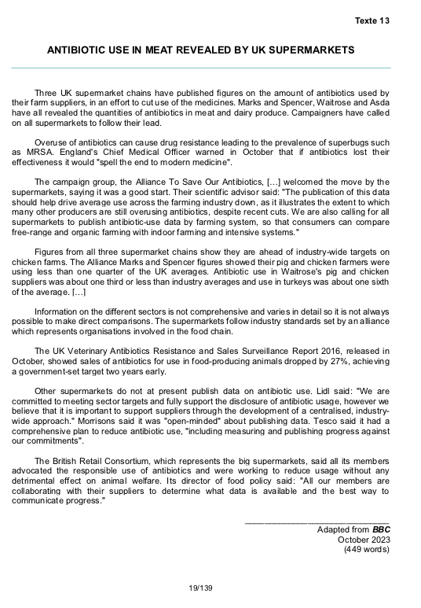
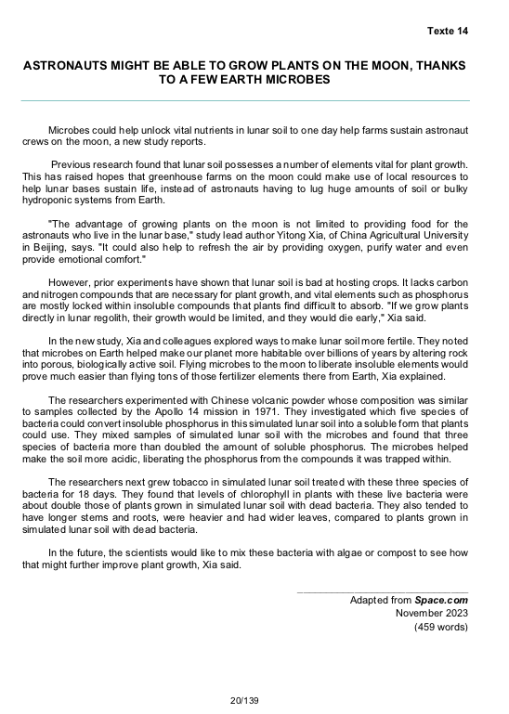
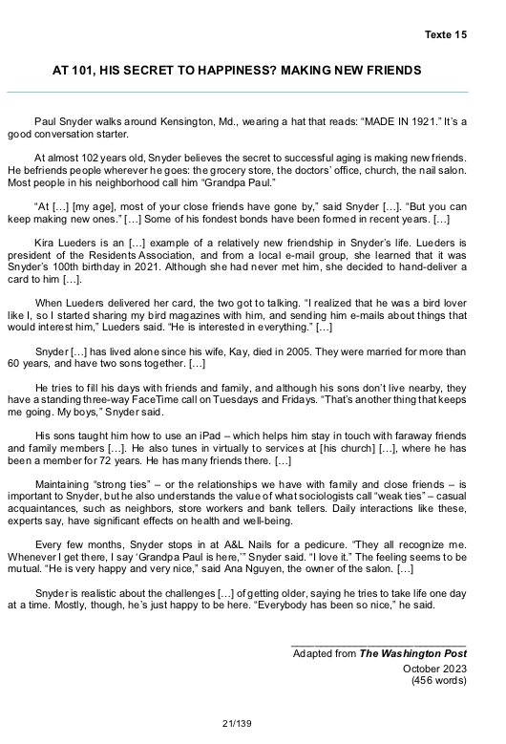
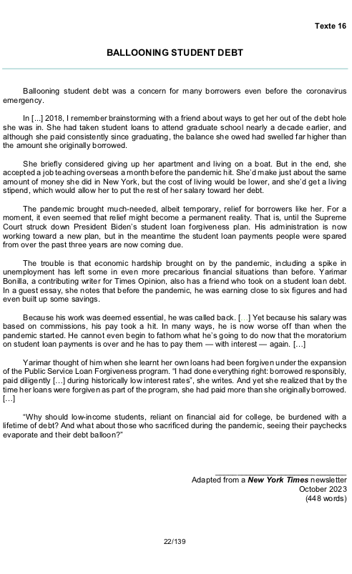

BIKE RIDING AND MENTAL HEALTH
Middle school is a good time to encourage kids to embrace the benefits of bike riding, according to Outride, a nonprofit which promotes cycling at school. Teaching middle schoolers bike riding skills as part of physical education classes may help improve their mental health. That's according to a new study that looked at the effects of a 6-8 week cycling class taught in schools across the U.S.
The mental health benefits of exercise are well-documented. And anyone who's lived through middle school knows those years can be particularly challenging. The new study comes at a time when research shows that youths across the U.S. are struggling with mental health.
The study involved more than 1,200 students, aged 11 to 14, enrolled in middle schools across the U.S. that offered a program called Ride for Focus from the nonprofit Outride, which conducts research and provides cycling programs and equipment for youths – primarily middle schoolers.
Students participated in a cycling class for at least three days a week, for a minimum of 6 weeks. They learned cycling safety and maneuvering skills outdoors while raising their heart rate and just having fun. The students completed standardized screening questionnaires before and after the program designed to measure their well-being.
Middle school is a good time to encourage kids to embrace the benefits of bike riding, because they're starting to experience all sorts of social pressures, anxiety, stress from school, stress from home. So it's a really important time to provide additional outlets to explore not only physical activity, but also the freedom and relief that can come with going out for a bike ride during the day.
Exercise in general is "the most evidence-based, cheapest form of prevention and intervention that human beings can do for their mental health," says a professor of psychiatry and pediatrics at Stanford University School of Medicine.
While many forms of moderate-intensity exercise offer brain benefits, aspects of cycling give it a leg up on other physical activities, he says. "It engages all of these other parts of brain function, such as sensory perception," Reiss says. "You are looking at your hearing, you're balancing, you're navigating and turning. Oftentimes, you're doing it with someone else, so there's the positive effect of company or group activity."
Of course, while exercise has powerful mental health benefits, it's not a panacea. For example, research has shown that adolescent girls are at higher risk of mental health problems like depression and anxiety than boys... The study found that adolescents who didn't limit screen time to a maximum of two hours a day, or who got less than the recommended 8.5 hours of sleep, saw less improvement in their well-being.
______________________________ Adapted from NPR October 2023
(451 words)

BINARY THINKING — RIGHT FOR COMPUTERS, WRONG FOR US
George Boole made a profound contribution to today’s technological society, but one can also argue that he helped to entrench a damaging way of thinking that permeates our society. One of his prevailing contributions came in his 1854 book, entitled ‘’An Investigation of the Laws of Thought’’, which introduced what we now know as the ‘’Boolean algebra’’ which is crucial to computers. In this book, Boole applied the systematic language of algebra to the field of logic — a unification of two disparate fields which created a much more powerful one which is based on the simple idea that statements are either true or false. [...]
What was so unexpected then, is that “true”, “false” and a few simple logical operations such as “and”, “or” and “not” can be combined to make an equation that can add, multiply, compare, remember and do much more.
Indeed, 80 years later, Alan Turing — the British mathematician who developed the first electronic computer — proved that you only needed these simple operations to compute absolutely anything. From the great simplicity of binary logic, we have built the most complex of machines that is developing today into Artificial Intelligence.
However, this same attractive simplification is commonly behind poor decisions in other fields. We should not really blame Boole. Human nature has always tried to reduce the world to binary choices and states such as, for example, good and evil... But Boole gave strength to such thinking at a time when seemingly exact laws of physics promised to make the universe simple and predictable. [...]
But now, what seems limitless in computing raises issues in real life since the problem with binary thinking is that it leads to binary decision-making... [...] And binary decision-making may certainly make it easier to quickly direct people to a common goal, but it may fail to give the high- quality solutions we may need in the long term. For example, solving a waiting-time problem in the accident and emergency department may prove detrimental to the quality of response and care. [...]
So we need to improve our decision-making... Rather than use modern computing that reduces complexity to the point that all problems can be solved in a few seconds by a binary program, we need to be aware that the real world is not like that. We need to accept that practical problems do not necessarily have a single correct answer. Just as Boole combined mathematics and logic, we need to combine the power of computers with our natural intuition for a nuanced world.
Ultimately, is Boole the hero or villain of this story? He is neither... He’s something in between.
______________________________ Adapted from the Financial Times October 2023 (449 words)

Texte 20 BIRD FLU: SCIENTISTS SEE GENE EDITING HOPE FOR IMMUNE CHICKENS
Researchers have developed gene-edited chickens that are partially resistant to bird flu. Although the birds are not completely immune, the scientists say their work shows it might be possible to block the virus in three years. The latest results suggest that making further changes to the birds' DNA could produce fully immune chickens. Critics say gene editing tackles the symptoms of high-density farming rather than the root cause of animal diseases.
One professor from the University of Edinburgh said the team had made significant progress. "We have got to the point where the results are very encouraging and we want to take this approach further."
The recent spike in bird flu has been particularly harmful to protected seabird species like gannets. The researchers identified three genes they believed were important for the bird flu (formally known as avian influenza) virus to reproduce in the chickens. They made two small changes to one of the genes using a technique known as gene editing.
The resulting chickens had no side effects after two years. They also had increased resistance to bird flu, but were not fully immune: half the chickens infected with a high dose of the virus developed an infection.
Although any increase in resistance to bird flu should be welcome, only a solution that provides complete immunity can be used in practice. Any intervention that develops partial resistance would also encourage the virus to change in order to fight back and so, if the intervention were widely used, it would slightly increase the risk of another human global pandemic if a mutation made the virus deadly to humans.
Another professor from the same institute told BBC News that experiments in test tubes showed if changes are made to all three genes, then a fully resistant bird might be possible. "When we did these edits in the cells there was no growth of the virus at all. The changes stopped all replication of the flu. I am extremely confident that editing the three genes will give full immunity."
Gene editing involves making precise changes to DNA to change the function of a gene. In this instance the three genes were altered to stop them helping bird flu reproduce, but in a way that did not harm the bird.
The researchers are trying to identify the further genetic changes required, before producing gene-edited chickens for the next phase of their research.
Bird flu is a major global threat, with a devastating impact in both farmed and wild bird populations. In the UK alone, the current outbreak of H5N1 bird flu has decimated seabird populations and cost the poultry industry more than £100 million in losses.
______________________________ Adapted from BBC October 2023
(448 words)

