Synthesis PSI 18 December 2024 400-500w

Document 1

A String of Supreme Court Decisions Hits Hard at Environmental Rules

*Four cases backed by conservative activists in recent years have combined to diminish the power of the Environmental Protection Agency.*

A spate of decisions over the past two years by the Supreme Court has significantly impaired the Environmental Protection Agency’s authority to limit pollution in the air and water, regulate the use of toxic chemicals and reduce the greenhouse gasses that are heating the planet. This term, the court’s conservative supermajority handed down several rulings that chip away at the power of many federal agencies. But the environmental agency has been under particular fire, the result of a series of cases brought since 2022 by conservative activists who say that E.P.A. regulations have driven up costs for industries ranging from electric utilities to home building. Those arguments have resonated among justices skeptical of government regulation. (...)

“This court has shown an interest in making law in this area and not having the patience to wait for the cases to first come up through the courts,” said Kevin Minoli, a lawyer who worked in the E.P.A.’s office of general counsel from the Clinton through the Trump administrations. “They’ve been aggressive on ruling. It’s like, we’re going to tell you the answer before you even ask the question.” Collectively, those decisions now endanger not only many existing environmental rules, but may prevent future administrations from writing new ones, experts say. “These are among the worst environmental law rulings that the Supreme Court will ever issue,” said Ian Fein, a senior attorney with the Natural Resources Defense Council, an advocacy group. “They all cut sharply against the federal government’s ability to enforce laws that protect us from polluters.” (...)

President Biden has pledged that the United States will cut its carbon dioxide pollution in half by 2030 and eliminate it by 2050, which scientists say all major economies must do if the world is to avoid the most deadly and costly impacts of climate change. This year, the E.P.A. has rushed to finalize new rules to slash pollution from cars, trucks, power plants and methane leaks from oil and gas wells. If he wins a second term, Mr. Biden wants to cut emissions from steel, cement and other heavy industries that have never been required to reduce their planet-warming emissions. But the string of recent losses before the Supreme Court could make it difficult for the E.P.A. to follow through on those plans. (...)

The nation’s bedrock environmental laws, the Clean Air Act and the Clean Water Act, were both written more than 50 years ago, before the effects of climate change and a global economy that has reshaped the environmental and economic landscape. Since then, Congress has passed one major law to address climate change, the 2022 Inflation Reduction Act. It includes more than $370 billion in incentives for clean energy technologies, including wind and solar power and electric vehicles. Climate experts call it a strong first step in cutting the nation’s emissions, but say that far more is needed to eliminate them entirely in the next 25 years. “The agencies for more than 30 years have needed to use old, existing laws to deal with new environmental problems,” said Michael Gerrard, director of the Sabin Center for Climate Change Law at Columbia University. “And this new court is now making that extraordinarily difficult. Unless Congress is extremely specific, agencies can’t act. But since Congress is largely immobilized, this in turn freezes what they can do.” (...)

Coral Davenport, *The New York Times*, June 29th, 2024

Document 2

Renewable Energy Is Charging Ahead

*Renewable energy has seen considerable growth in recent years, but there is a long way to go to achieve a clean energy future that averts the worst effects of the climate crisis*

Humanity is at a crossroads in choosing the way we will power our future. Depending on what electricity infrastructure we build now, we could lock in still more decades of planet-warming emissions, or we could lay a solid foundation for a clean energy future and stave off the climate emergency’s worst effects. The choice is an urgent one because the window is quickly closing on our ability to meet the goal of the 2015 Paris climate agreement: keeping global temperature rise well below two degrees Celsius by the end of the century. The latest report from the Intergovernmental Panel on Climate Change (IPCC) stressed that the world needs fast and deep emissions cuts to meet that goal and eventually reach net zero emissions by 2050. Switching to renewable forms of power generation, such as solar, wind and hydropower, will be a key component of that effort. (...)

Globally, renewables account for about one third of electricity generation—and that share is rising. In 2022 renewable generation capacity grew by a record 295 gigawatts, according to the International Renewable Energy Agency (IRENA). Further, renewables accounted for more than 80 percent of all added power capacity last year, the agency reported. Last year renewables produced more electricity than coal-powered plants for the first time in the U.S. Wind and solar now produce about 14 percent of the country’s electricity, up from virtually nothing just 25 years ago. (...) The main reason renewable energy has grown so much in recent years is a dramatic decline in the expense of generating solar and wind power. The cost of solar photovoltaic cells has dropped a stunning 90 percent over the past decade, partly because of ramped-up manufacturing—particularly in China—Bahar says. (...)

But the current rate of renewable adoption is still far below what is needed to meet climate goals. Though global renewables capacity grew by 9.6 percent last year, IRENA says the capacity needs to grow at triple that rate to meet the Paris climate goals. And as other sectors such as manufacturing and transportation decarbonize, electricity needs will only increase. There are obstacles to accelerating the rate of adopting renewables, though. For one, solar and wind are intermittent power sources, meaning they need to be deployed with batteries or other types of energy storage; this can increase costs. Photovoltaic cells, as well as the lithium-ion batteries that are today’s key storage technology, also require critical (and sometimes relatively rare) minerals to produce them. Demand for these resources could outpace supply and create a future production bottleneck, Azevedo says. (...)

Financing is also an issue. Even though the overall costs of renewables have come down, “you need to invest everything upfront,” Bahar says, “which means that financing cost and risk management is extremely important.” Financing is particularly an issue in the equitable deployment of renewables. The U.S., Europe, India and China account for 80 percent of new renewables capacity. And “85 percent of investments in renewables has benefitted only 50 percent of the global population,” primarily in the world’s largest economies, says Roland Roesch, acting director of IRENA’s Innovation and Technology Center. He adds that multinational development banks (a key funding source for projects in developing countries) must support developing countries in adopting renewable projects—and that this could be done by addressing the upfront costs, as well as the added risk that can come from political instability in some places. “The last mile of net zero is the most difficult one,” Bahar says. “So it has to include everybody.”

Andrea Thomson, *Scientific American*, April 23rd, 2023

Document 3

*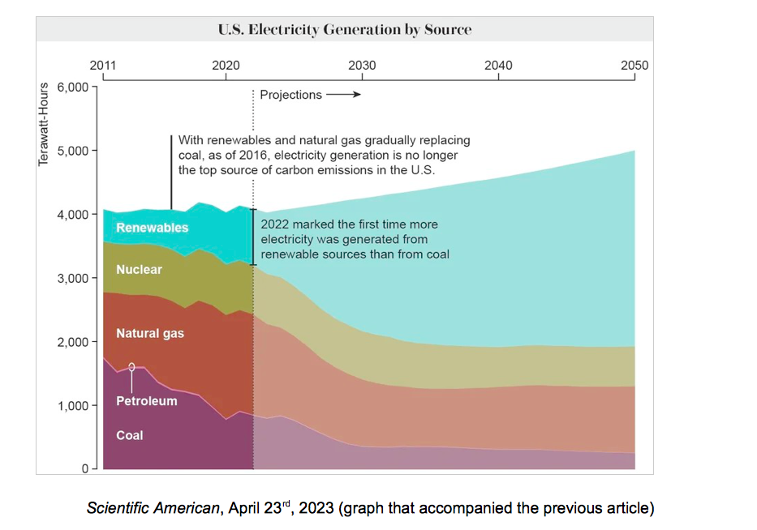*

Document 4

From Amanda Gorman "Earthrise", 2018

[...] Climate change is the single greatest challenge of our time,

Of this, you’re certainly aware.  
It’s saddening, but I cannot spare you  
From knowing an inconvenient fact, because  
It’s getting the facts straight that gets us to act and not to wait.

So I tell you this not to scare you,  
But to prepare you, to dare you  
To dream a different reality,

Where despite disparities  
We all care to protect this world,  
This riddled blue marble, this little true marvel  
To muster the verve and the nerve  
To see how we can serve  
Our planet. You don’t need to be a politician  
To make it your mission to conserve, to protect,  
To preserve that one and only home  
That is ours,  
To use your unique power  
To give next generations the planet they deserve. [...]