**DS Anglais**  11/01/25

Indiquer en début de devoir le sujet retenu et sauter des lignes.

**1. CCINP (3h)**

Rédiger en anglais et en 400 mots une synthèse des documents proposés, qui devra obligatoirement comporter un titre. Vous indiquerez impérativement le nombre total de mots utilisés (titre inclus) et vous aurez soin d'en faciliter la vérification en mettant un trait vertical tous les vingt mots. Des points de pénalité seront soustraits en cas de non-respect du nombre total de mots utilisés avec une tolérance de ± 10 %. Concernant la présentation du corpus dans l'introduction, vous n'indiquerez que la source et la date de chaque document. Vous pourrez ensuite, dans le corps de la synthèse, faire référence à ces documents par « doc.1 », « doc. 2 », etc.

Ce sujet comporte les 4 documents suivants, qui sont d’égale importance :

DOCUMENT 1 : un article de Martin Enserink paru dans *Science* en février 2023

DOCUMENT 2 : un article d’Ivan Oransky et Adam Marcus paru dans *The Guardian* le 9 août 2023

DOCUMENT 3 : deux graphiques parus dans *The Economist* le 22 février 2023

DOCUMENT 4: un article de Liam Mannix paru dans *The Sydney Morning Herald* le 27 juin 2023

**2. Centrale (4h)**

Rédiger en anglais et en 500 mots une synthèse des documents proposés, qui devra obligatoirement comporter un titre. Indiquer avec précision, à la fin du travail, le nombre de mots utilisés (titre inclus), un écart de 10 % en plus ou en moins sera accepté.

DOCUMENT 1 : un article de Martin Enserink paru dans *Science* en février 2023

DOCUMENT 2 : un article d’Ivan Oransky et Adam Marcus paru dans *The Guardian* le 9 août 2023

DOCUMENT 3 : deux graphiques parus dans *The Economist* le 22 février 2023

DOCUMENT **5** : un extrait du roman d’Allegra Goodman *Intuition* publié en 2007

L’ordre dans lequel se présentent les documents est arbitraire et ne revêt aucune signification particulière.

**3. X-ENS (4h)**

**PREMIERE PARTIE (A)**

**SYNTHESE DE DOCUMENTS**

Contenu du dossier : trois articles et un document iconographique, qui sont numérotés 1, 2, 3 et 4.

Sans paraphraser les documents proposés dans le dossier, le candidat réalisera une synthèse de celui-ci, en mettant clairement en valeur ses principaux enseignements et enjeux dans le contexte de l’aire géographique de la langue choisie, et en prenant soin de n’ajouter aucun commentaire personnel à sa composition.

La synthèse proposée devra comprendre entre 600 et 675 mots et sera rédigée intégralement dans la langue choisie. Elle sera en outre obligatoirement précédée d'un titre proposé par le candidat.

**SECONDE PARTIE (B)**

**TEXTE D'OPINION**

En réagissant aux arguments exprimés dans cet article (document numéroté 6), le candidat rédigera lui-même dans la langue choisie un texte d'opinion d'une longueur de 500 à 600 mots.

**Document 1**

**Journal declines to retract fish research paper despite fraud finding**

Martin Enserink*, Science*, February 2023

*The Proceedings of the Royal Society B: Biological Sciences* says it will not retract a paper on anemone fish behavior even though a lengthy university investigation found it was made up.

An independent investigative panel at the University of Delaware (UD) concluded last year in a draft report that “discrepancies and issues” with the 2016 study “constitute fabrication.” But the journal said in an editor’s note on 1 February that its own investigation did not turn up enough evidence of fraud, in part because a correction by the authors had solved the paper’s key problem.

Fish physiologist Timothy Clark of Deakin University, part of an international group of whistleblowers that found problems with the paper, calls the decision “infuriating.”

The paper, authored by marine ecologists Danielle Dixson of UD and Anna Scott of Southern Cross University in Australia, is one of 22 studies published between 2008 and 2018 that Clark and his fellow whistleblowers have claimed are fraudulent. The complaint focused in particular on Dixson and Philip Munday, Dixson’s Ph.D. supervisor at James Cook University in Australia. Both have denied wrongdoing.

An independent panel at UD that investigated Dixson’s work was “struck by a serial pattern of sloppiness, poor recordkeeping, copying and pasting within spreadsheets, [and] errors within many papers under investigation,” according to a heavily redacted draft report obtained by *Science*. It also concluded that several papers involved research misconduct. UD said it has asked journals to retract three papers.

For one of those, published in *Science* in 2016, Dixson did not have enough time to carry out the massive number of experiments described in the paper, the panel wrote, and an Excel file purportedly containing the study’s raw data contained more than 100 inexplicable duplications that showed it could not be real. *Science* retracted the paper in August 2022.

The *Proceedings B* paper suffered from similar timeline issues, according to the panel. The paper’s conclusion—that anemone fish can “smell” whether coral reefs are bleached or healthy—was based on a series of experiments in which fish are placed in a laboratory apparatus called a choice flume that forces them to decide which direction to swim.

Dixson collected the data for the study, which involved some 1800 individual trials, each 9 minutes long, according to the draft report. If she used a single flume, completing the trials would have taken 22 12-hour days. But the paper said the experiments ran from 12 to 24 October 2014, a period of just 13 days. Scott and Dixson posted a correction to the paper in July 2022, in which they said the experiments actually took place over 33 days, between 5 October and 7 November 2014.

One of the whistleblowers, Josefin Sundin of the Swedish University of Agricultural Sciences, says the journal appears to have been too credulous in running the correction. “Why would anyone run an experiment for 33 days but by mistake write the methods and data as if it was conducted during 12 days?” she asks. “That is a very large discrepancy.”

Along with the correction, Dixson and Scott also uploaded the raw data for the study, which had been missing even though the paper stated it was available online. That data set “raised a second set of issues,” according to the editor’s note. This apparently refers to an analysis of the Excel file by the whistleblowers showing that it suffered from some of the same problems as the one for the Science paper, including duplication of data across columns and numbers that did not add up correctly.

But the journal’s investigation found there were other possible explanations for any suspicious patterns, and that some problems with the data “are more likely the result of mistakes or poor data curation, and their correction would not change the conclusions,” according to the note.

**Document 2**

**OPINION: There’s far more scientific fraud than anyone wants to admit**

Ivan Oransky and Adam Marcus, *The Guardian*, 9 August 2023

Scientific misconduct has enjoyed some limelight lately. The president of Stanford, Marc Tessier-Lavigne, resigned last month after a series of investigations exposed serious problems in his research; an independent review of Tessier-Lavigne’s work found no evidence that he falsified data himself but concluded that his research failed standards “of scientific rigor and process” and that he failed to correct the record on multiple occasions.

And in June it was revealed that a scholar at Harvard Business School, Francesca Gino, was accused of having falsified research about – wait for it – honesty.

Of course, scientific misconduct does not happen only at Stanford and Harvard. Of the nearly 5,500 retractions we catalogued in 2022, and the thousands of cases we have reported on since launching our watchdog website Retraction Watch in 2010, the vast majority involve researchers at institutions without anywhere near Stanford and Harvard’s pedigrees.

The number of retractions each year reflects about a tenth of a percent of the papers published in a given year – in other words, one in 1,000. Yet the figure has grown significantly from about 40 retractions in 2000, far outpacing growth in the annual volume of papers published.

Retractions have risen sharply in recent years for two main reasons: first, sleuthing, largely by volunteers who comb academic literature for anomalies, and, second, major publishers’ (belated) recognition that their business models have made them susceptible to paper mills – scientific chop shops that sell everything from authorships to entire manuscripts to researchers who need to publish lest they perish.

These researchers are required – sometimes in stark terms – to publish papers in order to earn and keep jobs or to be promoted. The governments of some countries have even offered cash bonuses for publishing in certain journals. Any surprise, then, that some scientists cheat?

The truth is that the number of retractions in 2022 – 5,500 – is almost definitely a vast undercount of how much misconduct and fraud exists. We estimate that at least 100,000 retractions should occur every year; some scientists and science journalists think the number should be even higher. (To be sure, not every retraction is the result of misconduct; about one in five involve cases of honest error.)

The lengths to which scientists go to fight allegations of fraud is part of the reason the rate of retraction is lower than it should be. They punish whistleblowing underlings, sometimes by blaming them for their misdeeds. They sue critics. Although they rarely prevail in court, the threat of such suits, and the cost of defending against them, exerts a chilling effect on those who would come forward.

Journals and publishers also fail to do their part, finding ways to ignore criticism of what they have published, leaving fatally flawed work unflagged. They let foxes guard the henhouse, by limiting critics to brief letters to the editor that must be approved by the authors of the work being criticized. Other times, they delay corrections and retractions for years, or never get to them at all.

One of the main reasons scientists feel pressure to cut corners or fudge data is because funding rates are so low. The US National Institutes of Health last year approved about 20% of applications for new grants. And that’s a marked increase from recent years.

Funding to detect and sanction fraud should be a reasonable fraction of the dollars being spent – instead of mere millions in a sea of tens of billions. Until publishing papers is decoupled from earning funding and employment, however, it’s difficult to imagine how much will change.

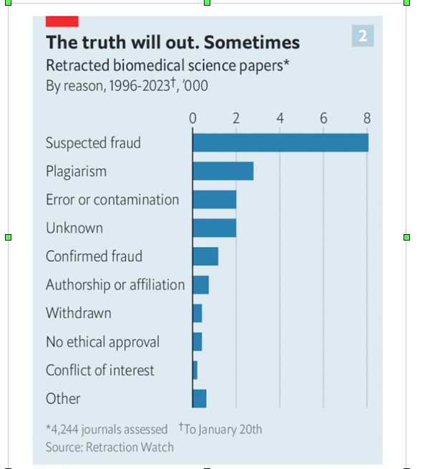**Document 3** *The Economist*, 22 February 2023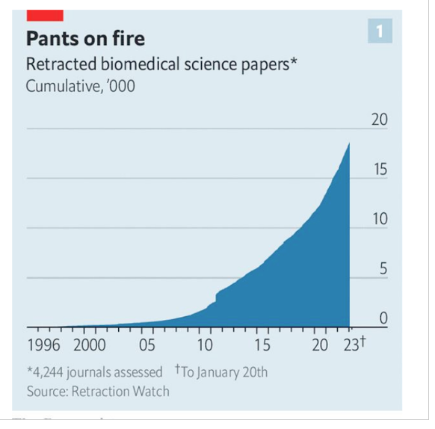

**Document 4**

**‘I lose sleep at night’: Experts fight to expose science fraud in Australia**

Liam Mannix, *The Sydney Morning Herald*, 27 June 2023

A leading scientist behind a bid to track scientific fraud and misconduct in Australia hopes it will shine a light on the issue.

Online tool Retractions Australia is tracking scientific papers that have been retracted – or pulled – by peer-reviewed journals.

It is backed by leading research institute Neuroscience Research Australia and already has about 500 entries drawn from a database maintained by the US-based Centre for Scientific Integrity

Retractions and scientific misconduct, once thought to be extremely rare, have come into sharp focus over the past decade as scientists have discovered more cases.

Ivermectin gained prominence as a treatment for COVID-19 based on a large number of fraudulent studies, some researchers argue.

One estimate suggests about one in every 50 published papers has evidence of deliberate manipulation; other scientists have even gone as far as claiming “most published research findings are false”.

Professor Simon Gandevia, deputy director of Neuroscience Research Australia and one of Australia’s most senior scientists, founded Retractions Australia after having increasingly strong concerns about the direction of the country’s research establishment.

“I thought I was part of a river that was going in the right direction. But it is totally clear now there are major forces that are distorting all that. I lose sleep at night,” he said.

The new project was welcomed by the Association of Australian Medical Research Institutes on Monday. “Research integrity is the cornerstone of ensuring quality scientific work,” a spokeswoman said. “The Australian public are now able to see with more reliability when scientists review work, which will help them understand the lengths scientists will go to to constantly verify and validate results.”

Rather than making innovative breakthroughs, modern scientific careers tend to depend more on publishing papers in scientific journals – a process nicknamed “publish or perish”.

That encourages researchers to pump out studies and push the boundaries of accuracy.

In recent years, a thriving “paper mill” industry has also taken hold in certain countries, allowing academics to pay to be listed as an author on a paper.

In Australia, research misconduct is policed by a scientist’s own institution – creating an incentive for things to be swept under the rug.

**Document 5 (Centrale)**

Marion sat in her office, staring at the chromatograms on her desk. Cliff's work had been so flawless, so remarkably consistent. That was part of what had impressed her from the beginning. And yet, now that she'd seen the original lab notebooks, she couldn't unsee what had been erased: faint scratch marks where the real numbers had been. Was it deliberate? Or had he just cleaned up messy raw data? There were so many questions. She thought back to the presentation Cliff had given to the lab. His confidence had been magnetic. But now, she wondered—had he been performing for them all along?

She glanced at the clock. If she raised her suspicions to the lab directors, she’d be accusing him of fraud. If she said nothing, she'd be complicit if the fraud was discovered later. Either way, someone’s career—maybe her own—was about to be destroyed.

*Intuition*, Allegra Goodman, 2007

**Document 6 (X-ENS, seconde partie)**

**Retractions are part of science, but misconduct isn’t — lessons from a superconductivity lab**

Editorial, *Nature*, 24 April 2024

Research misconduct is hugely detrimental to science and to society. Defined as “fabrication, falsification, or plagiarism in proposing, performing, or reviewing research, or in reporting research results” by the US Office of Research Integrity, it violates trust in science and can do great harm to the wider public, scientific institutions and especially co-authors and students who had no part in the wrongdoing. In cases involving public funds, it squanders resources that could have been allocated to other research and it can erode lawmakers’ support for science.

Does the scientific community, as a whole, have appropriate processes for reporting, investigating and communicating about instances of potential misconduct? This question is not new. At *Nature*, we’re asking it again, after two separate studies that we published were subsequently retracted.

The studies were originally published in October 2020 and March 2023. The first was retracted in September 2022 and the second in November 2023. The corresponding author on both papers was Ranga Dias, a physicist studying superconductivity at the University of Rochester in New York, and a recipient of grants from the US National Science Foundation (NSF).

The papers by Dias and his co-authors claimed to report room-temperature superconductivity under extremely high pressures, each in different materials. Room-temperature superconducting materials are highly sought after. They could, for example, transform the efficiency of electricity transmission, from the smallest to the largest application. But high-pressure experiments are difficult and replicating them is complex. [...]

What can journal editors, funding organizations and institutions that employ researchers learn from such cases? We have the same goal: producing and reporting rigorous research of the highest possible standard. And we need to learn some collective lessons — including on the exchange of information. [.[

Some researchers have asked why *Nature* published Dias’s second paper in March 2023, when questions were being asked about the first one. Others have asked why the retraction notices didn’t spell out that there has been misconduct.

It’s important to emphasize that it’s *Nature*’s editorial policy to consider each submission in its own right. Second, peer review is not designed to identify potential misconduct. The role of a journal in such situations is to correct the scientific literature; it is for the institutions involved to determine whether there has been misconduct, and to do so only after the completion of due process, which involves a systematic evaluation of primary evidence, such as unmodified experimental data.

Access to raw data is fundamental to resolving cases of potential misconduct. It is also something we constantly think about in relation to publishing. Indeed, for certain kinds of data, *Nature* requires authors to deposit them in external databases before publication. But there must be more the research community — including funders and institutions — can all do to incentivize data sharing.

Another question is whether the matter could have been dealt with more quickly. *Nature*’s editors have been asking the same question: specifically, could there have been more, or better, communication between journals and institutions once evidence of potential misconduct came to light? Publish, and be damned...

Last month, the Committee on Publication Ethics (COPE), a non-profit organization that represents editors, publishers and research institutions, updated its guidelines on how publishers and universities could communicate better. The guidelines are full of important advice, including that institutions, not publishers, should perform integrity or misconduct investigations. Investigators require access to primary evidence. As employers and grant-givers, institutions are the appropriate bodies to mandate access to unmodified experimental data, correspondence, notebooks and computers and to interview relevant staff members — all essential parts of an investigation.[...]

This case is not yet closed. Both the university and the funder need to formally announce the investigation’s results, and what action they intend to take. They should not delay any more than is necessary. When there is credible evidence of potential scientific misconduct, investigations should not be postponed. There is strength in collaborating to solve a problem, and nothing to be ashamed of in preserving the integrity of the scientific record.