Chapter 4: The Disenchanted United Kingdom
In July 2024, a new wind of hope seemed to blow across the United Kingdom. However, one year into a Labour government, internal tensions have become increasingly visible. Immigration has once again taken centre stage, Reform UK has emerged as the main opposition party, and the cost-of-living crisis has yet to be effectively addressed, as the British economy continues to lag behind. Against this backdrop, this chapter seeks to examine the extent to which social cohesion in the United Kingdom has been weakened and to analyse the growing dynamics of political polarisation. Ultimately, it raises a central question: how united is the UK today?

The United Kingdom: the four nations and its political system
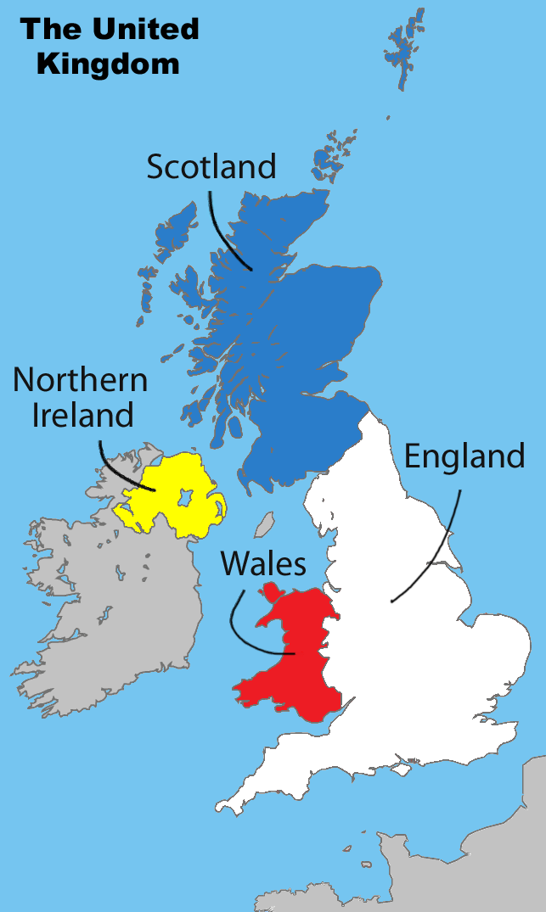
The United Kingdom is composed of four nations: England, Scotland, Wales and Northern Ireland. Its flag is called “the Union Jack”. Great Britain (sometimes just referred to as “Britain”) is not really a country, it is the largest island in the British Isles, so it refers to the island which houses the countries of England, Scotland and Wales.
The currency is the pound (“livre sterling” in French), and its symbol is £.
Political System
The United Kingdom is a parliamentary monarchy (also called a constitutional monarchy). There is not a unique, founding text comparable to other nations’ Constitution. The country is governed by a series of statutes, court judgments, traditions and conventions that make up the country’s “unwritten” constitution.
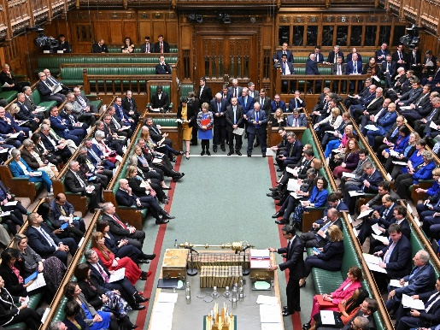
The King has gradually come to have an essentially symbolic function as head of State (of the UK and also of the British overseas territories). He must remain politically impartial. He “reigns but does not rule”.
The UK Parliament is a bicameral Parliament, it is composed of the House of Commons and the House of Lords (made up of non-elected members called peer). In the Commons, MPs (members of parliament) debate over government policy. In the Parliament, the two sides sit opposite to each other. The Parliament is located in the Palace of Westminster in London.
The two main parties are the Conservative Party (called the Tory Party), currently in power, and the Labour Party. Following a general election, (every 5 years, or before if the PM calls for a general election) the party which has won the most seats in the House of Commons forms the ruling government, and the leader of the party becomes Prime Minister (PM). He is the head of the executive power. Whitehall is a road and area in Westminster that is occupied by numerous government departs and ministries. For this reason, “Whitehall” is commonly used to refer to the British government.

- The 2024 general election (adapted from emilemagazine.fr)
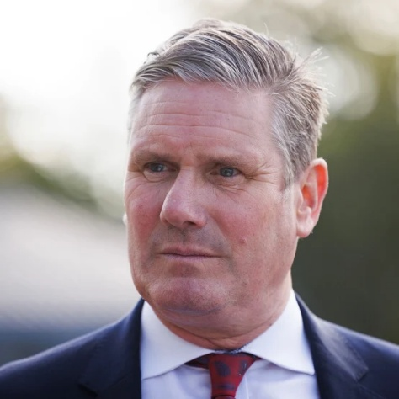
4 July 2024: A landslide victory
In line with many polls predicting the outcome for months, the Labour party has won a landslide victory in the July 4th British general elections. Sir Keir Starmer’s success is comparable to that of Tony Blair in May 1997 and opens a new chapter in contemporary British politics after 14 years of Conservative power. Noticeably, under Starmer’s leadership, Labour has managed to overcome its internal divisions, to overhaul its policy platform, and to reconnect with voters lost in 2019. The party now promises to stabilize and grow the economy, tackle the public services crisis, and reunite the country while keeping public finances under control.
Past Prime Ministers – 21st century
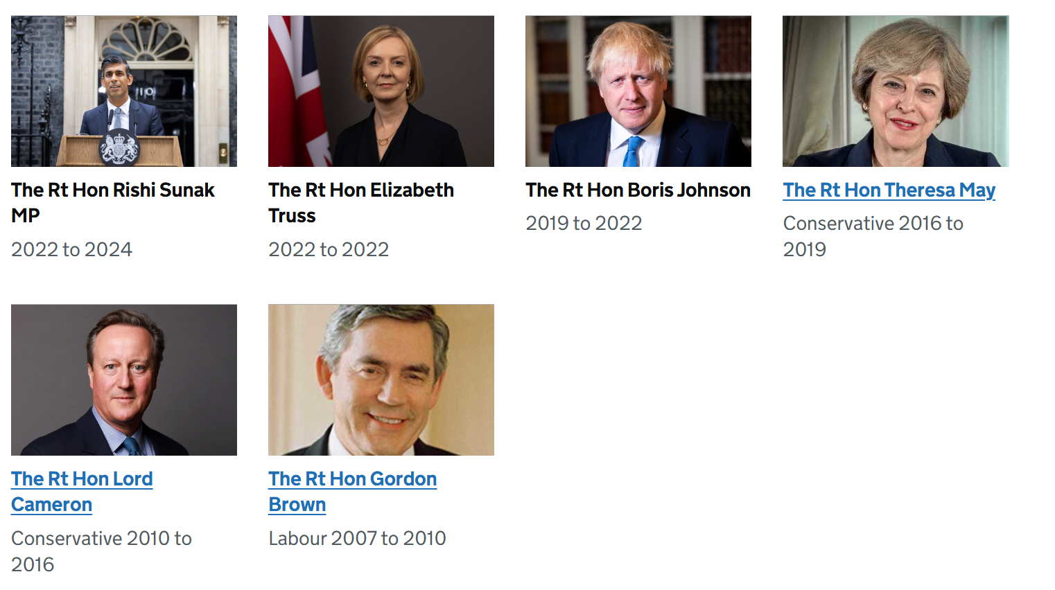

Step 1: A year of Keir
Document 1
Is this Keir's year? The challenges ahead for Starmer in 2026
Natasha Clark, LBC, 31 December 2025
It's an open secret in Westminster that Labour MPs, No10 and Whitehall are planning for when, not if, the PM faces a challenge to his leadership this year.
The new year will see a shake-up of the Downing Street media operation, with more press conferences, influencers, and TikToks.
And there'll be a foot put on the gas in terms of policy and delivery, to show and not just tell voters what the difference a Labour government's made.
Many people think Starmer has just four months to turn things around before Labour face a set of crunch elections in May.
London heartlands will be squeezed by both the Greens and Lib Dems, with new leader Zak Polanski keen to make gains.
And Reform will be eying up the 'doughnut' of outer London boroughs to see if they can carve out chunks from former Tory areas.
Kemi Badenoch will also be hoping to keep up her momentum with members and see that translated into any sort of poll gain.
Can Starmer turn things around? Here are the three things I'm watching closely to see. […]
- Understanding political and cultural references
  - Match each word to its meaning
Westminster  MPs  No10  Whitehall  PM  Downing Street | The government  The Parliament  Keir Starmer

  - Name the five political parties that are mentioned and make sure you can place them on the political spectrum:
Left |  | Middle | Right | Far-right

  - “the 'doughnut' of outer London boroughs” (l.11): what area is the journalist referring to?
- General understanding the text
  - What is the journalist’s understanding of Keir Starmer’s situation today?

Document 2
Video: Key markers of Labour’s first year in power

- Watch the video and identify the key political, economic, and social landmarks of Keir Starmer’s first year in power.
- In your opinion, was Starmer more successful in his domestic policies or his international policies? Support your answer with specific examples from the video.

Document 3
Labour’s summer of discontent –
George Eaton, New Statesman, 30 July 2025
At No 10’s summer media reception, Keir Starmer sought to conjure optimism. He invoked the success of the Lionesses – who won the European Championship five days later – and the return of Oasis. As memories turned to the 1990s, he conceded there was at least one difference: Labour’s parlous poll ratings. But, he said, “things can only get better”. It was the party’s 1997 anthem that soundtracked the downfall of Rishi Sunak, who came to embody a stuck Britain: a country of stagnant living standards, crumbling public services and uncontrolled immigration.
Labour always knew it could not rely on the wellspring of optimism that accompanied Tony Blair’s first victory. But matters have deteriorated faster than pessimists anticipated. After a year in power, Labour’s average poll rating stands at just 22 per cent, putting it eight points behind Nigel Farage’s Reform (not until the fuel strikes in 2000 did Blair briefly lose his lead to the Conservatives). Cabinet ministers openly speculate over whether Starmer will still be leader by the next general election. The word that Britons are most likely to use to describe the country, according to research by More in Common, is “broken”.
Evidence of why surrounds this government. In Epping, Essex, on 27 July, around 500 protesters gathered for the fifth time to demonstrate against the use of the Bell Hotel to house asylum seekers (one of whom has been charged with sexual assault against a 14-year-old girl). Similar demonstrations were held in towns and cities across England. The following day, resident doctors held a fourth day of strikes over pay restoration. Their union, the British Medical Association, is emblematic of a newly militant middle class (the logo of Broad Left, an influential faction in the BMA, features a stethoscope in the style of a hammer and sickle). Doctors complain their earnings remain below the 2008 level even after a 28.9 per cent pay increase. But the sympathy of a public contending with an NHS waiting list of 7.36 million is exhausted.
Looming over all this is the state of the economy – which it is Labour’s defining mission to grow. It has shrunk for the last two months, with business closures at a 20-year high and consumer confidence falling at its fastest rate since Liz Truss’s 2022 premiership. Inside Westminster and the City of London, the UK’s fiscal precarity is the subject of animated conversation (Britain has the sixth-highest debt, fifth-highest deficit and third-highest borrowing costs among advanced economies). “There’s a real risk there could be a crisis quite quickly because of the situation with the bond markets,” Helen Thompson, the Cambridge professor of political economy and author, has warned. […]
- Understanding political and cultural references
  - Match each word with its meaning
The Lionesses  Oasis  Rishi Sunak  Tony Blair  Nigel Farage  Liz Truss  The City of London | The financial district in London  The England women’s national football team  A former Labour PM  The leader of the far right  A former Conservative PM  A famous British band
  - What is the NHS (l.23)? “consumer confidence” (l.25-26)

  - What is this? =>

    - Understanding the text
  - True or False, justify by quoting the text
    - Reform UK now has more support than the Labour party.
    - There was the same enthusiasm for Starmer’s victory as for Blair’s victory.
    - People fully support the doctors’ demands.
    - The number of companies closing down has reached its highest level in 20 years.
    - l.15-23 explain what the two demonstrations were about.
  - What is the biggest problem according to the author?

Step 2: The rise of Reform and the question of immigration
Reform UK claims it has overtaken Labour as Britain’s largest part
Eleni Courea , The Guardian, 12 Dec 2025
Farage said: “As we have suspected for some time, Reform has overtaken Labour to become the largest political party in British politics – a huge milestone on our journey to win the next election. The age of two-party politics is dead.”
Meanwhile, the Times reported that, according to internal figures, the Labour party’s paid-up membership had fallen below 250,000.
Mainstream, the centre-left group backed by Andy Burnham, said the Labour’s “plummeting membership” showed that its “top-down model has failed”.
Its interim council said in a statement: “To transform Britain and defeat the far-right, Labour needs a grassroots movement in every community. The answer is to democratise, open up, and empower members. A vibrant, member-powered Labour party is the only way to win – for our party and the country.”
Labour does not publish a running tally of its membership figures, disclosing them only once a year as part of its annual reporting.
Party accounts published in August showed in the year ending December 2024 it had 333,235 members, down from 370,450 at the end of 2023.
The numbers have fallen over consecutive years from a high of more than 500,000 under Jeremy Corbyn’s leadership.
A Labour party spokesperson said: “Our membership figures are published in our annual report. We do not give a running commentary on them throughout the year.”
The apparent increasing number of membership contributions to Reform will boost its electoral war chest alongside a recent spate of donations.
The party received a £9m donation in August from the Thailand-based businessman Christopher Harborne, Electoral Commission records recently revealed. The sum was the biggest single donation in modern history to a political party from a living person.
Farage insisted Harborne wanted “nothing in return” for the donation and said he was “very, very comfortable and confident” in the source of the cash.
The Greens have seen their membership swell from about 70,000 to more than 180,000 since the party’s new leader, Zack Polanski, was elected in September.
This suggests the Greens have overtaken the Conservatives, whose membership numbers have dwindled in recent years and now stand at about 123,000.

French authorities ban British far-right activists from gathering at weekend
Diane Taylor, The Guardian, 23 January 2026
French authorities have announced a sweeping ban on British far-right activists planning to take part in a “stop the boats” protest against asylum seekers hoping to cross the Channel to the UK.
Friday’s announcement by the prefecture in northern France goes further than a previous ban by the French interior ministry on 10 unnamed far-right activists associated with the organisation Raise the Colours for “having carried out actions on French soil”.
The ban, from the Nord and Pas-de-Calais prefecture, aims to prevent British far-right activists involved in “Operation Overlord” from travelling to France this weekend. The ban comes into force at 11pm on Friday evening and continues until 8am on Monday morning.
Operation Overlord was launched by Raise the Colours, an anti-migrant group placing England flags and union jacks on lamp-posts. But Daniel Thomas, an associate of the activist Stephen Yaxley-Lennon, known as Tommy Robinson, parted company with the group and is now running Operation Overlord.
Bertrand Gaume, the prefect of the Nord department, and François-Xavier Lauch, the prefect of the Pas-de-Calais department, have issued an interdepartmental order prohibiting the British far-right activists from gathering.
In a statement they said: “For several months, the presence of activists from the British far-right movement, particularly the Raise the Colours movement, involved in actions of intimidation against migrants and humanitarian organisations, has been observed on the coast of Nord and Pas-de-Calais.
“These actions, widely disseminated on social media, are part of a xenophobic and anti-immigrant ideology and create a clear risk of public disorder.”
They said the ban had been introduced to “prevent any confrontation or threat to public safety”. It prohibits the presence and gathering of self-proclaimed members of the groups in the districts of Dunkirk, Calais, Boulogne-sur-Mer, Montreuil-sur-Mer and Lille.
The French prefecture statement added that the aim of the ban was to preserve public order in the area. “State services, particularly internal security forces, will be fully mobilised to ensure the proper implementation of this decree, with the aim of protecting migrants, who are often victims of exploitation by smuggling networks, and guaranteeing the safety of everyone on the coast,” it said.
“British nationals belonging to these groups, who are apprehended by law enforcement, will be returned to the border as quickly as possible.”
On Friday, Thomas posted on X: “Last night I gave an update on the gathering in Dover and on British and English lads travelling to France on the 24th of January. What I need people to understand is this: some details must be held back until the very last moment, not out of secrecy for secrecy’s sake, but because of how important this is and what we’re trying to achieve.
“The logistics are being handled carefully, responsibly, and with purpose. When the time is right, people will know what they need to know.”
Named after the Normandy landings on D-day in 1944, Operation Overlord, when part of Raise the Colours, circulated appeals for stab-proof vests, plate carriers, high-powered torches, thermal cameras, drones and encrypted radios.
Lachlan Macrae of Calais Food Collective, an NGO working to support asylum seekers in northern France, said: “We welcome the decision by the French government to ban the actions of those involved with ‘Operation Overlord’. The decision from France shows these people to be what we in Calais always knew them to be, far-right racist agitators who are intent on coming out to France to harass displaced people and threaten violence.
“These are British citizens whose movement, groups and rhetoric have been normalised by the British government. They pose a threat to the stability of the UK and are promoting violence and hatred in the UK, too. The British government needs to take action against them and face up to the challenges of racism and hatred.”
The Home Office has been approached for comment. So far 931 people have crossed the Channel in small boats in 2026.

Step 3: A Decade After the Brexit Referendum: The Legacy of Brexit

