Chapter One: Plastic Fantastic

What can we do to stop plastic pollution?

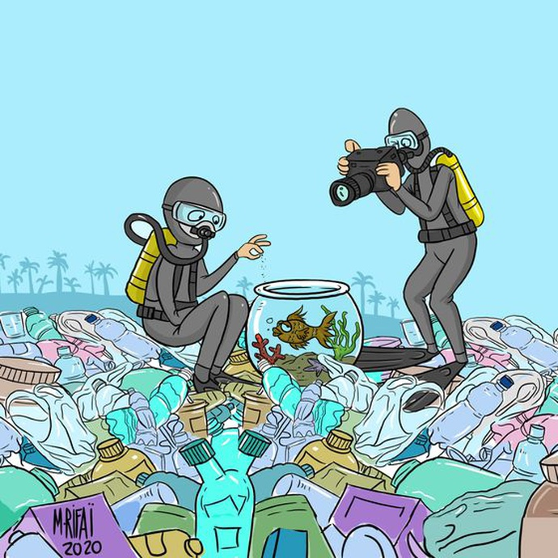
Document 1

- Describe the picture
- Analyse the picture: What is the message?
- Going further: What do you know about this issue? (causes, consequences and potential solutions)

To prepare your contribution, if you need vocabulary, check the “vocabulary corner” section at the end of the chapter.
Artist: Mahmoud Rifai | Jordan

Document 2
The world’s plastic pollution crisis, explained
Much of the planet is swimming in discarded plastic, which is harming animal and possibly human health. Can plastic pollution be cleaned up?
By Laura Parker, edited from National Geographic, May 28, 2025
PART 1
Plastic pollution has become one of the most pressing environmental issues, thanks to the overwhelming rise in production of disposable plastic products.
Plastic pollution is most visible in developing Asian and African nations, where garbage collection systems are often inefficient or nonexistent. But the developed world, especially in countries with low recycling rates, also has trouble properly collecting discarded plastics.
Plastic trash has become so ubiquitous it has prompted efforts to write a global treaty negotiated by the United Nations.
Why was plastic invented?
Plastics made from fossil fuels are just over a century old. Belgian chemist Leo Baekeland created the first fully synthetic plastic in 1907. Production and development of thousands of new plastic products accelerated after World War II, which transformed the modern age so much that life without plastics would be unrecognizable today. In plastic, inventors found a light, durable material that can be used in everything from transportation to medicine.
Plastics revolutionized medicine with life-saving devices, made space travel possible, lightened cars and jets—saving fuel and pollution—and saved lives with helmets, incubators, and equipment for clean drinking water.
The conveniences plastics offer, however, led to a throw-away culture that reveals the material’s dark side: today, single-use plastics account for 40 percent of the plastic produced every year. Many of these products, such as plastic bags and food wrappers, have a lifespan of mere minutes to hours, yet they may persist in the environment for hundreds of years.
That's why some governments have taken steps to limit or ban the use of plastic bags. Most recently, California passed legislation to ban all plastic bags by 2026.
- General Understanding
  - What sort of document is it?
  - Does the writer express an opinion?
  - What is the topic?
- Vocabulary
  - Find two synonyms for “rubbish” and find a synonym for “advantages”.
  - “A rise in” (l.4): does means more (augmentation) or less (decrease)? Do you know other words to refer to this?
Augmentation | Decrease

  - Using the context, select a definition or synonym for “discarded” (l.1; 8): already-used / recycled / thrown away as garbage
  - Is “disposable” (l.4) an adjective/ a noun / an adverb? Can you guess the verb it is derived from? Find an antonym and in the text, find a word that has a similar meaning.
  - “food wrappers” > Using these sentences, guess the meaning of the verb “wrap”:
I need to wrap her Christmas present.
I will wrap this sandwich to take it to school.
In French, “to wrap” means……….Therefore, “food wrappers” are….
- Understanding the text
  - True or False? Justify by quoting the text.
    - Plastic pollution is only in developing countries.
    - Plastic can take millennia to decompose.
    - 4 in 10 plastic items produced are not reusable.
  - Find in the text the two adjectives that describe the main qualities of plastic.
  - What two actions to reduce plastic pollution are mentioned in the text?
- Analysing the text
  - What is a “throw-away culture” (l.21)? What impacts do you think it has had on our lifestyles? Illustrate your answer (100-200 words)
- Going further
  - Imagine what life would be like without plastic (100-200 words)
Vocabulary & Methodology
What are the words in bold characters ? Why and when do we use them? (Fill in the chart and then try to find other examples of such words).
Idea/
meaning
 | Thanks to | But, however, yet | And, also | That’s why | Such as
Vocabulary Corner

Rubbish, trash, garbage | Les ordures | To dump | déverser
A rubbish dump, a tip, a landfill | Une décharge | To litter | Jeter des déchets dans
Litter | Les détritus (sur le sol) | To throw away | Jeter
waste | Les déchets | To scatter | éparpiller
A bin (UK), a trash can (US) | Une poubelle | A fish tank, a fish bowl | Un aquarium

Increase (augmentation)
- rise
- growth
- climb
- improvement (careful: not always numerical)
- gain
👉 Phrases:
- go up
- go higher
- an upward trend

Decrease (diminution / baisse)
- fall
- drop
- decline
- reduction
- loss
👉 Phrases:
- go down
- go lower
- a downward trend

Follow up exercise (for later)

taux

